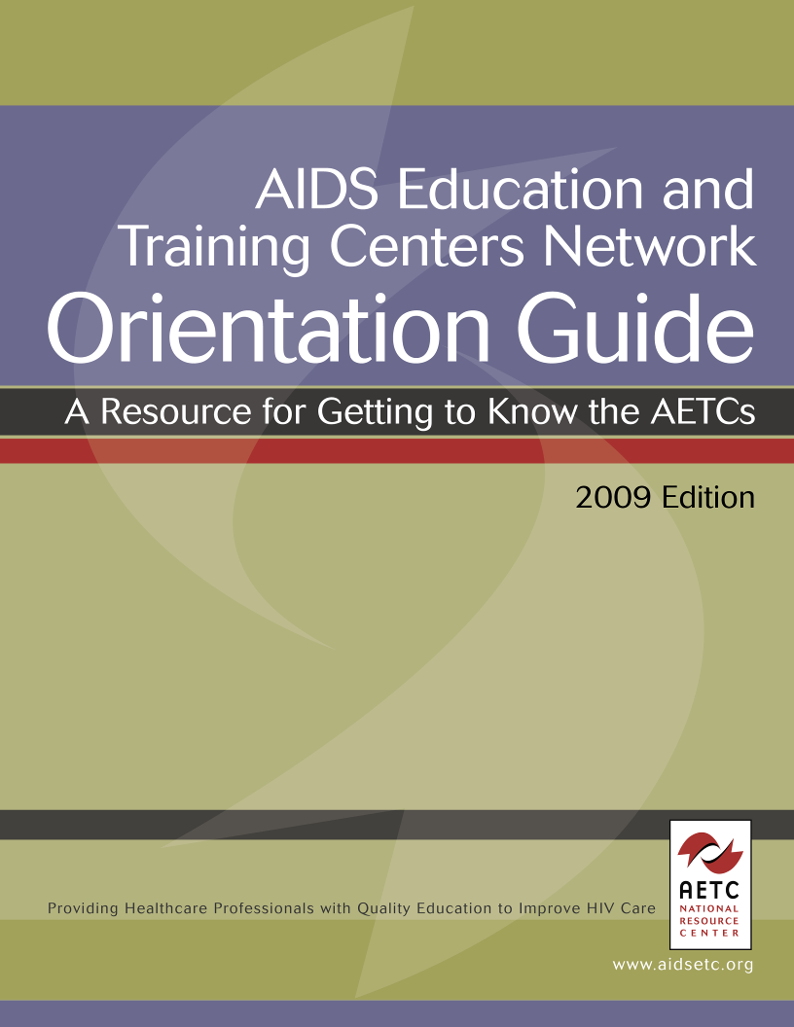

Table of Contents
Section 1: about this guide……………………………………………………………………2

Introduction……………………………………………………………………………………3
Acknowledgements……………………………………………………………………………4

Section 2: General Information about the AETCs……………………………………….5

Overview………………………………………………………………………………………..6
The Ryan White HIV/AIDS Program…………………………………………………….6
AETC History and Mission………………………………………………………………..8
AETC Website……………………………………………………………………………….9
AETC Training Levels……………………………………………………………………10
Work plans and Budgets………………………………………………………………...11
AETC Required and Region-Specific Evaluation………………………………………. 13
Purpose of Data Collection……………………………………………………………13
Overview of HRSA Required Data Collection Forms………………………………13
Overview of Types of Region-Specific Evaluation Activities……………………..14
Overview of AETC National Evaluation Center (AETC NEC)…………………….15
AETC NEC Website - AETC Only Section……………………………………………...16

Section 2A: AETC Special Projects…………………………….…………...……………...17

Minority AIDS Initiatives (MAI)……………………………………………………………18
Background……………………………………………………………………………….. 18
The Creation of the Minority AIDS Initiative…………………………………………18
Goals of the Minority AIDS Initiative………………………………………………….19
Selected MAI Funding Examples…………………………………………………………...20
AETC MAI Background………………………………………………………………….. 22
Selected AETC MAI Projects……………………………………………………………. 23
MAI Regional Contacts……………………………………………………...…………...32

section 3: AETC staff Members and Roles……………………………………….………34
Resources for Event/Training Coordinators and LPS Coordinators

What’s My Job?........................................................................................................................ 34
The Coordinator’s Corner……………………………………………………………...….37
Continuing Education Credits…………………………………………………………….38

section 4: Training…………………………...……………………………………….………39

Overview……………………………………………………………………………………….40
Adult Learning………………………………………………………………………………. 41
Final Thoughts………………………………………………………………………………..47

section 5: HelpfuL Resources………………………………………………………………49

AETC Website Scavenger Hunt…………………………………………………………….50
AETC Website Scavenger Hunt Answer Key……………………………………………..52
table of contents (con't)

Workplan Template……………………………………………………………………….....53
Stratified Program Budget Template……………………………………………………………54
How to write S.M.A.R.T……………………………………………………………………...55
S.M.A.R.T GOALS ASSESSMENT TOOL……………………………………………………56
Coordinators Checklist Sample 1………………………………………………………... 57
Coordinators Checklist Sample 2…………………………………………………………59
Conference Attendants’ Notebooks...................................................................................61
Preceptorship Procedure…………………………………………………………………... 62
Sample Preceptorship Schedule……………………………………………………………63
Sample Post-Training Thank You Letter…………………………………………………64
Sample Collection of Ice breakers/Exercises/Closing Activities…………………....65
Silent Assessment………………………………………………………………………… 65
Get them up and moving…………………………………………………………………..66
Pick Pocket…………………………………………………………………………………66
Closing Statements……………………………………………………………………….67
AETC Lingo: Acronyms and Abbreviations………………………………………………68
References…………………………………………………………………………………..75



Introduction

The AIDS Education and Training Centers (AETCs) Network Orientation Workgroup is pleased to share this resource, the Network Orientation Guide – A Resource for Getting to Know the AETCs. This Guide is a collection of tools, resources, and program descriptions developed by the network to help AETC staff better understand the network, their roles, and how to navigate useful resources.

This Guide contains four main sections that cover general information about AETCs (including AETC special projects), staff member roles, training and helpful resources. Sample documents such as planning checklists, training ice breakers, and an overview of the AETC website are also incorporated. The goals of this Guide are to:

- Provide an overview of the AETC network
- Assist staff and faculty in understanding their role(s) within the network
- Outline the training component of the AETC program
- Provide useful resources to support staff with their roles and responsibilities

The Guide has been designed to provide a general overview of the entire AETC network. Placeholders have been left throughout this document so that regional AETCs may modify sections for their specific needs. Members of the AETC Network Orientation Workgroup encourage all regional, local, and national centers to utilize the Guide to enhance their current orientation processes for new AETC staff and faculty.

The AETC Program is funded by the U.S. Department of Health and Human Services (HHS), Health Resources and Services Administration (HRSA), HIV/AIDS Bureau (HAB).

Acknowledgements

This Guide was developed by members of the AETC Network Orientation Workgroup.

Authors/Workgroup Members:
- Daria Boccher-Lattimore, DrPH; New York/New Jersey AETC
- Patricia Charles, DrPH, MPH; Pacific AETC
- Marla Corwin, LCSW, CAC III; Mountain Plains AETC
- Amy de la Cruz, MEd, RN; Texas/Oklahoma AETC
- Durrell Fox, BS, CHW; New England AETC
- Linda Frank, PhD, MSN, ACRN; Pennsylvania/MidAtlantic AETC
- Chelsea Gilts, BA; AETC National Resource Center
- April Grudi, MPH, CHES; Midwest AETC
- Veronica Jones, MPH; AETC National Resource Center
- Kevin Khamarko, MA; AETC National Evaluation Center
- Andrea Knox, MS; Health Resource and Services Administration, HIV/AIDS Bureau
- Supriya Modey, MPH, MBBS; AETC National Resource Center
- Shirley Murphy; Pennsylvania/MidAtlantic AETC
- Nadine Nader; New York/New Jersey AETC (Workgroup co-leader)
- Andrea Norberg, MS, RN; AETC National Resource Center
- Joanne Orrick, PharmD, BCPS; Florida/Caribbean AETC
- Sarah Rybicki, MSW, MPH; Midwest AETC
- Dianne Weyer, RN, MS, FNP-BC; Southeast AETC (Workgroup leader)

Guide book Reviewers:
- Marla Corwin, LCSW, CAC III; Mountain Plains AETC
- Veronica Jones, MPH; AETC National Resource Center
- Andrea Norberg, MS, RN; AETC National Resource Center
- Jamie Steiger, MPH; AETC National Resource Center

Workgroup Coordinators:
- Veronica Jones, MPH; AETC National Resource Center (Managing Editor)
- Andrea Norberg, MS, RN; AETC National Resource Center

Graphic Designer:
- Karen A. Forgash, BA; AETC National Resource Center

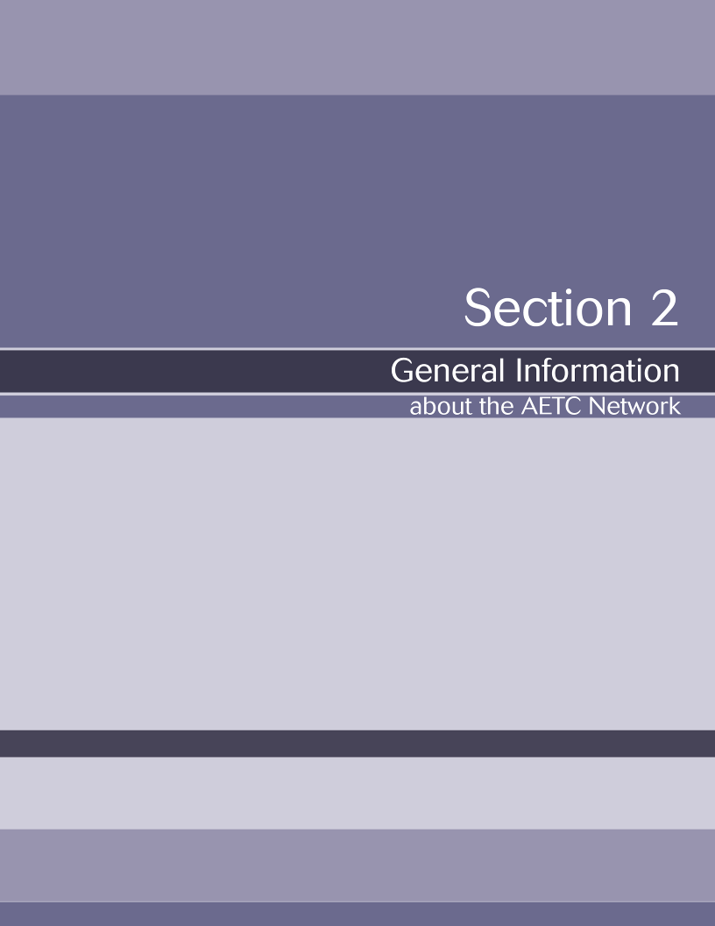

Overview

The AETCs form a network of 11 regional centers, four national centers, and more than 130 local performance sites (LPSs) representing all 50 states, the District of Columbia, Puerto Rico, the Virgin Islands, and the six US affiliated Pacific Jurisdictions. This network is a part of the Ryan White HIV/AIDS Program.

The Ryan White HIV/AIDS Program

The Ryan White HIV/AIDS Program is a federal program that provides HIV-related health services. The program works with cities, states, and local community-based organizations to provide services to more than half a million people each year.

The program offers support to those who do not have sufficient health care coverage or financial resources to cope with HIV disease. Ryan White fills gaps in care not covered by these other sources, and is the payor of last resort. The majority of Ryan White HIV/AIDS Program funds support primary medical care and essential support services. A smaller but equally critical portion is used to fund technical assistance, clinical training, and research on innovative models of care.

Ryan White is administered by the U.S. Department of Health and Human Services, Health Resources and Services Administration, HIV/AIDS Bureau (HRSA HAB). Federal funds are awarded to agencies located around the country, which in turn deliver care to eligible individuals under funding categories called parts. The AETCS are funded under Part F. First authorized in 1990, the Ryan White HIV/AIDS Program is currently funded at $2.1 billion.

Table 1 describes the various parts that make up the Ryan White HIV/AIDS Program. Links are also provided on the table that will direct you to additional information and downloadable fact sheets for each part.

This and more information about HRSA HAB can be found on their website at http://www.hab.hrsa.gov/aboutus.htm. See also the TARGET Center at http://careacttarget.org, the central source of Ryan White TA, for various training and technical assistance resources for Ryan White agencies—including those available from the AETC network.

Table 1: Ryan White HIV/AIDS Program
The HIV/AIDS Program: Ryan White Parts A-F
Part | Description
Part A | Provides emergency assistance to Eligible Metropolitan Areas (EMAs) and Traditional Grant Areas (TGAs) that are most severely affected by the HIV/AIDS epidemic. Services include outpatient and ambulatory care services.  For more information on Part A: http://hab.hrsa.gov/treatmentmodernization/parta.htm
Part B | Covers grants provided to States and Territories, including all 50 states, the District of Columbia, Puerto Rico, Guam, the U.S. Virgin Islands, and 5 U.S. Pacific Territories or Associated Jurisdictions. Medical services include outpatient and ambulatory care as well as support services for people living with HIV/AIDS.  Part B also funds The AIDS Drug Assistance Program (ADAP) and provides medications for the treatment of HIV disease.  For more information on Part B: http://hab.hrsa.gov/treatmentmodernization/partb.htm
Part C | Early Intervention Services (EIS) that provides primary care services for people living with HIV disease in a primary care setting.  Part C also includes:  - The Planning Grant program that funds planning of HIV primary health care services in rural or urban underserved areas and communities of color.  - The Capacity Development Grant Program to assist public and nonprofit entities in their activities that promote organizational infrastructure development that will lead to the delivery or improvement of HIV primary care services.  For more information on Part C: http://hab.hrsa.gov/treatmentmodernization/partc.htm
Part D | Supports family-centered care for women, infants, children, youth and their families. Services include primary and specialty medical care, support services and logistical support and coordination. Grantees also educate clients about research opportunities.  For more information on Part D: http://hab.hrsa.gov/treatmentmodernization/partd.htm
Part F | Special Projects of National Significance Program (SPNS)  - SPNS Program advances knowledge and skills in the delivery of health and support services to  - underserved populations diagnosed with HIV infection.  For more information: http://hab.hrsa.gov/treatmentmodernization/spns.htm  AIDS Education and Training Centers (AETC) Program  For more information: http://hab.hrsa.gov/treatmentmodernization/educating.htm  Dental Programs  Funding focuses on providing oral health care for people with HIV through the Dental Reimbursement Program (DRP) and the Community-Based Dental Partnership Program (CBDPP).  For more information: http://hab.hrsa.gov/treatmentmodernization/dental.htm  Minority AIDS Initiative (MAI)  MAI grants provide funding to evaluate and address the disparities of HIV/AIDS on women and minorities  For more information: http://hab.hrsa.gov/treatmentmodernization/minority.htm

AETC History and Mission

The AETCs were formed in 1988 to provide education to healthcare professionals about HIV disease. Over the last 20 years, the work of the AETCs has contributed significantly to the development of a comprehensive network of healthcare professionals prepared and committed to improving HIV patient care and treatment.

The mission of the AETCs is to improve the quality of life of patients living with HIV/AIDS through the provision of high-quality professional education and training to providers. Training is offered through expert clinical consultation, intensive clinical rotations and preceptorships, workshops, seminars, hands-on supervised clinical experiences, and technical assistance (TA).

Training and technical assistance are available for physicians, physician assistants, nurses, advanced practice nurses, pharmacists, and oral health professionals. These professions are the main target audience for the AETCs and are commonly referred to as the “Big 6.” Training efforts have expanded over the years to reach other healthcare professionals including medical case managers, social workers, mental health workers and other Ryan White funded providers.

As mentioned on page 6, the AETC program is comprised of 11 regional AETCs, more than 130 LPSs within the regions, and four national centers. The map below depicts the location and territory of the regional AETCs.

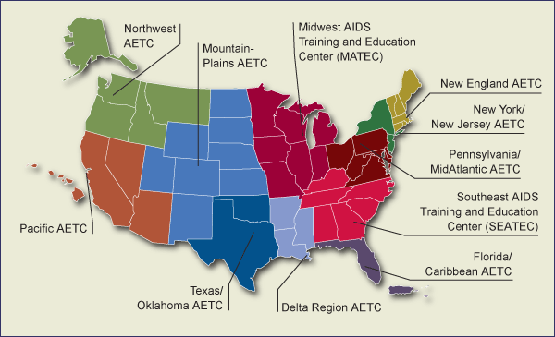

Not shown on the map are the four national centers. These are the AETC National Resource Center (NRC), AETC National Evaluation Center (NEC), National Minority AETC (NMAETC), and the National HIV/AIDS Clinicians’ Consultation Center (NCCC). More detailed information about each national and regional center is available online at http://www.aidsetc.org/aidsetc?page=ab-00-00. There is also an online directory with contact information of AETC faculty and staff.

In addition, a link to the HRSA HAB fact sheet for Part F can be found within the table on page 7.

A partnering organization included under the HRSA HAB AETC network is the International Training Center on HIV (I-TECH). I-TECH collaborates with organizations to support the development of health work forces and health delivery systems on a global level. For more about I-TECH, visit their website at http://www.go2itech.org/.

AETC Website

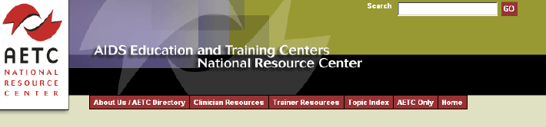

Overview of www.aidsetc.org

The website is a central repository for AETC program and contact information. It is also a virtual library of online training resources available for adaptation to meet local training needs. Furthermore, it provides timely, high quality, state-of-the-art clinical information and resources.

The website is monitored and maintained by the AETC NRC. To learn more about the services of the AETC NRC, including an overview of the website, visit http://www.aidsetc.org/aidsetc?page=home-nrc-tour

For a personalized tour of the website over the telephone, or to request a website brochure contact the NRC by sending an e-mail to info@aidsetc.org.

See also the TARGET Center at http://careacttarget.org, the central source of Ryan White TA, for various training and technical assistance resources for Ryan White agencies—including those available from the AETC network.

The Inside Scoop – AETC only

The AETC Only area of the website is password protected. This area allows access to information about AETC listservs, AETC NRC workgroups, and materials being developed by other regions. An online order form for AETC promotional items such as brochures and quarterly newsletters is also available in this area.

To request access to the AETC Only area, follow the instructions provided online at http://www.aidsetc.org/aidsetc?page=home-welcome. You will be guided through a brief online orientation of this section of this website. Upon completion, fill out the form to request access. The NRC will verify your information and a staff member will contact you with further details.

Scavenger Hunt

To familiarize yourself with the website, try using the AETC website scavenger hunt tool located in Section 5 of this Guide (pg. 50).

AETC Training Levels

As previously mentioned, training is a critical component of the AETC program. Training activities are guided by the assessment of local needs. AETC faculty and staff work hard to conduct educational activities that are interactive, hands-on, and offer clinical consultations on complex issues related to the management of HIV. Since 1991, the AETCs have sponsored well over 700,000 training interactions for providers.

Table 2 describes the current components of the five training levels recognized by the AETCs. AETC trainings must contain at least one of the defined levels (listed below) to count as an AETC program.

Please note: New categories and language describing training levels are being discussed. Proposed changes will include the renaming of “training levels” to “training categories or types” and an expanded table that outlines the method of trainings, training objectives, role of the learner and examples of each type. The revised training table is anticipated to be adapted by HRSA in July 2010.

Table 2: AETC Training Levels

AETC Training Level | Description
Level 1:  Didactic Presentation | Participants are often passive learners, with programs varying in length from brief lectures to conferences.  Format used:
Level 1:  Didactic Presentation | Panel discussions  Self-instructional materials | Journal clubs  Teleconferences  Didactic presentations
Level 2:  Skills Building Workshops | Participants may engage in interactive and skills-building activities characterized by active trainee participation.
Level 2:  Skills Building Workshops | Format used:  Case discussions  Role play |  | Simulated patients  Train the trainer (TOT)  Other skill building activities
Level 3:  Clinical Training | Participants may engage in training that includes activities in which they are actively involved with clinical care experiences involving patients.
Level 3:  Clinical Training | Format used:  Preceptorships |  | “Mini-residencies”  Observation of clinical care at either AETC training site or the trainee’s worksite
Level 4:  Clinical Consultation | Participants may engage in training that includes patient-specific clinical consultation provided to health care professionals.
Level 4:  Clinical Consultation | Format used:  Clinical consultation |  | Case-based discussions
Level 5:  Technical Assistance | Technical assistance offered by the Local Performance Site (LPS).
Developing Regional Approaches to Training Community Pharmacists, 2008
For more specific examples and resources under these training levels, please visit AETC NRC website: www.aidsetc.org

Work Plans and Budgets

Information and tools for this section are taken from the HRSA HAB Technical Assistance AETC Directors Meeting (October 2007) - Developing Effective Work Plans & Budgets

HRSA HAB has identified three interrelated steps to develop a comprehensive work plan. They are: 1) conduct needs assessment activities, 2) develop a regional training plan, and 3) develop a work plan using the budget. The AETC work plan includes the following functions:
- Provides a blueprint for everyone to follow
- Tests whether the objectives and activities can be accomplished
- Becomes a tool for managing/tracking projects
- Reveals critical paths and potential barriers
- Serves as a contract for everyone involved
- Forces grantees to reconsider and refine the proposed scope of work, as needed
- Tracks directly to the project budget

Work plan objectives should be S.M.A.R.T: Specific, Measureable, Achievable, Realistic and Timed. For Web related information about S.M.A.R.T objectives and an assessment tool, see pages 55-56.

The budget development process should be integrated into the work plan development process. Figure 1 shows which components are included in the budgeting process.
Budget
Goals & Priorities
Realistic Potential Resources
Existing Resources
Existing Committed Expenses
Timing of cash receipts and expenses
Prioritized wish list for new expenses
Figure 1: Components of a Budget
Sample stratified program budget template is provided in Section 5, pg. 54.

The work plan and budget will help with progress reporting. AETCs are required to complete a six month and annual progress reports that describes the following:
- Status of activities/significant accomplishments to date
- Major problem(s) encountered
- Strategies for problem solving
- Identification of any budget issues
- Work plan revisions as needed

Other requirements and suggestions for progress reporting will be set by HRSA HAB and communicated via your project officer.

AETC Required and Region-Specific Evaluation

Purpose of Data Collection

The AETCs are required to collect and submit data files on an annual basis. The purpose of national data collection efforts is to create a uniform set of data elements that will produce an accurate summary of the national scope of AETC professional training, consultation, and technical assistance events. The elements forming the national database have been selected for their relevance in documenting the AETCs’ efforts in achieving the program’s stated goals — to improve the care of people living with HIV/AIDS by providing education, training, clinical consultation, technical assistance, and other forms of support to clinicians and other providers serving this population. HRSA HAB needs this information to respond to requests from the Department of Health and Human Services (HHS), Congress, and others.

The national data elements are also intended to establish a meaningful core set of elements that individual AETC programs can use in program and strategic planning. Each AETC can collect additional data —using other forms that they create— to address specific training activities or other data collection needs.

Overview of HRSA Required Data Collection Forms
Types of Forms

The two forms used by the AETCs to depict their activities include the following:

- The Event Record (ER) gathers information on each activity, including topics covered, number of people trained, type of training conducted, training modality, length of training, and collaborations with other organizations

- The Participant Information Form (PIF) captures information from the individuals who attend an event — including their profession, primary role, employment setting, and the characteristics of the HIV-infected population they serve

These forms were developed collaboratively to better reflect reporting needs. HRSA and the AETC Data Workgroup are currently in the process of revising the forms to address the various types of information requests HRSA receives, however the following data elements are required:
- Unduplicated count of all training, consultation, and technical assistance encounters
- Unduplicated count of individuals receiving AETC professional training, consultation, and technical assistance encounters
- Number of hours of AETC training events, consultations, and technical assistance encounters
- Number of trainees who treat and manage the medical care of people with HIV
- Proportion of trainees who care for underserved minorities and vulnerable populations
- Proportion of AETC trainees employed by agencies funded by the Ryan White Program
- AETC use of various training modalities, including distance learning, clinical consultation, internet-based instruction, and technical assistance
- AETC contribution to improved access to medical care for underserved and vulnerable populations by increasing the capacity of medical care providers available to care for HIV- infected patients
- Number of offerings on specific topics, including clinical management of HIV disease, highly
active antiretroviral therapy (HAART), state-of-the-art antiretroviral therapy, and technical assistance designed to increase capacity

Overview of Types of Region-Specific Evaluation Activities

The majority of regional AETCs have an evaluator/evaluation team located at their central office. These individuals are knowledgeable of the context of your region and are able to develop tools to evaluate the training programs offered. Some common evaluation activities regional AETCs conduct include, needs assessment, pre/post test evaluation, and follow-up surveys. The AETC trainers’ role in this is primarily to ensure forms are distributed to trainees and collected before individuals leave. AETC trainers may also be asked to collect contact information (e.g., email addresses) and notify trainees that the AETC will be contacting them in the future for feedback on the trainings.

- Needs Assessments. Recently, HRSA has required regional AETCs to conduct needs assessments to demonstrate the need for specific trainings. They are commonly conducted to 1) identify gaps in training knowledge, 2) identify possible solutions, and 3) develop an appropriate course of action. Within the AETC network, needs assessments are conducted to better understand the skill level of the individuals trained and identify future trainings to improve the quality of the care they provide. Regional office staff utilizes the data collected from needs assessments to justify all training, consultation, and technical assistance encounters in their work plans. Your regional AETC evaluator/evaluation team may ask you to distribute these short surveys to individuals during your trainings.
- Pre/Post Tests are commonly used by AETC regional evaluators to gauge the knowledge, skills, and attitudes (KSAs) of trainees before and after the training event. These activities are conducted to help understand the effectiveness of the training in changing individuals’ KSAs. Additionally, many regional AETCs use these forms to collect information on the quality of the training, trainer, content, delivery, and other variables of interest. Many AETCs collect self-reported information from trainees on these forms, while others also utilize specific knowledge/case-based questions to determine actual changes in knowledge. These evaluation forms help improve the training programs provided and many AETC trainers find this feedback beneficial for themselves as they grow as educators.
- Follow-up Surveys are another form of evaluation that many regional AETCs implement. These evaluation instruments are typically sent to trainees one to six months after the training event. Follow-up surveys can take the form of an actual mailing or can be sent via email as an online survey. These surveys may include self-report and/or specific knowledge questions. The primary intent of these surveys is to assess whether trainees applied the information learned and have sustained the KSA objectives for the training.

Overview of AETC National Evaluation Center (AETC NEC)

The AETC NEC’s mission is to provide leadership in the development, design, testing, and dissemination of effective evaluation models for the AETC network. The AETC NEC works with regional AETC evaluation staff to determine the effect of their clinical education and training programs on provider behavior and clinical practice, with respect to changes in knowledge, skills, clinical practice behavior, and improved patient outcomes. The AETC NEC is available to provide both onsite and distance consultation to regional evaluators and to individuals interested in developing evaluation capacity within local performance sites.

The AETC NEC’s website (http://aetcnec.ucsf.edu) highlights various AETC evaluation activities and also houses the following resources for AETC program staff:
- A searchable resource library of evaluation related journal articles, AETC-specific literature, sample questionnaires, technical assistance guides, and other evaluation tools
- An archive of AETC NEC products such as newsletters and AETC evaluation pilot packages
- Information on Clinical Vignettes Online, an interactive online evaluation tool that allows AETC trainees to respond to a set of HIV patient vignettes simulating clinical practice.
- An AETC Evaluation Curriculum for self-study or for use by regional evaluators to train local performance sites (Available as PowerPoint slides)
- An AETC Only section, which includes online AETC data collection tools, a secure file upload center, and notes from monthly AETC Evaluation conference calls. To request access to the
- AETC Only section of the AETC NEC’s website, please contact Jennifer Bie at the AETC NEC at Jennifer.Bie@ucsf.edu or call 415-597-9258.

AETC NEC Website - AETC Only Section
The AETC NEC website features a secure password-protected AETC Only section where regional AETCs and LPS staff can access the following AETC evaluation tools and resources:

- Survey Center: Users can create, schedule, monitor, and analyze online AETC evaluation surveys, which can be linked to specific training events by using the following tools:

- Online Event Registration: Create online registration for AETC training events. This feature captures the AETC training event name, trainer name, training end date, and program ID

- Online AETC Data Collection Forms: Utilize online Participant Information Forms (PIFs) and
Event Record (ER) forms for AETC data collection

  - Online Participant Information Form (PIF): to be completed by participants at the start or conclusion of an event. The PIF captures information from individuals who attend an event, including their profession, primary role, employment setting, and the characteristics of the HIV-infected population that they serve
  - Online Event Record (ER) Form: to be completed by trainers when creating an event for online registration. The ER Form gathers information on each activity, including topics covered, number of people trained, type of training conducted, training modality, length of training, and collaborations with other organizations

    - Survey Forms: AETC online surveys for the Behavior Change Evaluation Project, the Cross-Region HIV Testing Evaluation Project and other custom online data collection projects can be created for specific AETC regions

- Survey Tool: This tool allows AETC staff to administer standardized or customized online surveys to AETC trainees. Features include:
  - Adding "logic" to survey questions (i.e., skip patterns and contingent questions)
  - Assigning "meta data" (e.g., event ID, trainer name)
  - Viewing all surveys created from a specific AETC region
  - Creating a link to online AETC surveys for distribution to respondents
  - Sending automated survey invitations to an email list
  - Downloading online survey data (.csv file)

    - File Upload Center: Users can upload and view AETC region-specific data using the File Upload Center. This feature allows regions to share data securely with collaborators across the AETC Network, including the AETC NEC. The following file types can be accepted: .doc, .txt, .xls, .ppt, .pdf, .mdb, .sav, .sas
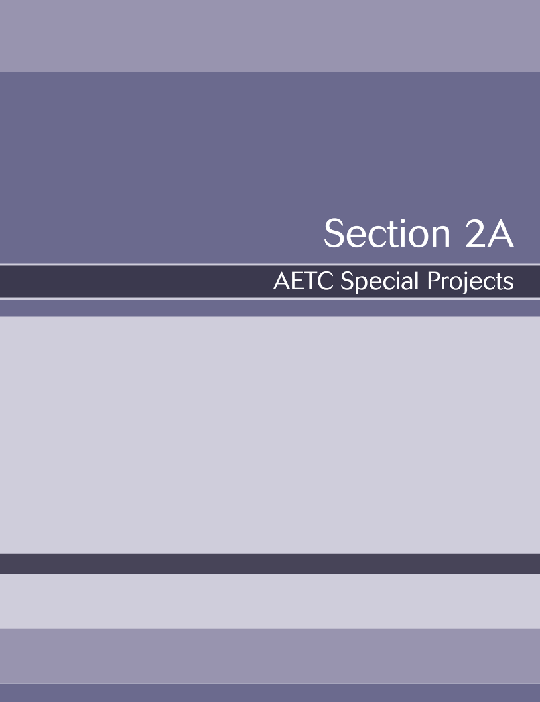

Minority AIDS Initiatives (MAI)

The MAI Projects of the AIDS Education and Training Centers: A Rich History and Commitment to Providing Opportunities for Training, Education and Capacity Building

This section contains general information about the Minority AIDS Initiative (MAI) and describes all of the projects that fall under the AETC MAI program umbrella. It is important for all AETC central offices and LPS staff members to know the basics related to the overall national MAI, in order to have a better perspective of the role and contributions of the AETC network.

Background

The Disproportionate Impact of HIV/AIDS on Racial and Ethnic Minorities

Racial and ethnic minorities have been disproportionately affected by HIV/AIDS since the beginning of the epidemic, and this impact has become more pronounced over time. Today, racial and ethnic minorities represent the majority of new HIV infections, AIDS cases, people living with HIV/AIDS (PLWHs), and AIDS-related deaths in the United States. African Americans are particularly hard hit, accounting for approximately 13 percent of the U.S. population, and about half (49 percent) of all new estimated HIV infections and AIDS diagnoses. A similar, yet less pronounced, impact exists among Latinos, who represent 14 percent of the U.S. population, but accounted for 20 percent of estimated AIDS diagnoses in 2002. Together, Asian/Pacific Islanders and American Indian/Alaska Natives represent 1–2 percent of estimated new AIDS diagnoses.

The Creation of the Minority AIDS Initiative

The creation of the Minority AIDS Initiative (MAI) in October 1998 was both the beginning of a new initiative and the culmination of a community-based advocacy campaign that began more than six months earlier in Atlanta, Georgia. In March of that year the Centers for Disease Control and Prevention (CDC) convened a meeting of African American service providers and community leaders to brief them on the agency’s African American Initiative. As part of the briefing, the CDC provided new surveillance data indicating alarmingly high rates of HIV infection among African Americans.

These data prompted community leaders to declare a “state of emergency” in the African American community with respect to HIV/AIDS, and to call on then Surgeon General, David Satcher and President Bill Clinton to make such a declaration on behalf of the federal government. The statement of emergency also included a call for: various federal agencies to develop new strategies targeting African Americans within 90 days; the provision of federal demonstration funding to test new community planning and program models; and an analysis of the correlation between the allocation of federal AIDS funding to communities and epidemiological trends.

In the weeks following the meeting in Atlanta, a number of national and local groups, including the White House’s Presidential Advisory Council on HIV/AIDS and the Congressional Black Caucus (CBC), endorsed the community leaders’ call for a state of emergency. While stopping short of declaring a formal public health emergency, President Clinton ultimately declared HIV/AIDS to be a “severe and ongoing health care crisis” in racial and ethnic minority communities during a White House ceremony announcing the creation of the MAI. Community members worked closely with the CBC and the House Appropriations Committee in 1998 to secure funding in the fiscal year (FY) 1999 Labor, Health and Human Services and Education (LHHS-E) appropriations legislation for the new initiative.

At the conclusion of the appropriations process, the Omnibus Consolidated and Emergency Supplemental Appropriations Act of 1999 included over $110 million in new funding and another $46 million in reprogrammed funds for what eventually became known as the MAI, to be administered primarily by the Department of Health and Human Services (DHHS). Later DHHS reprogrammed an additional $10 million in funding toward the MAI, for a total of $166 million allocated in FY 1999. In its first year, the MAI was most commonly referred to as the “CBC Initiative,” reflecting the CBC’s leadership in creating the framework and securing funding. Its name was subsequently changed to the Minority AIDS Initiative to reflect a broader focus on disproportionately affected racial and ethnic minority communities in general. Approximately $398 million was allocated in FY 2008.

After the first year, support for the MAI in Congress also expanded. In June 2001, the CBC, Congressional Hispanic Caucus (CHC) and Congressional Asian Pacific American Caucus (CAPAC) held a hearing on HIV/AIDS among racial and ethnic minority communities, focusing on early implementation of the MAI. This was their first-ever joint hearing on any topic.

Goals of the Minority AIDS Initiative

The primary goals of the MAI are to improve HIV-related health outcomes and reduce HIV related disparities for racial and ethnic minority groups. As stated by Congress in FY 2002 appropriations report language, the MAI: … “was designed to focus special attention on solving a growing public health problem and to develop and improve the capacity of minority community-based organizations to more effectively serve their communities … This approach was tailored to yield innovative and successful strategies specifically targeted to the highest risk and hardest to serve populations, which for the past two decades have eluded more traditional HIV/AIDS prevention, treatment and education efforts.”

The MAI has a particular emphasis on capacity building, which is a distinctive feature of the initiative. In addition to funding direct services, the MAI supports training and other technical assistance designed to strengthen community-based organizations’ core capacities in such areas as financial management, program development, administration, planning and evaluation. Such efforts have been directed primarily towards minority community-based organizations (MCBOs). Though numerous definitions of an MCBO exist, the term generally applies to organizations with a history of providing services in minority communities, and whose boards of directors, management and/or other key staff are representative of the minority populations they serve. The MAI’s emphasis on capacity building within MCBOs is an effort to strengthen their ability to provide high quality services, expand the number of minority service providers in the HIV/AIDS system of care, and enhance their ability to compete for broader HIV/AIDS funding on an ongoing basis.

When creating the MAI, Congress stipulated that its funding be used to complement other federal HIV/AIDS activities targeting racial and ethnic minority communities. This intent would presumably apply to all major federal AIDS programs, which, given the epidemiology of HIV/AIDS, serve large numbers of racial and ethnic minorities. Moreover, as noted previously, the MAI focuses simultaneously on HIV prevention, care and research and, within these broad categories of funding, on direct services; technical assistance, training and capacity building, planning, and evaluation.

Selected MAI Funding Examples

Health Resources and Services Administration (HRSA)

Ryan White HIV/AIDS Program — The Program and its state, local and community-based grantees and sub-grantees provide a wide range of services designed to strengthen HIV service delivery in minority communities and expand access to, and utilization of, high quality HIV treatment and care.

Peer Treatment Educator Training — This program supports the training of HIV/AIDS peer treatment educators in highly impacted areas of the country in order to engage and retain more racial and ethnic minorities in local systems of HIV care.

Supporting Networks of HIV Care (SNHC) — The SNHC Project provides regional trainings and onsite, individualized capacity building training and technical assistance to small and moderately sized non-profit, community- and faith-based organizations. The goals of the program are to strengthen organizational infrastructure, enhance the quality of HIV service provision and expand the number of organizations in the federally funded system of HIV care.

In addition to these programs, MAI funds are also used for an external evaluation of HRSA administered MAI programs. In previous years, HRSA used General Departmental Management (GDM) funds for the Targeted Provider Education Demonstration (TPED) program. TPED provided training on the HIV-related health care needs of racial and ethnic minorities for non-clinical, HIV health and support service providers (i.e. case managers, treatment educators and outreach workers) in minority community-based organizations. At the conclusion of the demonstration grant, elements of the TPED program were incorporated into the AETC program of the Ryan White HIV/AIDS Program.

Centers for Disease Control and Prevention (CDC)

Cooperative Agreements — Funds are allocated to state and local health departments through existing cooperative agreements to assist them in meeting the CDC requirement in HIV community planning cooperative agreements that the allocation of federal prevention funding match the racial and ethnic demographics of the HIV epidemic locally.

HIV Prevention Among Racial and Ethnic Minority Men Who Have Sex With Men (MSM), Including Young MSM — Through one of two grant programs, the CDC funds community-based organizations, national, regional and local minority organizations to provide health education, outreach, counseling and testing and prevention case management services to minority MSM, as well as technical assistance to help these organizations strengthen service delivery. Since FY 2001, a second young minority MSM project encourages linkages between organizations that serve minority youth and those working on HIV prevention.

Innovative Testing Strategies—These funds are used by state and local public health entities and CBOs to promote and implement nontraditional, community-based HIV testing strategies to increase knowledge of serostatus among high-risk racial and ethnic minorities and link individuals who are newly diagnosed to care. This includes support for National HIV Testing Day, the expanded use of rapid testing, and the use of multi-media, consumer-driven marketing strategies as part of the “Know Now” campaign.

Indian Health Services (IHS)

School Health Program — Through a Memorandum of Agreement (MOA) with the CDC, the IHS provides teacher training, curriculum support and other technical assistance to improve school-based HIV prevention efforts targeting Native American youth attending Bureau of Indian Affairs schools and public schools.

American Indian/Alaska Native Health Care Provider Training Initiative — Through an MOA with HRSA, this program partners AETCs with American Indian/Alaska Native and or Urban Indian Health Centers to develop and implement HIV training programs for health care providers and paraprofessional health care providers serving tribal areas and communities.

Behavioral Surveillance and Assessment — As part of this assessment, the IHS and CDC are evaluating HIV/AIDS case reporting practices at IHS, Tribal and Urban health facilities in order to strengthen the collection of surveillance data for American Indian/Alaska Native communities.

Office of Minority Health (OMH)

Technical Assistance and Capacity Development Demonstration Program for HIV/AIDS-Related Services in Minority Communities — This program provides grants to public or tribal governmental entities and private, non-profit organizations to provide technical assistance and mentoring to community-based, minority serving organizations. The goal of the program is to stimulate, foster and support the development of effective and sustained HIV prevention and treatment service delivery capacity within such CBOs.

Minority Community Health Coalition Demonstration Program, HIV/AIDS — These grants support local coalitions working to increase understanding of HIV/AIDS and improve access to HIV/AIDS prevention, testing and treatment services. Coalitions must include a community-based, minority serving organization with extensive experience in conducting HIV/AIDS prevention and outreach activities, an AIDS service organization, and at least one organization rooted in the community with no prior experience in an effort to expand the network of HIV service providers.

State and Territorial Minority HIV/AIDS Demonstration Program — This program provides funds to state and territorial offices of minority health to: assist in identifying local HIV/AIDS prevention needs; facilitate linkage of community-based, minority serving organizations with other recipients of federal HIV funds to develop greater resource capacity; and assist in coordinating federal resources in high need minority communities.

AETC MAI Background

General Information

The AETCs have a long tradition of serving providers of color and providers serving HIV-infected people of color across the country. Since the AETCs creation they have served all providers serving people living with HIV.

The AETC program is a “safety net” training program for professional HIV/AIDS treatment education, just as the other components of the Ryan White HIV/AIDS Program are the safety nets for HIV/AIDS care. AETCs are expected to prioritize resources to provide training and education to remote, underserved parts of their regions or other areas with identified need but no, or insufficient, alternate training resources.

In the late 80’s -early 90’s, many of the AETC regional centers were building strong, lasting partnerships and collaborations with clinical sites, AIDS service organizations (ASOs) and community-based organizations (CBOs) that serve people of color living with HIV.

With the creation of the Minority AIDS Initiative (MAI) in 1998 the AETCs received MAI funding and resources to support and strengthen these partnerships as well as to form new collaborations and partnerships. With the infusion of MAI funding, AETCs were able to develop and expand programs designed to meet the training and educational needs of clinical providers of color and clinical providers serving HIV-infected people of color. This shift included the development of programs aimed at building the capacity of providers and systems to better serve people of color with HIV.

The AETC focus for the MAI is to increase the capacity for minority and minority serving clinicians to treat HIV/AIDS and to document outcome measures relative to specific MAI training activities. This supplements the overall programmatic intent to target clinical training in areas of increased need, limited care capacity, and continuing health disparities.

MAI funding supports several types of AETC initiatives including:
- Approximately 20 percent of AETC regional center core funding is from the MAI and designated to support MAI activities
- Creation of the National Minority AETC (NMAETC) in 1999
- Special MAI Capacity Building Project which provided new targeted funding resources in 2005
- Collaboration with Indian Health Services in 2002, American Indian/Alaskan Natives (AI/AN) Project funding became available to the AETC Network; eight AETCs currently receive AI/AN funding support
- U.S.-Mexico Border AETC Steering Team (UMBAST) was established in 2002

Selected AETC MAI Projects

National Minority AETC (NMAETC)

MAI funding also supported the creation of the NMAETC in 1999. The NMAETC was created to focus 100 percent of their efforts on MAI priorities and to provide leadership and coordination with the regional centers to ensure our collective efforts were effective in attaining MAI goals. The NMAETC provides capacity building services from the perspective that the center and its partners have a history of providing services to minority populations and the communities where they live. The center provides national leadership for the coordination, evaluation, and development of the required infrastructure and services that address the clinical needs of underserved communities and populations increasingly affected by the HIV/AIDS epidemic.

To find out more about the NMAETC, visit their website at http://www.nmaetc.org/ .

AETC Special MAI Capacity Building Projects

The design of these projects vary across the AETC Network and focus on providing technical and capacity building assistance to providers, clinics and clinical systems so they are responsive to, and better meet treatment and the care needs of HIV-infected people of color. These projects are developed to be consistent with the congressional intent of the MAI “to expand or support new initiatives . . . targeting African American, Latinos, Native Americans, Asian Americans, Native Hawaiians, and Pacific Islanders in highly impacted communities.”

American Indian/Alaskan Natives Project (AI/AN)

Under this initiative, each funded AETC AI/AN project uses training, technical assistance and capacity building activities to achieve the following goals:
- To provide capacity building activities designed to strengthen Native American organizations to be able to implement or enhance their HIV testing, screening and care programs.
- To increase the number of IHS and AI/AN serving clinicians routinely perform HIV risk assessments, screening, testing, diagnosis in AI/AN populations.
- To reduce the rate of new HIV infections of AI/ANs in the U.S.
- To reduce the percentage of people diagnosed with AIDS at first HIV diagnosis among racial and ethnic minority communities.
- To develop culturally-relevant training sessions to support service providers who are AI/ANs or serve AI/AN populations. Trainings are designed to be longitudinal and to affect behavioral change.

U.S.-Mexico Border AETC Steering Team (UMBAST)
Established in 2002 UMBAST’s mission is to promote high quality, culturally sensitive education and capacity building programs for health care providers and agencies that provide HIV/AIDS related prevention and clinical management services in the U.S.-Mexico border region; and to serve as the coordinating body to provide focused collaboration through joint planning, resource sharing and evaluation of AETC border activities. UMBAST participating agencies include three regional AETC centers (Mountain-Plains, Pacific and Texas-Oklahoma); two AETC national centers (National Resource and National Evaluation Centers); and HRSA HAB.
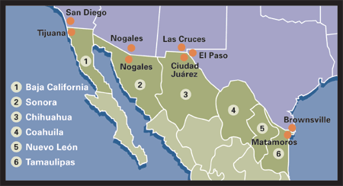

To learn more about UMBAST, check out the following webpage, http://www.aidsetc.org/aidsetc?page=ab-01-10
AETC Regional MAI Programs

AETC regional centers employ many different strategies and program models to reach and engage MAI priority provider populations across the country. Some regions employ a centralized approach where the AETC central office and one to three subcontracted sites, referred to as local performance sites (LPS), plan and implement training and capacity building programs throughout the region. Other regional centers have a more decentralized model that supports multiple LPS, four or more, across their region to plan and implement training and capacity building programs.

Targeted capacity building, technical assistance, training and longitudinal participant programs are made available to African American, Latino, Asian Pacific Islander, and Native American clinicians, or to those whose practice primarily provides services and care to minority populations. Capacity building and technical assistance includes targeted outreach and training (at all levels) for providers working in high need medically underserved minority communities. This also covers faculty/staff at regional Historically Black Colleges and Universities (HBCUs) and Hispanic Serving Institutions (HSIs) as well as enhanced efforts at promoting culturally competent HIV care. MAI is a multi-year, multi-phase initiative and is an integral part of AETC training programs nation-wide.

Below, in alphabetical order, are brief descriptions of each of the regional AETC MAI programs. The descriptions below were submitted by a representative from each region. For more information please visit regional AETC websites or connect with the regional MAI contact person(s) listed at the end of this section.

Delta

Each LPS within the Delta AETC (DAETC) is expected to develop at least 20 percent of their programs for the MAI. The Central Office has applied for approval by Louisiana State University for a Regional Manager of MAI Activities who will work with each LPS to strengthen their MAI and AI/AN Programs and act as a trainer for many of these programs.

The budget for each LPS within the Delta AETC is split into 80 percent base and 20 percent MAI with additional funds, when available, added for AI/AN and CDC HIV Testing Initiatives based on proposed work plans and projections. The DAETC continues to put forth a large effort to engage minority providers’ interest in HIV care to increase capacity for these disproportionately affected populations.

Florida-Caribbean

The Florida-Caribbean AETC currently allocates their MAI funding to be used in Puerto Rico. The Minority AIDS Initiative Project at University of Puerto Rico, Medical Sciences Campus purpose is to provide targeted training to Hispanic clinical providers and other Hispanic health professionals who provide services in programs funded under the Ryan White HIV/AIDS Program. The project targets providers serving HIV-infected people at rural centers, programs serving medically underserved, and incarcerated populations distributed in 78 municipalities throughout the island. Some of the project activities include dissemination of information, training, clinical consultation, chart reviews, and mini-residencies.

Midwest

The Midwest AIDS Training and Education Center’s (MATEC) MAI funding supports each of the seven local performance sites in the region by allowing partial, if not all, of the efforts of at least one program coordinator to focus on effective education for clinicians serving racial and ethnic minority communities and/or who are racial/ethnic minorities. In the Midwest, approximately 20 percent of each LPS’s base budget is allocated toward MAI activities.

MATEC has expanded the MAI initiative to include MAI Longitudinal Program Participants (LPP), who are minority or minority-serving providers who enroll and engage in multiple activities offered by MATEC through a tailored program design, based upon intake and assessment at enrollment. In this program, clinicians work directly with a MATEC staff member at their LPS to identify their specific goals for HIV/AIDS testing and/or care, and to develop a program of study that will accomplish these goals. At least three times each year these individuals will meet, in person or by telephone, with local MATEC staff to assess progress toward their goals. At the end of the year, LPPs and local MATEC staff meet to create a program for the next year, if additional support is needed to accomplish their goals.

MATEC also organizes a regional MAI specific training bi-annually, entitled “Committed to Caring: African American and Latino Clinicians Responding to HIV/AIDS.” This two day symposium is host to many of the top minority clinicians in the country and attended by approximately 200 participants from across the Midwest. Regionally, MAI activities/materials are shared during site director meetings.

LPSs that receive American Indian/Alaskan Native project funding specifically to target this minority population are not included in the MAI initiative.

Mountain Plains

The Mountain Plains AETC regional office (Denver) conducts an annual 3 day specialized clinical training for healthcare providers serving Native American patients. Most MAI programs are, however, carried out through eight LPSs (one per MPAETC state). Each LPS has specific needs related to MAI and each collaborates with organizations within its respective state. Projects designed for relationship building with minority and minority-serving communities are included. Many, if not most, of the MAI programs within the MPAETC region are targeted at providers serving Native Americans. LPSs have individual programs designed around capacity building, particularly for increasing HIV testing and referral. At quarterly face-to-face regional Management Team meetings, LPS coordinators and medical directors share best practices, successes and challenges in their MAI programming and outreach, as well as evaluation updates on these projects.

An annual Faculty Development Conference focuses on stigma and culturally sensitive care delivery, with an emphasis on services to Native Americans.

The MPAETC also receives funding to expand and improve HIV care and services around the U.S. Mexico Border. The New Mexico LPS is an instrumental part of UMBAST, whose goal is to increase HIV case-finding, and to expand the capacity of HIV care providers in the border communities to provide high-quality prevention, diagnosis and clinical care services.

MPAETC allocates approximately 40 percent of its annual budget to support MAI activities within the region. Training sites include correctional facilities, community health centers, Native and tribal health centers (including IHS), and community-based organizations.

New England AETC

The MAI program includes the New England HIV Education Consortium (NEHEC), a MAI Special Capacity Building Project, MAI core projects and a Native American Initiative. NEHEC began as a HRSA Targeted Provider Education Demonstration (TPED) Project in 1999, and in 2002 transitioned to being the umbrella project to coordinate all MAI activities in the region.

There are 14 LPSs in the region that receive MAI funding and the LPS coordinators participate in monthly regional LPS coordinator meetings hosted by the NEHEC-MAI Project Director. During the meeting a plan is developed to implement cross-site and cross state collaborative MAI programs and partner on many initiatives. MAI training and capacity building programs are hosted to provide technical assistance to providers and agencies serving HIV-infected people of color across the region. This includes a mix of individual provider clinical trainings, smaller onsite training programs and lager workshops and conferences.

Recently NEATEC collaborated with one national and two other regional centers on the Tri AET MAI Longitudinal Preceptorship Evaluation Project, which has helped to improve the quality of mini-residency and preceptorship programs across the region.

New England AETC allocates approximately 40 percent of its overall funding each year to support MAI activities, with the bulk of funding supporting NEHEC’s multi site consortium of community-based organizations. Each year two major MAI programs are hosted, the Multicultural HIV/AIDS Provider and Adolescent HIV Summits that feature collaborations with multiple sites in the different states of our region, as well as collaborations with AETC national centers. These major MAI programs are held in different areas throughout the region each year to ensure access to diverse populations of providers.

The NEHEC Project Director has also been a MAI leader within the AETC Network representing and doing presentations on behalf of the Network’s MAI programs, hosting national MAI coordinator conference calls, and collaborating with the AETC National Resource Center (NRC) and NMAETC on MAI related projects.

New York/New Jersey

The New York and New Jersey AETC MAI programming is organized under two headers: Capacity Building and ACCESS. ACCESS stands for AETC Community Clinical Exchange & Sustained Support Certificate Program and is a more than 20 hour, multilevel, longitudinal preceptorship program for MAI clinicians. The Capacity Building program includes targeted outreach and training (all levels) for providers working in high need medically underserved minority communities in New York and New Jersey. Included in the category of capacity building are also outreach and training of faculty/staff at regional HBCUs and HSIs as well as enhanced efforts at promoting culturally competent HIV care. MAI is a multi-year, multi-phase initiative involving all levels of training and all 15 local performance sites in the region.

Some activities that fall under MAI include an evaluation of the ACESSS mini-residency program with the NEC’s Tri-regional AETC MAI Enhanced Evaluation Project; curriculum development; the Cultural Competency Workgroup, which liaisons with the NMAETC, develops and monitors indicators in AETC program data, and advises central staff on faculty development events and tools.

The bulk of MAI efforts are longitudinal multilevel training in minority-serving Ryan White Programs, FQHCs, CHCs, AIDS Service Organizations, emergency departments, correctional health facilities, HBCUs, HSIs, and others safety-net providers that were identified using the MAI Index.

Northwest

The Northwest AETC MAI program is comprised of Central Office staff and four dedicated, population-based MAI LPSs: two American Indian/Alaska Native-serving agencies, one Hispanic/Latino (Part C) clinic with a focus on migrant farm worker populations, and one non-profit agency serving African/African-American populations. These LPS are not state specific and provide training across the region. Though a variety of trainings and TA are conducted, much activity is focused on building the HIV care capacity of targeted clinics (e.g., clinics serving African American patients, tribal clinics, etc.) serving minority populations. The Northwest AETC targets minority and minority-serving providers in these settings.

The Northwest AETC MAI program comprises 31 percent of the base funding award. In addition AI/AN funding received in 2009 was distributed to two of MAI LPSs and one Basic Grant (BG) LPS (another population-based agency serving minority patients).

Pacific

The Pacific AIDS Education and Training Center (PAETC) addresses the Minority AIDS Initiative (MAI) portion of regional effort by coordinating 11 projects funded specifically to engage in capacity building training activities. Because Pacific covers a large and diverse geographic region, the LPSs were invited to respond to a competitive proposal and were awarded according to the merits of the proposed projects. The focus of these projects included providers working with African American, Latinos, Asian and Pacific Islanders, and Native Americans, those working in correctional settings, as well as transgender populations. The sites work closely with the PAETC evaluator in order to determine clinical outcomes and to improve the quality of educational programs. All of the sites are engaged in long term strategies whose aim is to increase provider capacity to serve minority populations.

Pacific has three AI/AN projects housed at University of Nevada, University of Arizona and University of California, Irvine. The three projects work closely with IHS to coordinate their capacity building efforts.

Pacific utilizes 21 percent of funding to provide support for MAI focused projects in the region. In addition, a small amount of support is received for AI/AN related work.

Pennsylvania/Mid Atlantic

The PA/MA AETC has a long history of work with minority providers and those serving minorities. The core funding for the AETC represents 78 percent which is utilized across the region to reach goals and objectives outlined in the work plan. Training that is designated to address specific minority concerns for minority providers comprise 22 percent of the total budget.

The approach used is based upon several methodologies including the integration of cultural competency training, health disparities, needs of minority clients and their providers, clinical issues, prevention interventions, and community capacity building into all of our training programs.

The PA/MA AETC has consistently recruited minority staff at the local performance site level, minority clinical and training faculty, and the involvement of minority HIV consumers in planning groups, committees, and other venues to assure that training approaches meet the needs of minority health care professionals and HIV consumers.

Given the vast geography and diversity within the PA/MA AETC region, in addition to the above, each of the 11 LPSs has chosen a specific targeted minority population that will have emphasis for training, capacity building, and materials development.

Due to the scope of the HIV epidemic in the Baltimore/DC area, the PA/MA AETC has developed a special initiative called the “Baltimore/DC training collaborative” which has the aim of increasing the outreach and intensity of AETC training, consultation, and technical assistance in this area. The members of the local performance sites and center headquarters for the PA/MA AETC meet regularly to plan activities to meet the growing needs of PA/MA AETC services in this area.

Southeast

SEATEC’s MAI projects consists of long-term capacity-building training, short-term training, clinical consultation, and technical assistance for minority and minority-serving providers administered through the Central Office (Emory University), and at five local performance sites in Alabama, Kentucky, North Carolina, South Carolina, and Tennessee.

MAI programs include: (1) level III clinical preceptorships; (2) longitudinal capacity-building training and evaluation for five Part C Ryan White Clinics and Community Health Centers in four states, and at Winston-Salem State University, a North Carolina Historically Black College and University; (3) clinical and community education for HBCU campus health services staff and community referral partners in five states; (4) clinical and cultural competency education for providers who treat migrant farm workers; and (5) outreach to minority professional associations. Other programs serve providers for Native American populations, and providers based in corrections and mental health and substance abuse settings. SEATEC’s Clinical Director/Senior Instructor provides year-round clinical preceptorships to identified clinicians from programs described above. The MAI project provides training scholarships for select health care providers to attend SEATEC’s Orientation to Adult HIV Care course, and Medical Management of HIV in Rural Southeast conference.

SEATEC’s Associate Director for Training and training staff hosts quarterly conference calls with regional LPSs to plan and brainstorm cross-site and cross state initiatives. MAI project collaborators include county and state health departments, prevention training centers, community health centers, Office of Minority Health Resource Center and two NMAETC regional performance sites - Morehouse School of Medicine, and Meharry Medical College.

SEATEC allocates 20 percent of its total resources to MAI activities. Approximately 75 percent of all regional MAI activities are managed by the Central Office with the remaining 25 percent awarded to individual local performance sites (LPS).

Texas/Oklahoma

The TX/OK AETC MAI funds are used to increase the capacity of minority or minority serving health care providers, in particular African American clinicians and patients. The Border Project provides training, technical assistance and support to HIV and other health care providers serving PLWH along the US-Mexico border. The Native American project is designed to identify and provide training and educational opportunities to clinicians serving Native American populations in the 2-state region living with or at risk for HIV/AIDS.

The University of Oklahoma Health Sciences Center continues to work closely with the American Association of Indian Physicians and maintains contact with Indian Health Services, and have also sought to establish a relationship with the Latino Community Development Association, to reach a greater proportion of the Latino population. Additionally, a new contact has been established with a Native American healthcare facility on the Ponca Indian reserve, the White Eagle Health Center. The Health Sciences Center is working closely with the Academy for Educational Development (AED) to provide this T.A. for capacity building.

The Border Case Management mini-conference, held in Harlingen, Texas, has continued to build the capacity of the border HIV case managers. As part of MAI collaboration with the Latino Commission on AIDS in addressing the Latino HIV crisis, draft recommendations to the federal agencies and highlighted clinical/service issues related to the Border have been discussed.

MAI Regional Contacts

Please note: This is the listing of MAI coordinators as of October 2009; it is recommended that you check with the regional office as staff changes may have occurred.

Region | Coordinator Name | Contact Information
Delta | - Earl Benjamin  - Debbie Konkle-Parker | E-mail: ebenjamin@medicine.umsmed.edu  E-mail: dkparker@medicine.umsmed.edu  Website: www.deltaaetc.org
Florida/ Caribbean | - Margarita Parrilla | E-mail: maria.parrilla@upr.edu  Website: www.FCAETC.org
Midwest | - Amanda Wilkins | E-mail: awilkins@uic.edu  Website: www.matec.info
Mountain Plains | - Beth Mullin Rotach | E-mail: beth.rotach@ucdenver.edu  Website: www.mpaetc.org
New England | - Durrell Fox | E-mail: dfoxnehec@aol.com  Website: www.neaetc.org
New York/  New Jersey | - Melissa Laurie  - Oswaldo A. Luciano | E-mail: ml2489@columbia.edu  E-mail: ol2154@columbia.edu  Website: www.nynjaetc.org
Northwest | - David Lee | E-mail: leedave@u.washington.edu  Website:http://www.northwestaetc.org
Pacific | - JoAnne Keatley | E-mail: joanne.keatly@ucsf.edu  Website: www.ucsf.edu/paetc
Pennsylvania/MidAtlantic | - David Korman | E-mail: roman2@pitt.edu  Website: www.pamaaetc.org
Southeast | - Felicia Guest  - Johnetta Holcombe | E-mail: fguest@emory.edu  E-maill:jholcom@emory.edu  Website: www.seatec.emory.edu
Texas/ Oklahoma | - Tracy Tessmann | E-mail: ttessm@parknet.pmh.org  Website: www.aidseducation.org
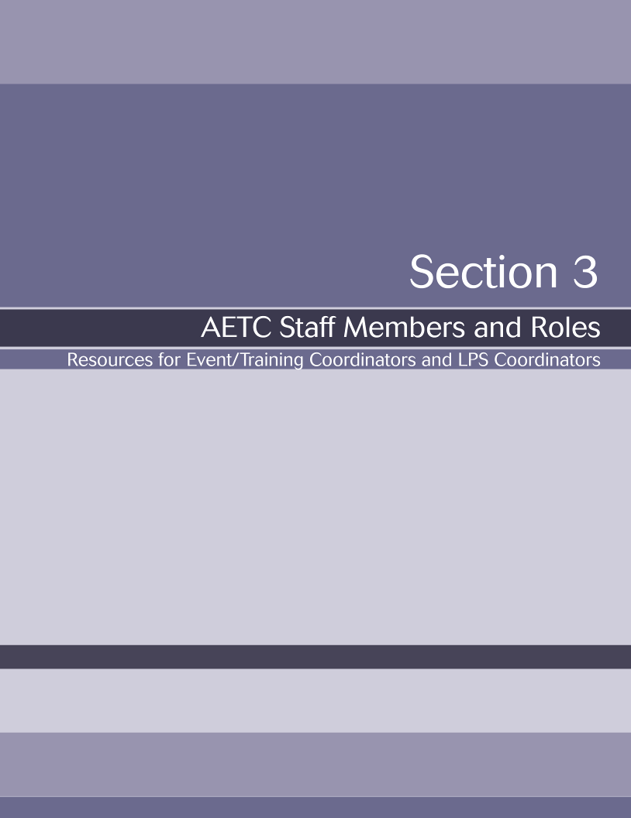

Resources for Event/Training Coordinators and LPS Coordinators

What’s My Job?

Knowing your role and the roles of others you work with is an important part of understanding the AETCs. The table below outlines and describes various roles within the network. The list below is a sampling of jobs compiled by the authors’ of this manual. It should be noted that each national center, regional center, and LPS is unique. Roles and functions vary by location. Also, it is important to note that your
AETC job title may differ from the job title used within your university or institution.

Job Title | Typical job Duties
- Principal Investigator | - Directs, plans, and organizes overall AETC program including strategic planning, administrative activities, programmatic, fiscal, and education and training activities  - Supervises and manages program staff
- Clinical Director  - Medical Director  - Medical Education Director  - Clinical Program Specialist | - Provides input on the development of medically-focused materials  - Conducts training on clinical topics  - Collaborates with LPSs to develop and conduct educational programs  - Consults with healthcare providers on patient- and clinic-specific issues  - Provides mentorship
- Director  - Executive Director  - Associate Director  - Program Director  - Project Director  - Site Director | - Works in collaboration with the principal investigator to manage day-to-day operations of the AETC program  - Primary contact/liaison among stakeholders, including funders, health department, and other federal/state agencies  - Responsible grants and reports  - Provides technical assistance to LPS  - Maintains university relationships
- Education/Training Coordinator  - Program Coordinator  - Regional Training Coordinator  - Training Specialist | - Coordinates and implements educational and training efforts related to HIV/AIDS for healthcare providers, and ensures training objectives are effective and measurable  - Plans and coordinates faculty development conferences  - Supports development of curricula and educational materials  - Contributes to enduring HIV materials  - Serves as liaison between stakeholders and collaborating partners  - Participates on national AETC workgroups  - May coordinate special initiatives such as MAI, UMBAST, HIV Testing  - Collaborates with other members of the Federal Training Centers Collaborative (FTCCs) (e.g., AETCs, PTCs, RTCs, ATTCs, and other national and regional training centers)
- Program Assistant  - Project Specialist  - Project Coordinator  - Data Coordinator | - Manages day-to-day office functions  - Prepares papers for programs (e.g., sign-in sheets, CEU certificates, name tags)  - Collects PIF data from program sites  - Manages financial records  - Organizes logistics for meetings/conferences  - Provides meeting facilitation and support (e.g., documentation help, moderating, speaker evaluations)  - Maintains program registrations and faculty information files  - Databases management
- Data Manager  - AETC Evaluation Coordinator  - Program Evaluator  - Education Evaluation Specialist  - Evaluator | - Coordinates evaluation and research  - Provides all required data submissions to HRSA  - Develops evaluation processes  - Maintains records of data produced through program implementation  - Assists with grant development  - Reviews educational agendas  - Conducts analysis and reports outcome measures  - Serves as a member of regional evaluation committee
- Administrative Professional  - Administrative Secretary  - Administrative Assistant  - Executive Administrative Assistant | - Provides logistical support for administrative and educational programming (e.g., coordinate catering, travel and hotel arrangements, honoraria)  - Responsible for data entry, maintaining records, generating reports on HRSA data collection forms  - Assists in preparation for board and committee meetings and takes minutes  - Assists in the development of program folders, PIFs and evaluation forms  - Database management  - Maintains payroll  - Answers main AETC phone line
- Finance/Grants Operations Analysts | - Responsible for fiscal administration  - Prepares and submits financial data spreadsheets  - Prepares contracts and agreements for consultants  - Supports preparation of grant proposals  - Ensures compliance with internal policies

In addition to the roles and duties outlined in the table, health policy, capacity building, and technical assistance are also important components to the work of the AETCs. Health policy can include things like handling reimbursement issues and overseeing clinic policies. Capacity building and technical assistance expands beyond training. It emphasizes developing and strengthening resources (i.e., human resources, organizational, legal), improvement of HIV service delivery, continuous quality improvement, community linkages, and technology.

Feel free to insert copies of your national, regional or local jobs duties after this page.

The Coordinator’s Corner

As a coordinator you will be responsible for planning education and training efforts. You will work closely with your director, faculty, staff, and evaluators to ensure that each aspect of the planning process is carried out.

In Section 5 you will find various resources that may be useful in completing daily activities. Your region may also have samples similar to the ones provided in this guidebook. Below is a listing of the coordination resources that are found in pages 55-64 of this manual.

- How to write S.M.A.R.T: List of websites useful when writing goals and objectives

- S.M.A.R.T. Goals Assessment Tool: Checklist of characteristics of S.M.A.R.T goals

- Coordinator’s Checklist for Event Planning: Sample list of all the various components of event planning which affords easier tracking and documentation when planning an event

- Conference Attendees Notebooks: Sample notebook for training participants

- Preceptorships

  - Preceptorship Procedural Outline
  - Preceptorship Clinic Observational Schedule
  - Participant Thank You Letter

Continuing Education Credits

Attendance at AETC programs may be boosted by offering Continuing Education (CE) credits. State medical and nursing regulatory boards require a minimum number of credits per year to maintain licensing. Psychology, social work, pharmacy, nutrition, and other national boards likewise require continuing education to assure that practitioners keep their knowledge up-to-date. By assuring that AETC programs are approved for continuing medical education (CME) or continuing education units (CEU) for nurses, and continuing education for other health care professions and practitioners add an additional incentive to attend events.

Offering continuing education can be costly and involves time and paperwork. The benefit is that all programs offering continuing education must demonstrate, via the application form, that they have met standards of quality regarding program planning. These include describing how the need for the program was determined, setting specific/achievable objectives, getting speakers, assuring that the program is professionally presented, free of commercial bias, and that it is evaluated by the attendants. Generally, when physicians and nurses find that a program is approved for their professional continuing education, they are encouraged to attend and will view continuing education fees as part of their professional responsibility.

The medical profession is governed by the National Accreditation Council for Continuing Medical Education (ACCME) which accredits CME offices based in medical schools, hospitals and community agencies. When attempting to accredit a program for CME, the first step is to contact the local accrediting body to receive a copy of their application form, fees, and program administration requirements. ACCME guidelines can be found through http://www.accme.org/ and should be reviewed comprehensively before applying for activities.

For continuing nursing education credits (CNE), contact the State Board of Nursing to receive information regarding their application process. In some states the Board of Nursing gives provider status to various organizations who in turn administer programs and issue certificates of completion. Other professionals can give you the URL address of the accrediting body for their profession.

The question regarding whether or not to offer continuing education can be answered by posing two additional questions: Will the professionals who attend this program benefit and possibly decide to attend because continuing education is offered? Are the fees and additional paperwork and administrative requirements of maintaining files and distributing certificates worth the effort for the program that is being offered? Some one hour programs do not require continuing education credit to be pertinent, useful and successful. Generally, a conference or day-long program will benefit from being developed with the rigors of the continuing education process.

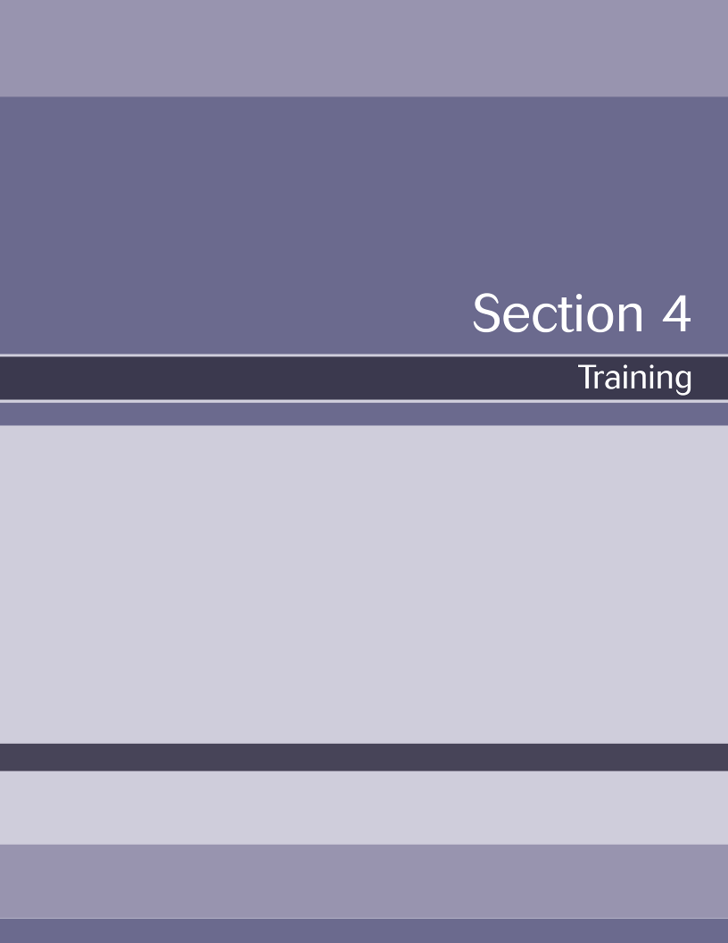

Overview

When developing any type of curriculum for adult learners it is imperative that trainers understand how adults learn, and thereby address adult learning needs. The content in this section describes the importance of active learning, encouraging trainers and trainees to share experiences and engage in open dialogue. This section also contains the various principles that inform adult learning.

While there are different nuances to adult learning theory, most theorists agree that a trainer must provide a skill for which the learner has identified a need. Such education is often self-directed. Training must be perceived as true to life, or as having value in informing current practices or life experiences. Adults must also be motivated to learn. Economic factors, professional advancement, and a desire to improve their community often prompt adults to seek continuing education.

Addressing the needs of an adult learner is outlined in Figure 2. As a trainer it is important that mutual learning is encouraged, experiences are made meaningful, and the learner is provided an opportunity for reflection and mutual discussion of experiences. The best way for this to be accomplished is to be flexible in training content and approaches.

Adult learners are very conscious of not embarrassing themselves in front of colleagues.
Offer advice in a non-condescending manner.
Ask trainees questions about their practices if they are unwilling to share a case.
Discuss personal anecdotes with both good and bad outcomes. They are more likely to discuss their own dilemmas.
Trainees who participate during training are more likely to retain the knowledge.
Ask trainees about their practices
Ask trainees how they would apply the topic with one of their cases
Encourage trainees to ask you questions
Interacting
Conscious of Others
Conscious of Self
Applying
To Real
Situations

Situations
Adult
Learner
Adult Learners are eager to learn when a topic or situation directly affects them.
Apply training topic using examples from trainees
Provide trainees with anecdotes from your practice or trainees practice
Create case studies that are similar to the patients in your trainees setting
Adult Learners seek training to address a need.
A new skill
Expand knowledge
To understand a problem they can not solve

Understanding and Addressing the Needs of an Adult Learner

Adult Learning and Training

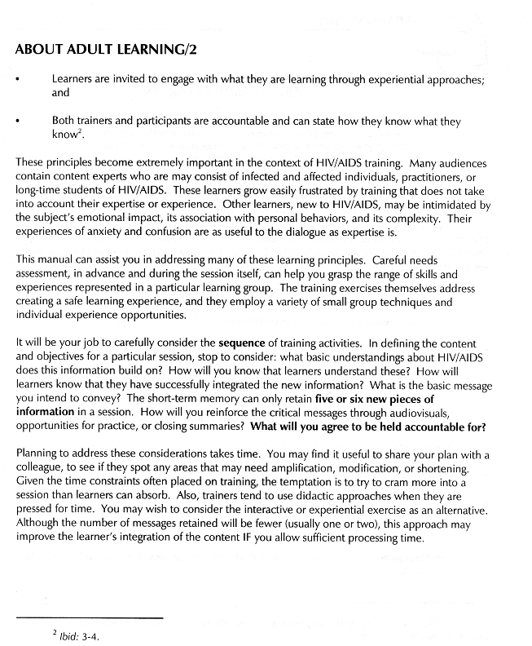
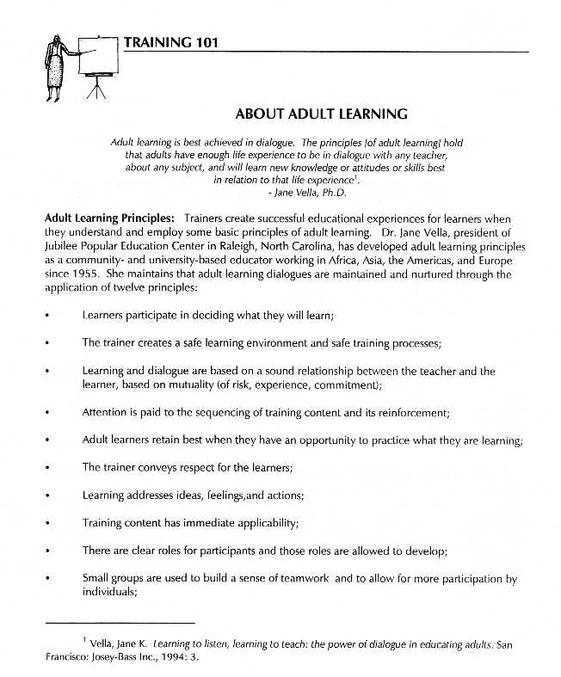
The following pages 40-46 are extracted from The HeART of Training: A Manual of Approaches to Teaching about HIV/AIDS from the Southeast AETC. These pages contain more about adult learning, needs assessments, developing goals and objectives, evaluation and preparing to train.

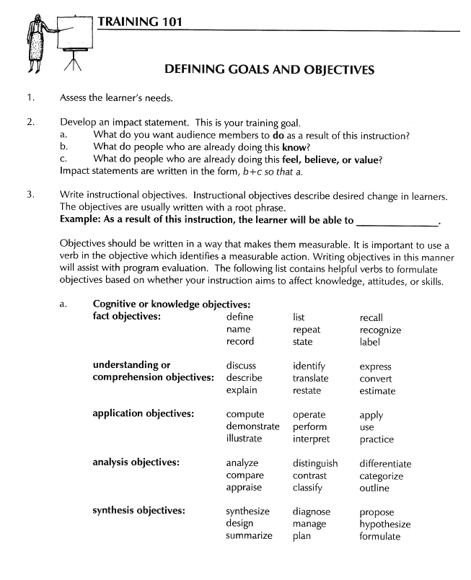

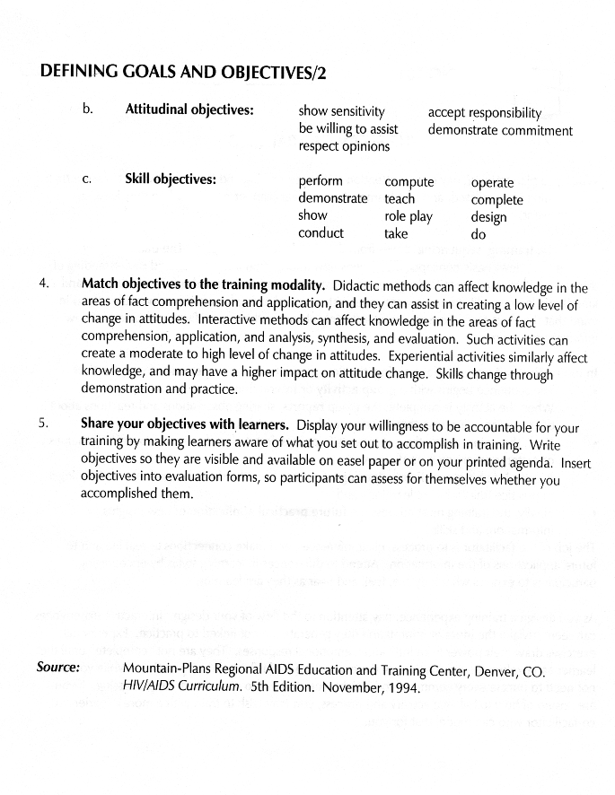

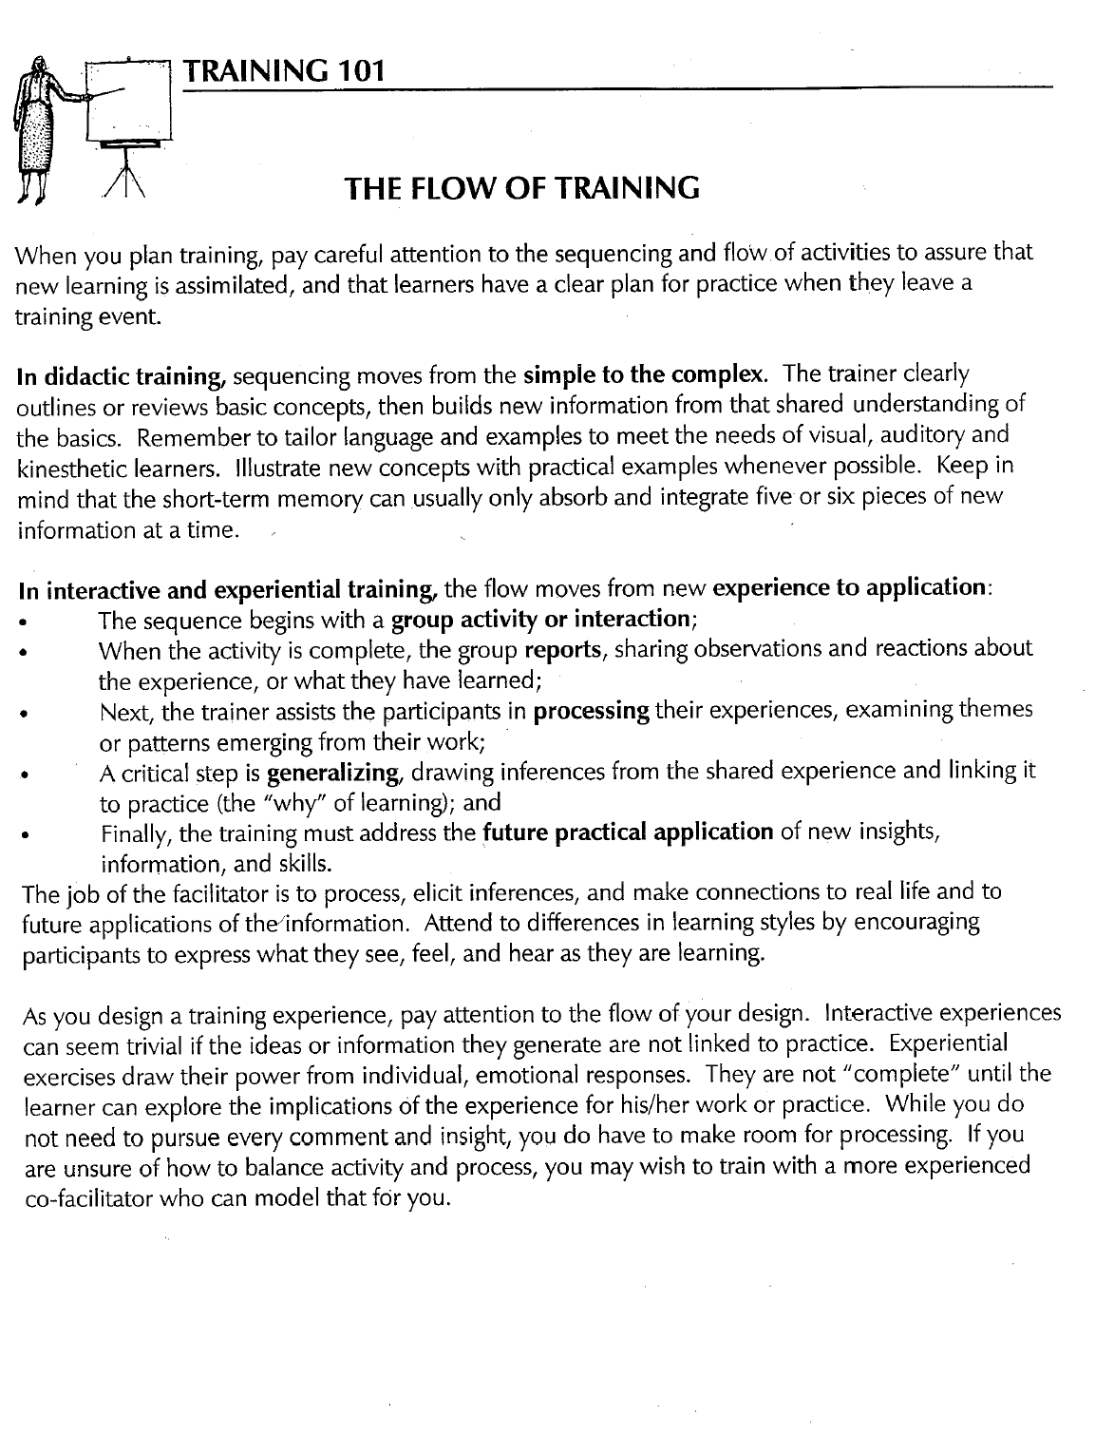

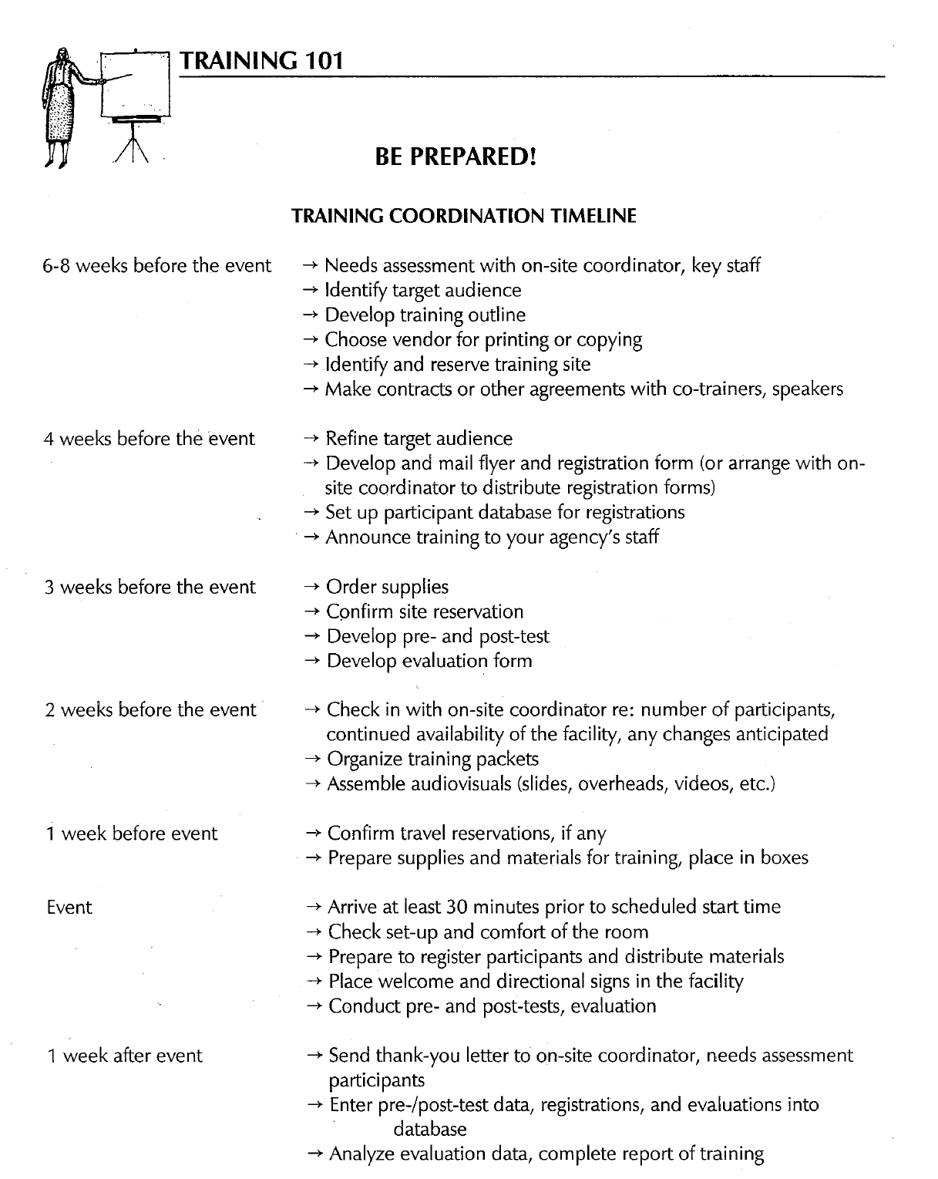

Final Thoughts
The following are tips, suggestions & lessons learned from your colleagues to assist you on your AETC journey.
Successful program planning and coordination
- Prepare a checklist for planning the training event.
- Engage medical faculty in the planning process. They are identified with the event, with the AETC, and with quality HIV specialty care.
- Find a dynamic speaker. It will help your event to be successful.
- Know your audience. Develop a program based on the needs of your participants.
- Create and encourage networking. As attendees cover a focused area, people have geography in common and connections made at the meeting can lead to future consultations. Group discussion also encourages networking.
- Go beyond the expected. All presentations are fresh to the group, and challenge our faculty to prepare the most up-to-date material.
- Limit break out groups. This encourages all participants to attend the same session and hear the same message. Note: this works best when the training audience is of the same discipline.
- Allow for some free time. For example, a family friendly program design might have presentations on a Saturday and Sunday morning (8 hours of CME) with free afternoons to enjoy down time.
- Have extra materials for unexpected participants on-site.
- Confirm with speakers or faculty 1 week ahead of time, and if possible, 1 day ahead of time.
- Archive events online for participants to access at later date if not able to make it

Planning for CME activities
- Be aware and attuned to the issues around funding and documentation as you begin to work with your local CME provider.
- Ask questions; for example “What challenges do you typically encounter when working with organizations to secure CME accreditation?”
- Be mindful of the five key areas involved: timelines, objectives, content planning, funding and documentation.
- Plan to have all details about the meeting partially covered before proceeding with the CME application. These include target audience, activity goal(s) and learning objectives, need for training/evaluation, title of the topics, speaker, date, and location.
- Develop a realistic timeline for each step of the accreditation process and allow adequate time for each task, Understanding that sometimes unrealistic expectations among planning committees and community partners still occur. Asking questions and expressing concerns in the beginning will decrease the chances of delays caused by logistical and communication challenges later.
- When writing objectives:
- Ensure that you understand the relationship between the objective and the change you are seeking to achieve. This can be accomplished by making sure objectives are measurable
- Review the latest epidemiology data on your topic
- Describe any CDC recommendations
- Identify emerging strategies or trends
- Discuss treatment options

Training Wisdom
    - Know your audience. Focus your message and anecdotes to them.
    - Develop your own unique style. There is no one correct way to teach or to convey information. Study the styles of other presenters to learn what you can adapt to enhance your own teaching. To be a great speaker, you must also learn to be "in the moment,” not thinking about what you are going to say five minutes from now.
    - Insert humor (without becoming a stand-up comedian) to keep your audience alert and engaged.
    - Practice makes perfect (or at least, better and better). Preparation and experience will help quell anxiety about presenting.
    - Be confident. When a presentation goes badly, don’t become discouraged. Sometimes it’s the speaker, sometimes the learners, the weather, the time of day or day of the week, or myriad unknown variables. The best way to become an excellent trainer is to keep on training and try to learn from each experience.
    - Be interactive! The lecture format has become more interactive, with faculty giving more time for discussion, and weaving case studies through their presentation. Allow time for questions.
    - Allow adult learning to occur. Examples: consider the set up for a room, use nontraditional methods such as diagonal tables facing center/podium, and have things for people to play with (pipe cleaners, pens, notepads). Note: this works best in an all-day event.
    - Allow for various learning styles including kinesthetic, linguistic, logic/math, musical, visual/spatial, interpersonal, intrapersonal, and naturalist (multiple intelligences).
    - Review training materials to ensure quality.

Training with Technology
- Carry your Power Point presentation with you on a flash drive, so that if anything goes wrong with the laptop, you can show the presentation from a different computer.
- Check software compatibility with the computer available on site. For example, a presentation saved in Power Point 2007 might not work properly on a computer with Power Point 2003.
- Have back up plan in case of equipment failure. Learn different ways to give your presentation besides Power Point. That way, in the event of equipment failure or a power failure, you can still teach your material.




The NRC website is a central repository for AETC program and contact information. It is also a virtual library of online training resources available for adaptation to meet local training needs. Furthermore, it provides timely, high quality, state-of-the-art clinical information and resources.

Visit www.aidsetc.org and answer the questions below to get better acquainted with navigating your way around the website!

Section I: About Us Basics

1. What are the six main tabs (in red) on the website?
2. If you needed to contact a regional AETC, you could use the links provided on the AETC ________ ________ (2 words) located in the About Us/AETC Directory section.
3. Where would you look to find a list of upcoming national conferences?
4. Name at least three AETC program special initiatives (http://www.aidsetc.org/aidsetc?page=ab-05-00)
5. Briefly describe what the website states about usage guidelines for citing materials.
(http://www.aidsetc.org/aidsetc?page=ab-01-00-00)

Section II: Clinician and Trainer resources

6. The sub sections: ARV treatment, Testing, Prevention, Primary care, OIs/ Co-morbid conditions, Population and Settings can be found under what heading of the website?

7. How many AETC training levels are there? Name each one.

8. Under the trainer resources tab, training materials sub-section, identify curricula on the following topics:

a. HIV testing
b. Oral health
c. Cultural competence

9. Under the clinician resources, clinician support tools sub-section, identify pocket guides available on the following topics:

a. Antiretroviral therapy
b. Primary Care
c. Mental illness/health

10. How would I order copies of the HIV/AIDS Clinician Toolkit?
(http://www.aidsetc.org/aidsetc?page=etres-display&resource=etres-194)

Section III: Name that AETC

Complete the table below by identifying which AETC has produced each resource. HINT: Try using the search feature.

Resource Type | Title | Regional/National AETC
A.  Pocket guide | Psychiatric Medications and HIV Antiretrovirals: A Guide to Interactions for Clinicians
B.  Fact sheet | How to Locate a Family Planning Clinic/Ryan White Clinic
C.  Online Training | HIV Web Study
D.  Self- study | BE SAFE: A Cultural Competency Model for American Indians, Alaska Natives, and Native Hawaiians Toward the Prevention and Treatment of HIV/AIDS
E.  Patient Information | Today We Are Going To Test You For HIV—Why?
F.  Pocket guide | STD/HIV Risk Assessment: A Quick Reference Guide

AETC Website Scavenger Hunt Answer Key

Section I:

(1) About Us/ AETC directory, (2) Clinician Resources, (3) Trainer Resources,
(4) Topic Index, (5) AETC Only, (6) Home
Regional Map
News & Events
Various answers, refer to http://www.aidsetc.org/aidsetc?page=ab-05-00
Refer to http://www.aidsetc.org/aidsetc?page=ab-01-00-00

Section II:

Topic Index
5 levels; Didactic, skills-building, clinical training, clinical consultation and technical assistance
Various answers, refer to http://www.aidsetc.org/aidsetc?page=et-04-00
Various answers, refer to http://www.aidsetc.org/aidsetc?page=etres-display&post=1&restrict=typeSearch=pocket&group=first-topic&sort=title

To order free copies from the National Resource Center, send an email to: info@aidsetc.org

Section III:

A. New York/ New Jersey AETC
B. AETC National Resource Center
C. Northwest AETC
D. National Minority AETC
E. Midwest ATEC
F. Mountain Plains AETC

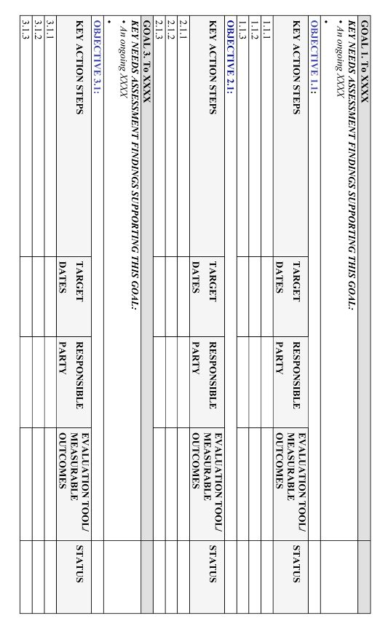

Work plan Template

Stratified Program Budget Template

STRATIFIED PROGRAM BUDGET (Recommended format, not required)
PERSONNEL |  |  | Program Area
Title | Annual Salary | Total AETC Program  (FTE) | AETC Basic Program |  | Special Project # 1  (Specify) |  | Program  Total  (dollars)
Title | Annual Salary | Total AETC Program  (FTE) | Admin./  Coord | Education/  Training | Admin./  Coord | Education/  Training | Program  Total  (dollars)
TOTAL FRINGE BENEFITS
TOTAL PERSONNEL
TOTAL TRAVEL
(e.g., staff travel)
TOTAL EQUIPMENT
TOTAL SUPPLIES
TOTAL SUBCONTRACTS
Name each contract (e.g., LPS, consultants) as a separate line item.
TOTAL OTHER EXPENSES
(e.g., centrally administered trainee travel)
Itemize other expenses by category.

TOTAL DIRECT COSTS
INDIRECT COSTS (not to exceed 8%)
TOTAL DIRECT AND INDIRECT COSTS

How to write S.M.A.R.T

The web addresses below are additional resources that you may find useful for learning more about S.M.A.R.T objectives and work plan development or working with staff, LPSs, or other organization on work plan development.

- This is a link to a self-study module on writing goals and objectives:

http://www.ala.org/ala/mgrps/divs/acrl/about/sections/is/webarchive/smartobjectives/whyshouldwrite.cfm

- This link provides information on what should go into a work plan. It offers a slightly different format for the work plan template, but good background information on work plan development.

http://www.endowmentforhealth.org/uploads/documents/grants/WkPlan_Guidelines.pdf

- The CDC work plan is in a different format, which you may also like. This is a self study program on work plan development.

http://www.cdc.gov/cancer/nbccedp/training/workplans/

- Here is a check list for S.M.A.R.T Objectives

http://doe.state.in.us/sdfsc/pdf/writing-gos.pdf

- This site offers a training program that may be useful for your capacity building work with other organizations:

http://www.sfdph.org/dph/files/CAMdocs/Skill-based_activities/2smartgyo/lp-GyOscomplete.pdf

S.M.A.R.T GOALS ASSESSMENT TOOL

Instructions: Use the following list of questions to determine if the SMART goals you have developed are Specific, Measureable, Attainable, Relevant and Time-framed.

SPECIFIC

What makes this particular goal specific?

- Clearly stated
- Describes a function to be performed
- Uses action verbs to describe what has to be done

MEASUREABLE

How is this goal measureable?
- It is quantifiable
- Limits and parameters are defined
- Results are observable

ATTAINABLE

How is the goal within reach?
- There is the required degree of experience
- The necessary skills and knowledge are present
- The resources to carry out the work are available

RELEVANT

How do you know this goal is relevant to the work to be done?
- It has a clear link to your agency and department goals
- It is clearly linked to your key job tasks
- It will help you achieve development objectives

TIME FRAME

What time frames have been set for the completion of this goal?
- It has a clearly defined completion date
- There is a clearly defined duration of the goal
- The frequency with which work must be performed is clearly defined

Coordinators Checklist Sample 1
Program Checklist
Program Name | Name of event
Decide on Captain | Name of lead person
Budget | $$
Exhibitors | Yes or no
Secure location | Name of location
Determine Food | Meals offered
Quantia MD | Yes or no
Project Team | Names of support people
Prior to Conference | Subtopic | Who | When | Status
Speakers | Identify
 | Contact
 | Webcasting Agreement
 | Contract
 | Presentation
 | Handouts
Food | Menu (MUST inc. vegetarian, water, diet soda)
 | Contract and signature
 | Final numbers to hotel
Binders | Compile
 | Print
Evaluation | Design
 | Print
PIFs | Print
Credits | Objectives
 | Application
 | Submission
 | Approval Follow up
 | Sign Up Sheets
 | Certificates
Marketing | Design Flyer - Save the Date
 | Design Flyer - Program Details
 | Develop strategy
 | Post on site
 | Email marketing
 | Mailing
Signage | Directional
 | Table Top
Nametags | Printing
 | Lanyards
 | Casing
Registration | Participant List
 | Agenda
 | Pens/Paper/Markers
 | Receipt Book
 | Credit Sign In
 | Certificate of Attendance
 | Box of name tags
Display | Regional materials
 | Booth
 | Banners
AV | Pointer
 | LCD
 | Laptop
 | Wireless Mic
 | Quantia Recorder
Invoicing | Room Rental
 | Catering
On Site Conference Responsibilities
Transport of Items
Greeters
Registration | Pre registered/On-site registration
PIFs
Binder/Packet Handouts
AV
Exhibitors
Meeting Room | Layout and temperature
Food
Traffic
Time Management
Evaluation
Certificates of Attendance
Post Conference
Location | Final invoice
Food | Final invoice
Printing | Final invoice
Certificates | All credit certificates
Evaluation | Tabulation
 | Communication
Speakers | Thank yous
 | Payment letter

Coordinators Checklist Sample 2
Action | By (Name) | Contact/Specifics
Day Before: Workshop Prep Day |  | Date
Check into hotel  Names | Coordinator Name &  Cell:
Confirm box(es) receipt  (Number of boxes & signature) |  | FedEx #:
Make sure there are enough copies of slide sets for attendees. Photocopy if necessary.
Workshop Day |  | Date
Move/deliver boxes to meeting room |  | By X AM  Registration = (Location)  Workshop = ( Location)
Check hotel event listings for accuracy |  | By X AM  Date:  Registration starts Time  Workshop starts Start time
Confirm hotel operator knows location and name of workshop room |  | By X AM  Date:  Registration starts Time  Workshop starts Start time
Meet AV tech and check set up of meeting room: staff table, sight lines from sides of room, sight lines from speakers. Set up or provide LCD and laptops for later set up |  | Hotel AV set completed by 7:00 AM
Check all equipment. Set title slide on screen. Double check equipment is set up properly!!

Organize boxes & materials |  | Time:
Put out faculty welcome packet(s) |  | Time:
Set up registration desk/materials for check in |  | By (Time)
Set up all signs: podium, registration, directional |  | By (Time)
Meet catering manager to make any changes to room or to F & B, if needed, and get contact info |  | Time:  Confirms room # and times of meals
Check breakfast/beverage set up |  | Keep eye on quantities; follow up with hotel
Double Check reg area: name badges, educational materials, topics journal, etc. |  | By (Time)
Open registration |  | Registration begins 8:00 AM
Register attendees
Confirm faculty arrival, direct to AV, moderator notes, new announcements, etc. |  | Time:
WORKSHOP begins |  | Workshop begins at X AM
Collect samples of educ materials for IAS-USA archival records
Check meeting room set, temperature, water, glasses, etc. |  | Input Break times
Check F & B break set up
Get and set up collection bowls or baskets from banquets for evaluation, ME form collection, name badge holders |  | Set out after coffee break
Registration list count – tally no shows, note # of attendees in room
Collect and number evaluations. Collect CME credit claim forms
Pack supplies, fill out air bills to IAS–USA; collect misc IAS–USA materials/equipment to be packed, lost & found items
Assist faculty with return arrangements if necessary
Collect the IAS-USA audio video equipment; inspect for any damage or missing items
Collect attendees issues; complete onsite coordinator’s evaluation

Conference Attendants’ Notebooks

A. Covers: Order notebook cover at the same time you order brochure
B. Tabs: To go between each topic time slot. Note: If breakout sessions, all handouts go under same tab for that time slot.
1. Date
2. Time
3. Room name (if available)
4. Order as soon as conference schedule finalized
C. Binding Choices
1. Coil
2. 3-Ring Binder
D. Layout for Printer
1. Notebook Cover
2. Cover Page
a. Conference Title
b. Date(s)
c. Location
d. City, State
3. Speakers
4. Planning committee (if appropriate)
5. Schedule
6. Title page between every different presentation
a. Presentation Title
b. Speaker Name, credentials
c. Job Title
d. Agency
e. City, State
Note: For multiple speakers, repeat A-E on same title page

7. For double-sided printing, insert blank piece of paper after
Speaker Title Page
8. Power Point Presentation handout
9. Blank “Notes” Pages if no Power Point
10. For double-sided printing, insert extra blank white sheet if odd
number of pages of presentation handouts
11. Should be sent to printer at least 14 days prior to event- verify
printer’s needs

E. Pocket Folder
1. Evaluations
2. Scantrons (if applicable)
3. Extra event announcements

Preceptorship Procedure

1. Pre-registration-upon acceptance:
a. Education Coordinator obtains a Needs Assessment (by phone or e-mail).
b. Using the current Preceptorship schedule, coordinator determines a tentative date with the candidate.
c. Coordinator or designated staff contacts the faculty to assure availability.

2. One month prior to scheduled preceptorship, Education Coordinator confirms the date with faculty and preceptee.

3. One to two weeks prior to the scheduled preceptorship:
a. Education Coordinator sends e-mail correspondence to preceptee and copies Administrative
Assistant (AA), involved faculty and others who may need to be advised. Appropriate attachments are included in the correspondence (as referenced in the letter).
b. AA prepares name badge, notebook, reserves room/equipment and places food orders.
c. Education Coordinator re-confirms attendance with Preceptee and faculty.
d. Education Coordinator assigns Program # and includes on Program Records & PIFs.

4. Registration: Upon arrival of preceptee, Education Coordinator assures:
a. Education Coordinator obtains signed Preceptorship agreement signed.
b. PIF is completed.
c. Schedule is reviewed.
d. Pre-tests are given.

5. Hospitality: AA assures
a. Food is delivered, set up and served.
b. Room/equipment is set up.

6. Wrap-up with preceptee. Education Coordinator:
a. Retrieves post-test.
b. Retrieves evaluation.
c. Retrieves PIF.
d. Gives preceptee pocket guide.

7. Follow-up (within 2 weeks), AA:
a. Copies/sends PIF/PR to Evaluation Center.
b. Mails certificate to client(s).
c. Send preceptorship agreement to Med Staff office for signature (orig. to precep notebook).

Sample Preceptorship Schedule

Parkland AIDS Clinic- Clinic Observation Schedule

Faculty/Staff: (list here)

Scheduled Attendee(s): (list here)

Monday, December 8
8:30-9:15 AM  9:15-10:00 AM  10:15 AM -12:00 PM  12:15-1:45 PM  1:45-2:00 PM  2:00-3:30 PM | Welcome, Breakfast, and Pre-post tests- 4811 Harry Hines, Bldg C  HIV 101, 4811 Harry Hines, Bldg C  Clinic Observation-Amelia Court (see additional schedule)  Lunch and Lecture: Adherence and HIV,  1936 Amelia Court, 2nd floor conference room  Break  Intake Case Management Panel Discussion,  2nd floor conference room
Tuesday, December 9
9:00 AM-12:00 PM  12:00-1:00 PM  1:00-4:00 PM | Clinical observation @ Bluitt Flowers COPC  Lunch and lecture, HIV as Primary Care Model;  Clinical observation @ Bluitt Flowers COPC
Wednesday, December 10
9:00 AM -12:00 PM  12:00-1:00 PM  1:00-4:00 PM | Clinic observation @ Women’s Specialty Clinic  Lunch and lecture in WSC Conference Room  Clinic observation @ SE Dallas clinic
Thursday, December 11
9:00-10:30 AM  10:30 AM-12:00 PM  12:00-1:00 PM  1:00-1:30 PM | Clinic observation at 1936 Amelia Court  Lecture: HAART of HIV  Lunch and case studies discussion  Post tests and evaluation

Sample Post-Training Thank You Letter

Date

Ms. Doe, RN, MPH
Attendee Address

Dear Attendee,

Thank you for participating in the Clinical Preceptorship Program with us at the Parkland HIV Clinic (Amelia Court and various COPC’s), (insert date). We hope the training was beneficial for you. A certificate acknowledging your participation is enclosed. Also enclosed are your pre/post test scores (bottom) & the original tests you took.

Please feel free to contact us at xxx-xxx-xxxx or xxx-xxx-xxxx if we can provide any further assistance in your practice setting, via clinical consultation or other training programs. You may want to browse our web site for further training & education opportunities at www.aidseducation.org.

Sincerely,

Education Coordinator

Sample Collection of Ice breakers/Exercises/Closing Activities

Please check with your regional director and trainers for additional interactive training approaches.
More resources may also be found at http://www.aidsetc.org/aidsetc?page=tr-26-00

Silent Assessment
This activity can be used at anytime in an educational session. It can be used as a way to get the participants interacting and to provide introductions. A great way to use it is in conjunction with teaching about risk assessment for both infected and uninfected (or not known to be infected) clients.
Ask participants to pair up with someone whom they do not know (or do not know well) and give each participant the form provided below. Instruct the group that they cannot talk but must fill in the assessment form simply by looking at their partners for the exercise. Give them 3-5 minutes to complete the form.

Silent Assessment Form
Do not speak to your partner to answer the following questions.

What is your partner’s:
Age? _______
Favorite color? __________________
Favorite kind of food? ______________________________
Favorite thing to do on vacation? _____________________
What kind of vehicle does your partner drive? ___________________________________
Does your partner have any tattoos? ____________
If so, where?___________________________
Does your partner have any piercings? _________
If so, where? ____________________
Where was your partner born? ______________________________________________
What is your partner’s ethnicity/race? ______________________________________________
What is your partner’s profession? ______________________________________________

Debrief: Give participants a short amount of time to share their impressions with each other, to determine what they each got right and what they each missed.
1. What did you learn about your partner that was completely unexpected?
2. What were you able to determine just by looking?
3. Why/how did you come to the conclusions that you wrote on the paper? How did the other person’s appearance affect your decisions? How did what you already know about your partner affect your decisions?

In a larger group (either the whole group or in groups of 6-10), stimulate a discussion around the following questions:
1. Why do you think you were asked to do this exercise?
2. Have you ever made assumptions about a patient that turned out to be right? That turned out to be wrong? What happened in each of those cases?

Get them up and moving
Have the participants get up and complete one of the following tasks.

Line up in order by shoe size
Line up in order by length of arm reach
Line up in order alphabetically by favorite color
Line up in order by number of siblings you have
Line up in order by hair color, lightest to darkest
Line up in order by age, youngest to oldest
Line up in order by length of time in current job
Line up in order alphabetically by last name
Line up in order by number of pets ever owned
Line up in order by length of hair, shortest to longest
Line up in order by number of bones you’ve ever broken
Line up in order by city where you live: east to west

Pick Pocket

Work in a group of 4-5 people; use pockets, backpacks, brief cases, or purses only. Find as many of the following as possible:

__________ picture of a close relative __________ a good photo on a
driver’s license
__________ AAA card __________ article on HIV
__________ dry cleaning receipt __________ candy
__________ social security card __________ a novel
__________ fitness club card __________ laptop computer
__________ coupon for a grocery item __________ frequent flyer card
__________ contact lens case __________ lip balm
__________ black comb __________ a novel
__________ money clip __________ laptop computer
__________ condom (extra credit: flavored condom) __________ frequent flyer card
__________ restaurant matches __________ voter registration card

Closing Statements
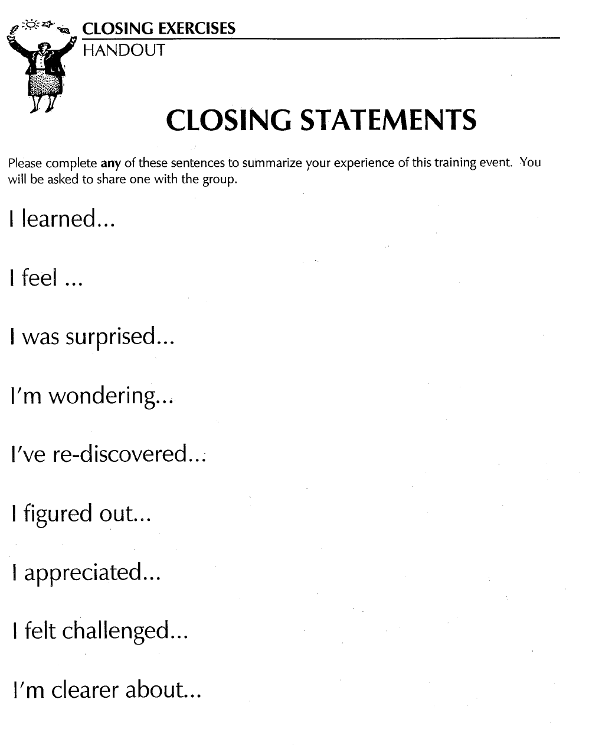

AETC Lingo: Acronyms and Abbreviations

A
AACTG | Adults AIDS Clinical Trials Group
AAHIVM | American Academy of HIV Medicine
ACCME | Accreditation Council for Continuing Medical Education
ACOG | American College of Obstetricians and Gynecologists
ACPE | Accreditation Council for Pharmacy Education
ACRN | AIDS Certified Registered Nurse
ACTG | AIDS Clinical Trials Group
ACTIS | AIDS Clinical Trials Information Service
ACTS | Assess, Counsel, Test, Support
ACTU | AIDS Clinical Trials Unit
ADA | American Dental Association
ADAP | AIDS Drug Assistance Program
AETC | AIDS Education and Training Centers
AGM | All Grantees Meeting
AHEC | Area Health Education Centers
AHP | Advancing HIV Prevention
AHRQ | Agency for Healthcare Research and Quality
AI/AN | American Indian/Alaska Native
ALLRT | AACTG Longitudinal Linked Randomized Trials
amFAR | American Foundation for AIDS Research
ANAC | Association of Nurses in AIDS Care
APA | American Psychiatric Association or American Psychological Association
ARC | AIDS-related complex
ART | Antiretroviral Therapy
ASO | AIDS Service Organization
ATTC | Addiction Technology Training Center
AUC | Area under the curve

B
BHRD | Bureau of Health Resources Development
BPHC | Bureau of Primary Health Care

C
CAB | Community Advisory Board
CADR | CARE Act Data Report
CAEAR Foundation/Coalition | Communities Advocating Emergency AIDS Relief Foundation/Coalition
CARE Act | Ryan White “Comprehensive AIDS Resources Emergency” Act
CBC | Congressional Black Caucus
CBO | Community-Based Organization
CDC | Centers for Disease Control and Prevention
CEC | Continuing Education Credit
CEU | Continuing Education Unit
CFARs | Centers for AIDS Research
CFCC | Comprehensive Family Care Center
CHC | Community Health Center
CHI | Center for HIV Information
CLAS | Culturally and Linguistically Appropriate Services
CME | Continuing Medical Education
CMS | Centers for Medicare and Medicaid Services
CNE | Continuing Nursing Education
CPCRA | Community Programs for Clinical Research on AIDS
CQI | Continuous Quality Improvement
CROI | Conference on Retroviruses and Opportunistic Infections
C & T | HIV Counseling and Testing

D
DAIDS | Division of AIDS (NIAID)
DCBP | Division of Community Based Programs
DHS | Division of HIV Services (within BHRD)
DHHS | U.S. Department of Health and Human Services
DSS | Division of Service Systems
DTTA | Division of Training and Technical Assistance

E
EIS | Early Intervention Services
EMA | Eligible Metropolitan Area

F
FBO | Faith-Based Organization
FDA | Food and Drug Administration
FHC | Family Health Center
FQHC | Federally Qualified Health Center
FSR | Financial Status Report
FTTC | Federal Training Centers Collaboration
FXB Center | François-Xavier Bagnoud Center

G
GAP | Global AIDS Program
GARC | Grant Application Review Committee
GCC | Group Clinical Consultation
GPRA | Government Performance and Results Act

H
HAB | HIV/AIDS Bureau (HRSA)
HBCU | Historically Black College or University
HCAP | Healthy Communities Access Program
HCC | Health Care Connections
HCH | Health Care for the Homeless
HICP | Health Insurance Continuity Program
HIPAA | Health Insurance Portability and Accountability Act
HIVMA | HIV Medicine Association
HIVTAC | HIV Training and Technical Assistance Center
HMA | Health Maintenance Alliance
HOPWA | Housing Opportunities for People with AIDS
HPTN | HIV Prevention Trials Network
HRSA | Health Resources and Services Administration
HRSA HAB | Health Resources and Services Administration HIV/AIDS Bureau
HSHC | Healthy Schools Healthy Communities Initiative
HSSP | Health Service Support Provider
HUD | U.S. Department of Housing and Urban Development
HVTN | HIV Vaccine Trials Network

I
IAS | International AIDS Society
IAS-USA | International AIDS Society-USA
ICAAC | Interscience Conference on Antimicrobial Agents and Chemotherapy
ICC | Individual Clinical Consultation
IDSA | Infectious Disease Society of America
IDU/IVDU | Injection Drug User/Intravenous Drug User
IGA | Intergovernmental Agreement
IHI | Institute for Healthcare Improvement
IHS | Indian Health Service
IRB | Institutional Review Board
IMPAACT | International Maternal, Pediatric and Adolescent AIDS Clinical Trials
IOM | Institute of Medicine
ISDI | Integrated Services Development Initiative
I-TECH | International Training and Education Center on HIV

J
JSI | John Snow Inc.

K

L
LPS | Local Performance Site
LTS | Longitudinal Training Site

M
MAI | Minority AIDS Initiative
MATEC | Midwest AIDS Education and Training Center
MCH | Maternal Child Health
MHC | Migrant Health Center
MIS | Management Information Systems
MSM | Men Who Have Sex with Men
MTCT | Mother to Child Transmission

N
NA | Needs Assessment
NACHC | National Association of Community Health Centers
NASW | National Association of Social Workers
NCCC | National Clinicians’ Consultation Center
NCCHC | National Commissions on Correctional Health Care
NEC | AETC National Evaluation Center
NGO | Non-Governmental Organization
NIAID | National Institute of Allergy and Infectious Disease
NIH | National Institutes of Health
NMAETC | National Minority AETC
NRC | AETC National Resource Center
NQC | National Quality Center

O
OAR | Office of AIDS Research
OMB | Office of Management and Budget
OPA | Office of Population Affairs
OPHS | Office of Public Health and Science
OSA | Organizational Self Assessment
OSE | Office of Science and Epidemiology
OSHA | Occupational Safety and Health Administration

P
PACHA | President’s Advisory Council on HIV and AIDS
PACTG | Pediatric AIDS Clinical Trials Group
PAHO | Pan-American Health Organization
PCA | Primary Care Association
PART | Program Assessment Rating Tool
PEP | Post Exposure Prophylaxis
PIF | Participant Information Form
PHPC | Public Housing Primary Care
PHS | Public Health Service
PHTN | Public Health Training Network
PLWH | People living with HIV
PMTCT | Prevention of mother-to-child transmission
PR | Program Record
PTC | STD/HIV Prevention Training Center
PWP | Prevention with Positives

Q
QA | Quality Assurance
QC | Quality Control
QI | Quality Improvement
QM | Quality Management
QOL | Quality of Life

R
RFA | Request for Applications
RFP | Request for Proposals
RTC | Regional Training Centers for Family Planning
RWCA | Ryan White CARE Act (now Ryan White HIV/AIDS Program)
RTMCCs | Regional Training and Medical Consultations Centers

S
SAMHSA | Substance Abuse and Mental Health Services Administration
SCSN | Statewide Coordinated Statement of Need
SEATEC | Southeast AETC
SMART | Strategies for Management of Antiretroviral Therapy
SNPs | Special Needs Plans
SOP | Standard Operating Procedures
SPNS | Special Projects of National Significance
STD | Sexually Transmitted Disease
STI | Sexually Transmitted Infection
SWOT | Strengths, Weaknesses, Opportunities and Threats

T
TA | Technical Assistance
TB | Tuberculosis
TC | Teleconference
TE | Training Exchange
TIPS | Tailored Information Provider Service
TPED | Targeted Provider Education Demonstration
TOT | Training of Trainers

U
UMBAST | United States Mexico Border AETC Steering Team
UNAIDS | United Nations Joint Program on AIDS
UTAP | University Technical Assistance Project
UNICEF | The United Nation’s Children’s Fund

V
VCT | Voluntary counseling and testing
VHNET | Viral Hepatitis Education and Training Projects

W
WHO | World Health Organization

X
Y
Z
Other:
Federal Training Centers Collaboration (FTTC) | Includes:  AIDS Education and Training Centers (AETC)  Addiction Technology Transfer Center (ATTC)  STD/HIV Prevention Training Center (PTC)  Regional Training Centers for Family Planning (RTC)  Viral Hepatitis Education and Training Projects (VHNET)  Regional Training and Medical Consultations Centers (RTMCCs)

Supplemental Resources:

Clinical Manual for Management of the HIV-Infected Adult, 2006 edition: Section 10, Abbreviations
AETC National Resource Center
http://www.aidsetc.org/aetc/aetc?page=cm-1004_abbrev

TARGET Center
Glossary: Ryan White HIV/AIDS Program
http://careacttarget.org/library/glossary/glossary.asp

Woman, Child, and HIV: Resources for Prevention and Treatment
Abbreviations
http://womenchildrenhiv.org/wchiv?page=abbr-a

** Updated 2009, AETC Network Orientation Workgroup
Originally developed by the AETC National Resource Center (www.aidsetc.org) in collaboration with Mountain Plains AETC (www.mpaetc.org) & New York/New Jersey AETC (www.nynjaetc.org), 2006.

References

MAI Section

HIV/AIDS Policy Brief - The Minority AIDS Initiative. Regina Aragón and Jennifer Kates. Kaiser Family Foundation June 2004

The Regional AIDS Education and Training Centers Non-Competing Continuation Guidance, Announcement Number # HRSA-5-H4A-09-00, Catalog of Federal Domestic Assistance (CFDA) No. 93.145 (3-6)

HRSA HIV/AIDS Bureau MAI Page http://hab.hrsa.gov/treatmentmodernization/minority.htm

The Office of Minority Health MAI page http://www.omhrc.gov/templates/browse.aspx?lvl=2&lvlID=36Ame

Indian Health Service MAI Page http://www.ihs.gov/MedicalPrograms/HIVAIDS/index.cfm?module=mai&option=index

Adult Learning

New York/New Jersey AETC – Trainer Resource Handbook

Apps, Jerrold. Mastering the Art of Teaching Adults. FL: Krieger Publishing, 1991.

Fink, L. Dee. (1991). Active Learning.*

Lieb, Stephen. (Fall 1991). Principles of Adult Learning*

* Articles available at: http://honolulu.hawaii.edu/intranet/committees/FacDevCom/

