Quarterly Newsletter-Fall 2016
AETC Program related news, resources and events:
Resources & Events:
The Effects of Stigma on People Living with HIV in Rural America (video)
Source: AETC National Coordinating Resource Center, AETC Program Rural Health Committee
Description: Through shared stories from patients and providers, this video highlights the effects of stigma on persons living with HIV in rural communities across the U.S.
Link to video

AETC Program HIV IPE Projects Infographic
Source: AETC National Coordinating Resource Center
Description: This infographic outlines the purpose and methodology for integrating HIV care into interprofessional education (IPE), and identifies how the AETC Program is helping to facilitate this training through community of practice. This resource is available in JPEG, PDF and PPT formats.
Link to infographic file formats
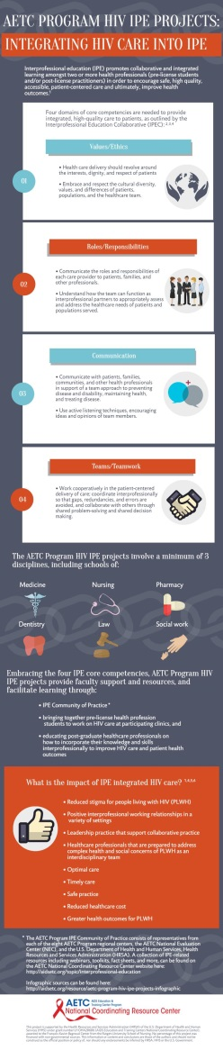

The 12th National Conference on HIV & Aging – September 23, 2016, Boston, MA
Source: New England AETC, New England Association on HIV over Fifty, University of Massachusetts
Description: This conference is dedicated to providing medical professionals with the latest updates concerning HIV/AIDS in aging populations. The 2016 program will focus on issues such as HIV/HCV co-infections, unique care concerns for aging populations, and current pharmacological advancements in the field. Registration closes 5:00 PM ET, September 21, 2016.
Link to registration and program agenda
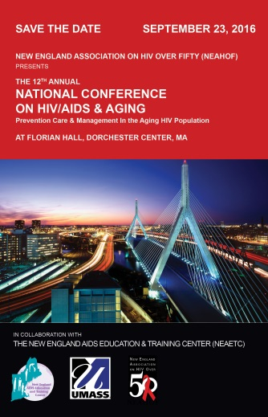

Minority AIDS Initiative
Building Providers’ Capacity to Provide Culturally Appropriate Care: African, African-American, and Caribbean Women
Source: Southeast AETC, Aniz, Inc.
Description: (Recorded August 3, 2016). The purpose of this training is to describe how to provide culturally competent health services to African American and Caribbean women using a holistic harm reduction approach, and identify resources and effective communication strategies to engage them in care.
Link to view presentation recording and slides

Practice Transformation
Adolescent and Health Professional Perspectives on the Medical Home: Improving Health Care Access and Utilization under the Affordable Care Act (health policy brief)
Source: ICF International, Philip R. Lee Institute for Health Policy Studies & Department of Pediatrics, Division of Adolescent and Young Adult Medicine at the University of California, San Francisco (UCSF) Benioff Children’s Hospital
Description: The findings in this report are from the perspective of both adolescents and experts in adolescent health and medical home policy. Findings are based on focus group discussions with adolescents about their perspectives about medical homes – to better understand the needs and challenges in providing adolescents with access to medical homes, which were presented to experts to share their reactions. This report includes a detailed description of the methods used, followed by a summary of key focus group findings and the expert reactions to these findings.

Link to policy brief
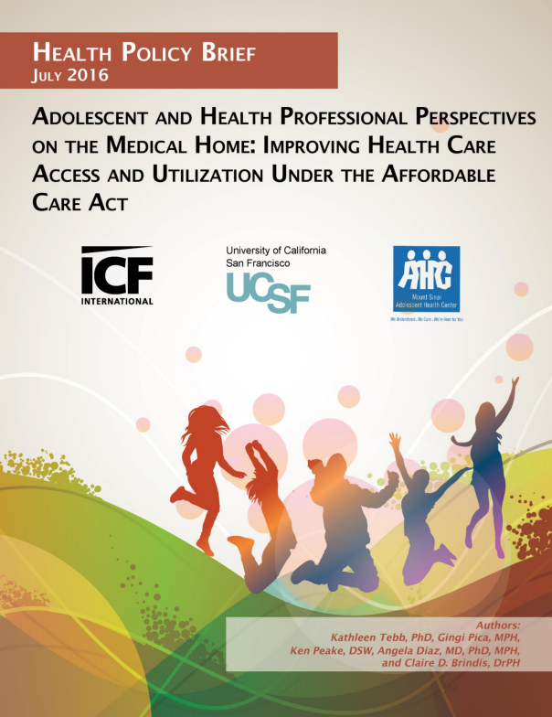

National Committee for Quality Assurance (NCQA) Patient Centered Medical Homes (PCMH) Recognition Redesign
Source: NCQA
Description: The NCQA is redesigning its PCMH Recognition program based on feedback from practices, policy makers, payers and other key stakeholders. Here’s a little about what you need to know going forward:
- The redesigned process and the new standards will be available starting March 31, 2017.
- New practices coming through recognition under the redesigned process must use the 2017 standards.
- Practices considering NCQA PCMH Recognition may still come through under the current recognition process using the 2014 standards.
- Practices have until September 30, 2017, to submit PCMH 2014 site surveys.
- After October 1, 2017, all practices must be recognized under the redesigned process and PCMH 2017 standards.
Follow the link below to learn more about the redesigned process including pricing and annual reporting, or to submit questions to NCQA representatives.
Link to NCQA PCMH redesign information

28th Annual National Forum on Quality Improvement in Health Care – December 4-7, 2016, Orlando, FL.
Source: Institute for Healthcare Improvement (IHI)
Description: This annual meeting provides an opportunity to network with nearly 6,000 healthcare professionals and gain actionable quality improvement ideas for your organization, to effect real change in health care quality and safety. Deadline for early-bird registration and proposal submissions is September 30, 2016.
Link to registration and general conference information

Interprofessional Education

Core Competencies for Interprofessional Collaborative Practice: 2016 Update
Source: Interprofessional Education Collaborative (IPEC)
Description: The Core Competencies for Interprofessional Collaborative Practice was designed to help frame the conversation around the need for interprofessional education and practice to facilitate improvement of team-based patient care and population health outcomes. This updated version reflects changes that have occurred in the healthcare system since the release of the original report (2011), including focus on the Triple Aim (improving the experience of care, improving the health of populations, and reducing the per capita cost of health care) and implementation of the Patient Protection and Affordable Care Act in 2010. In light of these changes, this updated version also integrates population health outcomes into the competency model to achieve improved health equity across the life span.
Link to report

Other resources, news and events:
TransECHO: Transgender Health ECHO
Source: The National LGBT Health Education Center, The Fenway Institute
Description: Using the Project ECHO model, Trans ECHO will create a network of health centers and faculty expertise to increase clinician access to knowledge and support they need to in order to provide culturally-responsible, comprehensive, primary care to transgender and gender non-conforming patients. This program is for:
- Clinicians interested in providing care to transgender and gender non-conforming patients.
- Health Center Staff with an ability to commit to 12 two-hour sessions in 12 months.
- Clinicians with an interest in the opportunity to tap into the collaborative power of health center teams and public health experts
TransECHO sessions will begin on October 12, 2016 from 2:00-4:00 PM ET and will continue every 2nd Wednesday of the month for 12 months. Email transecho@fenwayhealth.org with any questions or for more information.
Link to TransECHO application form

AVAC Report 2016: Big Data Real People
Source: AVAC Global Advocacy for HIV Prevention
Description: This report focuses on the gaps in the type and quality of data collected on prevention for HIV-negative people, arguing that much of the prevention data on who is being reached is inadequate. The report makes recommendations for changes in the approach to HIV prevention data and suggests that new prevention data model should provide detailed information on who is being reached and track linkages to evidence-based tools.
Link to full report and supporting materials
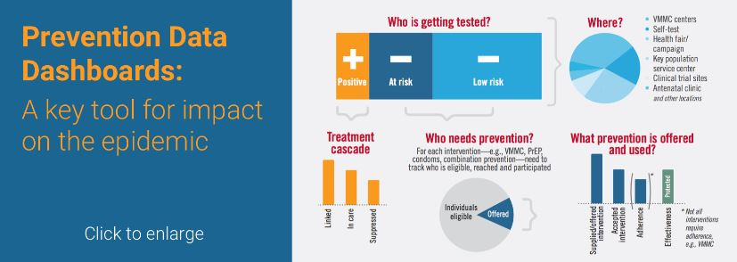

What Works in Youth HIV (website)
Source: JSI Research & Training Institute, Inc., Adolescent HIV/AIDS Prevention National Resource Center, U.S. Dept. of Health and Human Services, Office of Adolescent Health
Description: New website of the Adolescent HIV/AIDS Prevention National Resource Center is dedicated to providing emerging and evidence-based practices and practical resources to help-youth serving professionals effectively communicate HIV prevention information to adolescents. The site offers best practices and digital tools on HIV prevention and testing, evidence-based interventions, and social media/marketing outreach strategies, and the What Works team provides technical assistance on the use of these tools. The Adolescent HIV/AIDS Prevention National Resource Center also offers capacity-building opportunities to support the adaptation of intervention strategies.
Link to website

ANAC 2016: The Care to Cure Continuum: No One Left Behind – November 10-12, 2016, Atlanta, GA
Source: Association of Nurses in AIDS Care
Description: ANAC 2016 is the leading conference for nurse practitioners and nurses working in HIV and its associated conditions, co-infections and co-morbidities. ANAC2016 includes expert speakers, symposia, roundtable discussions and abstract-driven presentations. Conference objectives include:
- Discuss ways that nurses can develop interprofessional leadership roles to improve the comprehensive health of persons living with, or affected by HIV.
- Elaborate on innovative and emerging biomedical, psychosocial and behavioral HIV-related research.
- Discuss how nurses influence policy and advocacy in local, national and global communities.
- Describe the association between HIV risk, health disparities and social determinants of health.
- Demonstrate an enhanced ability to care for key populations living with, or affected by HIV and related co-morbidities.
- Improve nursing capacity to identify, treat and care for individuals at risk and/or living with viral hepatitis
Online registration will remain open through November 9, 2016; onsite registration will be available.
Link to conference registration and more information

Healthy Teen Network Annual National Conference – November 14-16, 2016, Las Vegas, NV
Source: Health Teen Network
Description: The theme of this conference is “Roles, Relationships, & Relevance in the Changing Landscape of Adolescent Health.” Colleagues and experts will meet to discuss the changing landscape of adolescent sexual and reproductive health in the face of politics, economics, demographics, and society’s values and beliefs, and the impact of these changes. Registration is now open; early bird rates expire September 30, 2016.
Link to conference website

New HIV-related articles on Consultant360
Source: Consultant360, HMP Communications LLC
Description: New HIV-related articles have been added to the HIV/AIDS topic page on Consultant360, an online resource for clinicians. Create an account at the link above to read the following:
- Tailored Behavioral Programs May Help HIV/AIDS Patients Quit Smoking: Tailored behavioral interventions may help patients with HIV/AIDS quit smoking, according to a recent meta-analysis.
- New Point-of-Care Test May Improve HIV Detection: A new fourth-generation point-of-care test (POCT) from Alere shows significantly improved sensitivity for detection of HIV core protein p24 (p24 antigen), according to lab testing by independent researchers in the UK.
- Study: Liver Cancer Is Increasingly Common with HIV/HCV Coinfection: A recent study examined the incidence of hepatocellular carcinoma and other causes of liver-related deaths in individuals coinfected with human immunodeficiency virus and hepatitis C virus.

Defining & Working with Hard-to-Reach Populations: Innovation & Game Changing Ideas
Source: U.S. Department of Health and Human Services HIV/AIDS Bureau
Description: Slide presentation from the Office of HIV/AIDS Training and Capacity Development (OTCD) Workshop at the 2016 National Ryan White Conference on HIV Care & Treatment on August 23, 2016. Discussion at this presentation focused on identifying key populations most at risk for HIV infection and what makes them “hard-to-reach,” and strategizing about how to address the gaps in care for hard-to-reach populations along the HIV Care Continuum, to meet the goals of the National HIV/AIDS Strategy for the United States: Updated to 2020. The slide set includes national and global data related to 2020 goals.
Link to slide presentation

IAS-USA Fall Activities
Source: International Antiviral Society-USA (IAS-USA)
Description: This fall IAS–USA is offering half-day hepatitis C virus (HCV) workshops, full-day HIV and HCV courses, and live HIV webinars. These activities are designed to blend interactive, advanced-level presentations with balanced, timely, scientifically rigorous, and clinically relevant information about HIV and HCV disease management. Physicians, nurse practitioners, nurses, physician assistants, and pharmacists can earn continuing medical education, pharmacy, and nursing credits at all live events and most online activities. Fellow and student discounts are available for full-day courses. Click on the links below for the fall schedule, course and workshop locations, and registration information.
Link to fall courses and workshops
Link to fall webinars

Awareness Days
National HIV/AIDS & Aging Awareness Day – September 18
National Gay Men’s HIV/AIDS Awareness Day – September 27
National Latino AIDS Awareness Day – October 15
National Health Education Week – October 17-21, 2016
National Day of Action to End Violence against Women with HIV – October 23
National Rural Health Day – November 17
World AIDS Day – December 1

