Quarterly Newsletter-Fall 2017
AETC Program related news, resources and events:
Resources & Events
AETC National HIV Curriculum
Source: AETC National Coordinating Resource Center (NCRC), University of Washington, U.S. Dept. of Health and Human Services (HHS), Health Resources and Services Administration HIV/AIDS Bureau (HRSA HAB)
Description: The AETC National HIV Curriculum (NHC) is launched and available for clinicians of all levels – from novice to expert – as well as health profession faculty and students to stay updated and informed about national guideline recommendations for quality HIV infection prevention, diagnosis, and treatment. The NHC serves as a quick reference guide, a self-study tool with FREE CME/CNE units, and provides slides and images for training purposes. The NHC is comprised of different core competency modules identified as essential by HIV care experts, and includes clinical screening tools and calculators, interactive self-assessment questions, antiretroviral medications guide and references, and clinical challenges answered by national HIV clinical experts. We encourage you to share this new tool with your colleagues and students. NHC posters and postcards are available to display and disseminate at your healthcare facility or training event. Download a PDF version of these resources for online sharing, or contact the AETC NCRC at info@aidsetc.org to order free copies.
Link to the curriculum
Download the poster PDF
Download the postcard PDF

HIV/HCV Co-infection: An AETC National Curriculum
Source: AETC NCRC, MidAtlantic AETC, New England AETC, Northeast/Caribbean AETC, South Central AETC, Southeast AETC, HRSA HAB
Description: This curriculum was developed as a component of HRSA/HAB’s Jurisdictional Approaches to Curing Hepatitis C among HIV/HCV Co-infected People of Color project. The goal of the curriculum is to provide an evidence-based online tool for healthcare providers and trainers of healthcare providers to increase their knowledge of HIV and hepatitis C virus (HCV) co-infection among people of color in the U.S. and its territories. Topics covered include prevention, screening, diagnosis and treatment recommendations as well as barriers and other co-factors that may impede optimal treatment outcomes for co-infected people of color. It is structured around six core competencies identified as essential for providers treating co-infected people living with HIV. We encourage you to share this new tool with your colleagues and students. HIV/HCV curriculum postcards are available to display and disseminate at your healthcare facility or with health trainers. Download a PDF version of this resource for online sharing, or contact the AETC NCRC at info@aidsetc.org to order free copies.
Link to the curriculum slides
Download the postcard PDF
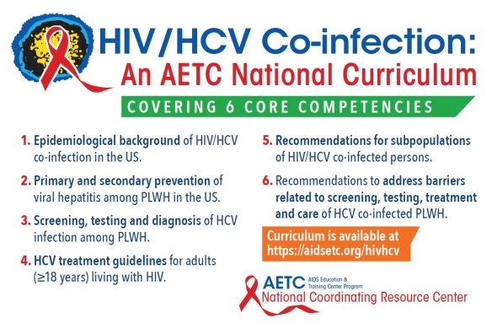

The Los Angeles HIV Public Health Fellowship
Source: Pacific AETC, University of Southern California Keck School of Medicine, Los Angeles County Department of Health Services, ViiV Health Care, LA BioMed
Description: Pacific AETC, Keck School of Medicine, and partners, are currently recruiting fellows for its two-year HIV Public Health Fellowship Program. The fellowship is for primary care physicians to become knowledgeable and have the necessary skills to provide comprehensive high-level, patient-centered HIV care, so they can develop community specific interventions, become systems leaders, and be successful community partners for the most vulnerable populations in HIV epidemics. Applications will be accepted through November 15, 2017. Up to four candidates will be accepted for this program which begins August 1, 2018.
Link to download the program brochure and application

New! In Brief: HIV and Hepatitis News
Source: New England AETC (NEAETC)
Description: NEAETC is launching a new information resource – In Brief: HIV and Hepatitis News – that will replace the online newsletter HIV and Health Disparities Update. In Brief consists of concise summaries of the latest information about HIV, hepatitis, and health disparities organized by topic for easy review. Each item includes links to source materials and resources for further exploration into featured news and developments. In Brief will also provide links to related information about NEAETC events and online resources to help build and maintain your expertise on all matters regarding HIV, viral hepatitis, and related issues. To subscribe, email aidsed@gmail.com and request to be added to the NEAETC listserv to receive the new In Brief and other relevant communications from NEAETC.

13th Annual National Conference on HIV/AIDS & Aging - September 29, 2017, Brookline, MA
Source: New England Association on HIV Over Fifty, New England AETC
Description: This annual event is dedicated to presenting the most up-to-date information on the care and treatment of people living with HIV over the age of fifty. The conference will cover themes such as hepatitis, mental health, substance use, and more. Registration will be open until September 28th.
Link to conference site
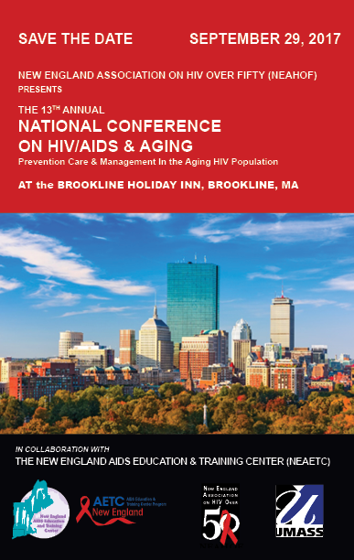
HIV Continuum of Care Conference – October 11 - 12, 2017, Portland, OR
Source: Oregon AETC
Description: The Oregon AETC, in collaboration with the Oregon Health Authority, is hosting a two-day training event for individuals in a professional role to support those at risk of or living with HIV/AIDS in their community. This inter-professional training opportunity will have both a clinical track and a patient navigation track with strategically overlapping general sessions to encourage systematic approaches to implementation of key strategies presented throughout the conference. Training topics Include:
- Innovations in HIV Prevention & Treatment in Rural Communities
- Pre-Exposure Prophylaxis (PrEP)
- Engaging Newly Diagnosed Patients
- HIV/STI Treatment Update
- Improving Access to Care for Latino Patients
- Mental Health, Substance Abuse and HIV
- Primary Care, Aging, and HIV
- Trauma Informed Care
- Co-Occurring Conditions, Including Hepatitis C
Link to conference registration

HIV Oral Health - Global & National Update, November 4, 2017, 1:00-5:00 PM, Atlanta, GA
Source: New England AETC, Georgia AETC, HIVdent, American Public Health Association 2017 Annual Meeting & Expo (APHA 2017)
Description: There has been much advancement in HIV over the past 36 years regarding diagnosis, treatment, oral implications, and policies. This pre-conference session of the APHA 2017 will review current trends in oral manifestations, the role of the oral healthcare team, oral systemic linkages and strategies, Rapid Testing for HIV and policies that affect us. The keynote will discuss the global and national status of HIV disease. Registration is limited, but you do not have to be an APHA member or register for APHA 2017 to attend.
Link to session registration and more information

Visit the National Clinician Consultation Center HIV hotlines and warmlines to obtain timely and confidential responses to clinical questions related to treatment of persons living with HIV infection and/or possible health care worker exposure to HIV infection, hepatitis C virus infection, and substance use.

Practice Transformation
The Impact of Primary Care Practice Transformation on Cost, Quality, and Utilization
Annual Review of Evidence 2016 – 2017
Source: Patient-Centered Primary Care Collaborative
Purpose: Implementation of the patient center medical home (PCMH) and high performing primary care differs depending upon the needs and preferences of those delivering, receiving, and paying for related care. This report reviews PCMH results from 45 peer-reviewed reports and additional government and state evaluations published between November 1, 2015 to February 28, 2017, and includes an executive summary and evidence report FAQ.
Link to access the report
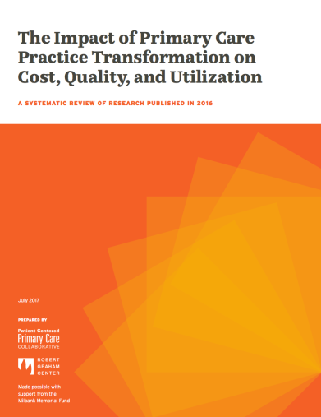

Disconnects in Transforming Health Care Delivery (e-Book)
Source: NEJM Catalyst, NEJM Group, Massachusetts Medical Society
Description: This free eBook contains original data and first-hand accounts from health care executives, clinical leaders, and clinicians on critical areas of division such as developing engaging care environments, the impact of market disruptors such as telehealth and retail clinics, and the role of value-based care. It is designed to help healthcare executives and clinical leaders recognize the differences that exist between them, to effectively organize and bridge the divide and transform health care delivery.
Link to download the eBook
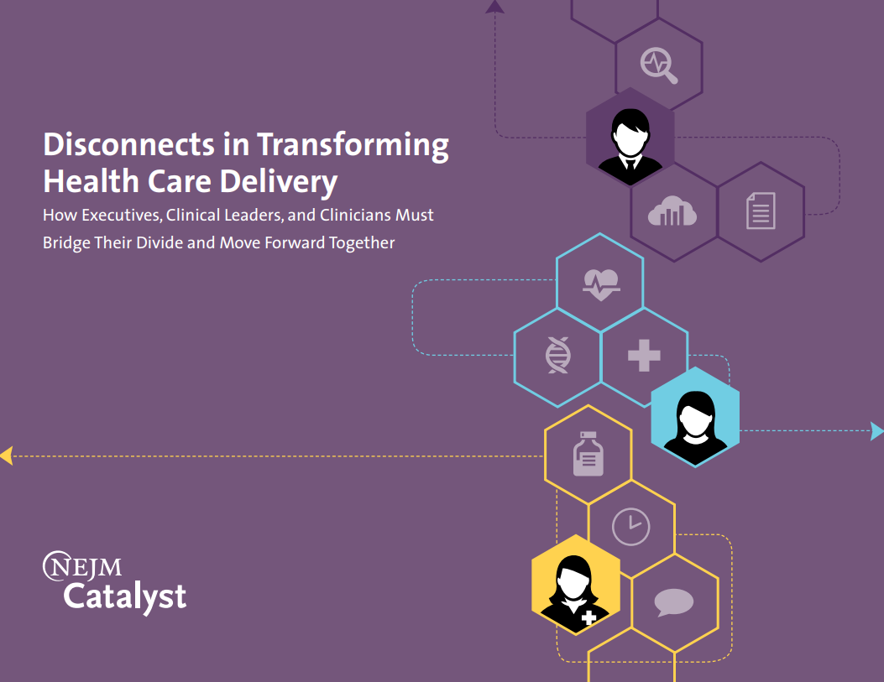

Interprofessional Education

Information Sharing in Medical-Legal Partnerships (MLPs): Foundational Concepts and Resources (report)
Source: The National Center for Medical Legal Partnership
Description: MLPs are designed to encourage and enable communication between healthcare practitioners and legal service providers to ultimately improve health, but the information privacy legal framework may present obstacles to effective information sharing. This may be particularly helpful for providers treating people living with HIV. This report addresses challenges in and possibilities for legally and ethically sharing patient-client information between partner organizations within the framework of existing privacy laws. You may also download the MLP Toolkit to aid in the development of new programs, as well as to help existing medical-legal partnerships strengthen services and operations.
Link to download the report

Pennsylvania Interprofessional HIV Conference – October 24 – 25, 2017, State College, PA
Source: MidAtlantic AETC
Description: This two-day conference will bring together regional experts in HIV and related fields in order to enable HIV care teams to recognize manifestations of HIV and other co-morbidities in a diverse population. The aim is to pursue efforts that support a collaborative healthcare approach. Experts will discuss public benefits, hepatitis C and the opioid epidemic, cultural competency, PrEP, trauma informed care, and much more. Professionals working in these areas will be able to increase their knowledge of new updates in an interprofessional environment. Registration fee is $65. Registration will close on Friday, October 13, 2017.
Link to conference registration

Minority AIDS Initiative/Secretary's Minority AIDS Initiative Fund

Secretary’s Minority AIDS Initiative Fund (SMAIF): A Catalyst for Change Infographic
Source: HHS, SMAIF, HIV.gov
Description: Infographic illustrates why SMAIF is important and how it is working to improve HIV prevention efforts, care and treatment for people of color in the U.S. It provides a snapshot of the impact SMAIF has had through various funding streams.
Link to download the infographic
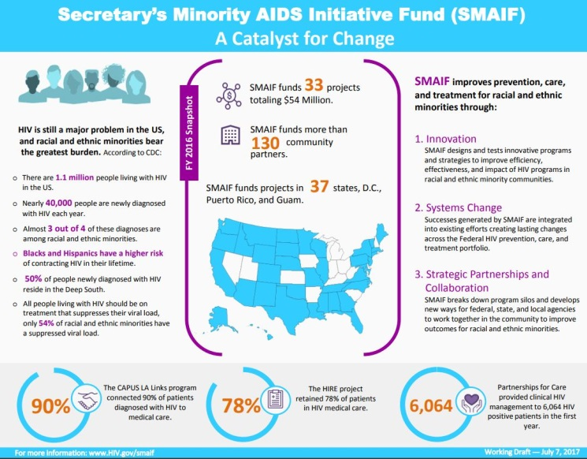

Other Resources, News and Events
What Works in Youth HIV Podcast: A Physician's Perspective
Source: What Works in Youth HIV, HHS, Office of Adolescent Health
Description: Some physicians may be hesitant to address sexual health with their adolescent patients. In this podcast, Dr. Colleen Lane, a physician specializing in HIV, discusses how she helps teens with this transition into adulthood. Tune in to hear how chronic diseases, like HIV, can affect youth development and why African American women, in particular, need to be empowered with pre-exposure prophylaxis.
Link to podcast

Pharmaceutical Company Patient Assistance and Cost-sharing Assistance Programs: Hepatitis
Source: National Alliance of State and Territorial AIDS Directors (NASTAD)
Description: Patient assistance programs (PAPs) are run through pharmaceutical companies to provide free or low-cost medications to people with low-incomes who do not qualify for any other insurance or assistance programs, such as Medicaid, Medicare or AIDS Drug Assistance Programs (ADAPs), and cost-sharing assistance programs (CAPs) offer cost-sharing assistance (including deductibles, co-payments and coinsurance) to people with private health insurance to obtain viral hepatitis drugs at the pharmacy. This updated resource provides information about pharmaceutical companies participating in PAPs and CAPs for hepatitis treatment, and identifies foundations providing access to care assistance for people living with hepatitis B and/or hepatitis C virus.
Link to resource
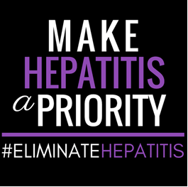

Updated HIV Care Guidelines for People Displaced by Disasters
Source: U.S. Dept. of Health and Human Services (HHS), AIDSinfo
Description: The Guidance for Non-HIV-Specialized Providers Caring for Persons with HIV Displaced by Disasters was updated on August 31, 2017. This revision includes recommendations based on the current standard of care for persons with HIV infection and includes specific guidance on management of HIV infection during pregnancy. In addition, the guidance now includes: 1) an intake form clinicians can use when evaluating a patient with HIV, 2) a collection of web-based resources for information on treating and preventing HIV infection, and 3) a list of temporary regimen substitutions for antiretroviral medications in case of supply shortages.
Link to guidance

MSM Sexual Health Standards of Care
Source: National Coalition of STD Directors (NCSD), NASTAD
Description: NCSD and NASTAD convened a panel of experts from academia, city and state health departments, the HHS U.S. Centers for Disease Control and Prevention (CDC), and the National Network of STD/HIV Prevention Training Centers (NNPTC) to develop optimal standards of client-focused clinical care for gay, bisexual, and other men who have sex with men (MSM). These standards illustrate the highest quality of sexual health care for MSM, expanding beyond federal guidelines to incorporate the collective experience of experts in the field of sexual health.
Link to publication

International Training and Education Center for Health (I-TECH) Launches New Website
Source: International Training and Education Center for Health (I-TECH)
Description: I-TECH is a global network that works with local partners to develop skilled health care workers and strong national health systems in resource-limited countries. I-TECH promotes local ownership to sustain effective health systems. Visit their new website for I-TECH program highlights, locations, news and access to training tools.

Healthy Teen Network Conference - Social Norms & Culture: Honoring Experiences & Perspectives – October 2-4, 2017, Baltimore, MD
Source: Health Teen Network
Description: Social norms and culture are powerful influencers on our individual experiences and perspectives. They affect every facet of our personal and professional life—our attitudes and outlook, who and what we value, dismiss, embrace, and fear. This conference will explore how race, gender identity, religious and spiritual beliefs, age, science and evidence, sexual orientation, laws and policies, ethnic heritage, economics, and other facets of social norms and culture impact work with young people, adolescents and young adults who are pregnant and/or parenting, professional colleagues, policymakers, and organizations. This conference presents an opportunity for providers treating adolescents and young adults living with HIV to learn meaningful engagement and retention in care strategies.
Link to conference registration

2017 Transforming Care: LGBTQ & HIV/AIDS Health Equity Conference - October 19-20, 2017, Columbus, OH
Source: Equitas Health Institute for LGBTQ Health Equity, Ohio AIDS Coalition
Description: This 2-day event will bring together activists, academics, community members, and health & social service professionals to address health disparities affecting the LGBTQ and HIV/AIDS community. Conference attendees will share research findings, best practices and practical information like family planning, wellness activities, and health and safety initiatives.
Link to conference registration

ANAC2017, November 2-4, 2017, Dallas, TX
Source: Association of Nurses in AIDS Care (ANAC)
Description: ANAC2017 will celebrate 30 years of working with nurses and nurse practitioners in HIV and its associated conditions, co-infections and co-morbidities. Conference objectives include:
- Analyze strategies to sustain and advocate for ongoing advances in HIV/AIDS care given the shifts in the domestic political, economic and social climate
- Discuss innovative biomedical, psychosocial and behavioral research in HIV and associated co-morbidities
- Evaluate the global impact of nurses’ and other health professionals' roles in addressing HIV health disparities, HIV risk and social determinants of health
- Demonstrate an enhanced ability to care for key populations living with, or affected by HIV and related co-morbidities
- Improve nurses and other professionals’ capacity to identify, treat and care for individuals at risk for and/or living with viral hepatitis
Follow the link above to register, view the conference agenda, and learn more about lodging and other activities to take part in during your stay in Dallas. Online registration closes October 29, 2017.
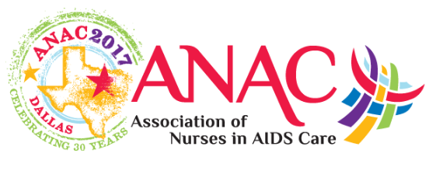

Awareness Days
National Gay Men's HIV/AIDS Awareness Day – September 27
National Latinx AIDS Awareness Day – October 15
National Day of Action to End Violence against Women with HIV – October 23
National Rural Health Day – November 16
World AIDS Day – December 1

