Quarterly Newsletter-Spring 2016
AETC Program related news, resources and events:
Resources & Events:
Updated Guidelines for the Use of Antiretroviral Agents in Adults and Adolescents: Training Slide Sets
Source: AETC National Coordinating Resource Center
Description: These training slides have been updated to reflect recent changes to the Guidelines for the Use of Antiretroviral Agents in HIV-1-Infected Adults and Adolescents. See the AIDSinfo website for the current version of the Guidelines.
Download the updated slides

New Mexico Annual HIV & HCV Update Conference – March 24-25, 2016, Albuquerque, NM
Source: New Mexico AETC, Continuing Medical Education & Professional Development
Description: The Annual New Mexico HIV Conference is the only HIV update conference in New Mexico. Local, regional and national experts in HIV will cover clinical and socioeconomic topics following the theme Native American health. Speakers from various locations and disciplines will discuss HIV and other health care issues in Native American communities. The conference is an opportunity for healthcare providers to gain access to relevant information and to network with statewide and national experts in HIV care.
Register
Save-the-date: The 12th National Conference on HIV/AIDS & Aging – September 23, 2016, Dorchester, MA
Source: New England Association on HIV over Fifty, New England AETC, University of Massachusetts
Description: This event is designed to promote engagement and mutual respect among professionals in aging and HIV policy, research, advocacy, and care; to champion the viewpoints and voices of those over 50 facing the health challenges of aging, including HIV/AIDS, its risks, treatment and prevention in an increasingly complex health and social matrix; to ask how factors of age and disease states effect HIV prevention, diagnosis and treatment; and to explore how HIV effects the experience of aging. Registration and more information will be available soon.

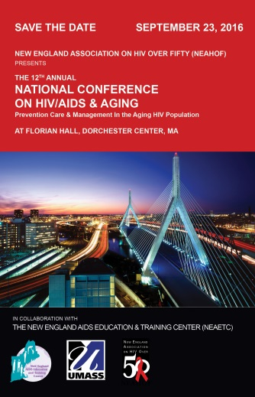
Updates from the Clinician Consultation Center (CCC):
Substance Use Warmline: Peer-to-Peer Consultation and Decision Support
The CCC is pleased to announce its newest consultation service for healthcare providers, the Substance Use Warmline, which offers free and confidential consultation for clinicians focusing on substance use in primary care. Consultation is available Monday through Friday, between 10 a.m. and 6 p.m. EST, from addiction medicine-certified physicians, clinical pharmacists, and nurses with special expertise in pharmacotherapy options for opioid use. Voicemail is available 24-hours a day. Please share this information with your faculty, clinical trainees and other providers who may benefit from free clinical advice on substance use management.
PEP Tips: Laboratory Cadaver Exposures: assessing the risk of transmission when stuck by an instrument while handling or studying a cadaver in a laboratory setting.
January case of the month: Initiating Hepatitis C Treatment in an HIV Co-Infected Patient

Minority AIDS Initiative
HIV/AIDS in the US Deep South: Trends from 2008-2013 (report)
Source: Southern AIDS Strategy, Center for Health Policy and Inequities Research at Duke University, Ford Foundation
Description: “…nine Deep South states are driving the HIV epidemic in the US.”
The trends documented in this report indicate a need to strengthen efforts to reduce HIV transmission and mortality within the region. Barriers to timely HIV testing and treatment may include HIV-related stigma, lack of transportation and housing, and inadequate availability of HIV medical providers, in addition to the failure of many of the Deep South states to adopt Medicaid expansion. This report highlights the need for the region to receive a reasonable share of HIV care and prevention funding, to be distributed consistent with the geographic prevalence of the epidemic.
Read the full report
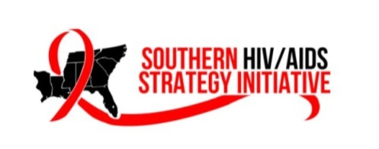

HIV Testing and Service Delivery Among Black Females — 61 Health Department Jurisdictions, United States, 2012–2014
Source: U.S. Centers for Disease Control and Prevention (CDC), Division of HIV/AIDS Prevention, National Center for HIV/AIDS, Viral Hepatitis, STD, and TB Prevention
Description: This is an analysis of the National HIV Prevention Program Monitoring and Evaluation data on CDC-funded HIV testing events and HIV prevention services from 61 state and local health departments and 151 community-based organizations from 2012-2014. Findings indicate that the number of HIV testing events among black females declined slightly and the HIV positivity rate remained relatively stable during this time. And, despite the fact that the linkage to care rate within 90 days of diagnosis for black women with newly diagnosed HIV infection has increased (from 33% to 50%, 2012-2014), it is below the goal set by the National HIV/AIDS Strategy to link 85% HIV-positive persons to HIV medical care. Enhanced efforts for early diagnose and linkage to medical care among black women newly infected with HIV are needed to eliminate health disparities among this population.

Practice Transformation
New Practice Transformation (PT) Resource Repository
Source: AETC National Coordinating Resource Center (NCRC)
Description: A new PT page has been added to the AETC NCRC website for easy access to a curated collection of expert PT resources, program tools, reports, and more, to support AETC Program PT facilitation and implementation projects in select clinics. This new initiative is designed to improve patient outcomes along the HIV care continuum by integrating principles of the patient-centered medical home model and integrated HIV care and behavioral health services. The PT process involves goal-setting, leadership, practice facilitation, workflow changes, quality improvement and outcomes measurement, and adapting organizational tools and processes to support advances in models of team-based care. The resources in this collection are organized to assist you along any stage of the PT process, like if you’re just getting started or if you need help engaging leadership. Materials can be accessed from the AETC NCRC website home page under “Popular Shortcuts.” If you have/know of other resources to add to this collection, or if you’d like more information, please contact Elizabeth Rolon at eir8@sn.rutgers.edu.

Organization Assessment Tools
Source: U.S. Centers for Disease Control and Prevention (CDC)
Description: CDC has arranged this collection of tools to help you assess your program’s health literacy issues, and help identify opportunities and barriers to make progress where needed. The Organization Assessment Tools package includes:

- Pharmacy Health Literacy Assessment Tool
- AHRQ Health Literacy Universal Precautions Toolkit
- Harvard Environmental Assessments
- CAHPS Item Set for Addressing Health Literacy
- Building Health Literate Organizations: A Guidebook to Achieving Organizational Change

Use these resources to help you get started with evaluating your program’s current situation.
Access the tools

Interprofessional Education

Interprofessional Education Collaborative (IPEC): Resources, News and Events
Source: American Dental Education Association, American Association of Colleges of Pharmacy, American Association of Colleges of Nursing, Association of Schools and Programs of Public Health, American Association of Colleges of Osteopathic Medicine, Association of American Medical Colleges
Description: IPEC was formed by six national associations of health professions to promote efforts to encourage advanced interprofessional learning to prepare future health professionals for enhanced team-based care of patients and improved population health outcomes. These associations represent higher education in allopathic and osteopathic medicine, dentistry, nursing, pharmacy, and public health. Core competencies for interprofessional collaborative practice were developed to guide curricula development across health professions schools. This website offers resources, news and events for interprofessional education.
Resources
Upcoming Conferences
News

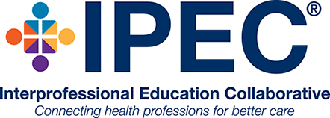

Other resources, news and events:
2016 National Ryan White Conference on HIV Care and Treatment - August 23 – 26, 2016, Washington, DC
Source: Health Resources and Services Administration (HRSA) HIV/AIDS Bureau
Description: HRSA's HIV/AIDS Bureau is pleased to announce the 2016 National Ryan White Conference on HIV Care and Treatment is scheduled for August 23 – 26, 2016 at the Marriott Marquis Hotel in Washington, DC. The theme of the conference is “Forward Momentum: Accelerating Access. Optimizing Care. Transforming Public Health.” The conference will feature seven session tracks: Program Management, Data to Care, Emerging Issues, Health Care Landscape, Quality Management, Innovative Practices, and Clinical Pathway. Register here to stay informed about new and updated conference details like registration, exhibits, and abstract submission details.
View more information via the Target Center website
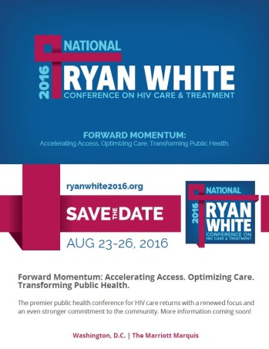

Final List of Essential Community Providers (ECPs) for 2017
Source: Centers for Medicare and Medicaid Services (CMS)
Description: CMS has released an updated list of Essential Community Providers (ECPs) to assist issuers with identifying providers that qualify for inclusion in an issuer’s plan network toward satisfaction of the ECP standard under 45 CFR 156.235 for the 2017 benefit year. This includes health care providers defined in section 340B(a)(4) of the Public Health Service (PHS) Act and described in section 1927(c)(1)(D)(i)(IV) of the Social Security Act(SSA). Click on the link below for a description of ECPs, an explanation of the purpose of this list, and identified improvements made to the list.
Learn more

Management of Osteoporosis in the HIV-Infected Patient
Source: International Antiviral Society-USA
Description: Age-related comorbidities such as osteoporosis and bone fractures are often associated with the aging HIV population. HIV primary care practitioners should be aware of the risks and be comfortable with assessment and treatment of patients with osteoporosis or fractures. Learning objectives for this training are
- Delineate the approach to screening for osteoporosis
- Choose the appropriate antiretroviral regimen for patients with low bone mineral density
- Choose the appropriate antiretroviral regimen for patients with fragility fractures
CEUs are available for his activity until January 14, 2017.
Register to access the training

IAS-USA Spring Courses
Source: International Antiviral Society-USA
Description: IAS-USA is offering full-day HIV courses and half-day HCV courses throughout the spring in several U.S. cities. HIV courses are designed to blend advanced-level presentations with balanced, timely, scientifically rigorous, and clinically relevant information about HIV disease management, while HCV small-group, interactive workshops are designed to improve the clinical care of people infected with hepatitis C virus (workshops are limited to 50 participants – clinical decision makers, i.e., physicians, nurse practitioners, PharmDs, and physician assistants). CME, pharmacy and nursing credits are offered at all live events, and most online activities; and, fellow/student discounts are available for full-day courses. Click on the links below for the spring schedule including course locations, registration information and more.
Spring 2016 HIV courses
Spring 2016 HCV courses

Securing the Future of Women-Centered Care (webinar) – March 10, 2016, 1:00-2:30 PM ET
Source: Positive Women’s Network – USA
Description: Honoring National Women and Girls HIV/AIDS Awareness Day, this webinar will present key findings from a community-based participatory research project where 14 women living with HIV (WLWH) from across the US surveyed other WLWH in their communities to assess what's working for women in the context of Affordable Care Act implementation, changes to Ryan White service delivery and the updated National HIV/AIDS Strategy.
Register and learn more

Adherence 2016 – May 9-11, 2016, Ft. Lauderdale, FL
Source: International Association of Providers of AIDS Care
Description: Adherence 2016 is the premier conference dedicated to the presentation and discussion of HIV treatment and biomedical prevention adherence research, as well as current behavioral and clinical perspectives in practicum, within the context of achieving an optimized continuum of HIV care. This year’s program will focus on five themes: 1) data for action, 2) optimizing the HIV care continuum, 3) optimizing the HIV prevention continuum, 4) leaving no one behind, and 5) ending AIDS as a public health threat. Registration closes May 6, 2016.
Register here

SAMHSA-HRSA Center for Integrated Health Solutions is Looking for Your Insights
Source: Substance Abuse and Mental Health Services Administration, Health Resources and Services Administration (SAMHSA-HRSA)
Description: SAMHSA-HRSA is looking for expert input on a range of activities for its Center for Integrated Health Solutions (CIHS) in 2016:

- Innovation Communities: learning communities for groups of up to 20 organizations to examine practices in integrated care
- Webinars: presenters, resources and case studies for their webinars are needed
- Issue Briefs: contribute your resources or offer subject matter expertise for a variety of Issue Briefs
Visit the CIHS website for more information and resources

HIV Update: Contemporary Issues in Management – May 12-14, 2016, Boston, MA
Source: Harvard Medical School, Beth Israel Deaconess Medical Center
Description: The HIV Update course is a comprehensive continuing medical education program specifically designed to foster the integration of all aspects of HIV care. It offers the opportunity to stay current with the latest developments in HIV clinical care including the management of non-AIDS-defining malignancies, lifelong antiretroviral therapy and issues regarding co-infections and hepatitis B and/or C. Presenters will address the challenges routinely faced in clinical practice and will provide recommendations for optimal management through state-of-the-art lectures, question-and-answer sessions and case-based workshops.
Register and learn more

Simply Put: A guide for creating easy-to-understand materials
Source: U.S. Centers for Disease Control and Prevention (CDC)
Description: This guide is designed to assist organizations with communicating a broad range of health messages to a wide variety of audiences. It provides practical guidance for organizing information using language and visuals. Consider its use when creating fact sheets, FAQ’s, brochures, booklets, pamphlets, and other materials, including web content.
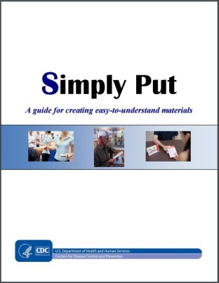

New HIV-related articles on Consultant360
Source: Consultant360, HMP Communications LLC
Description: New HIV-related articles have been added to the HIV/AIDS topic page on Consultant360, an online resource for clinicians. Create an account at the link above to read the following:

- Combination HIV Assay Detects Acute Infection in High-Risk Individuals
An HIV antigen/antibody combination assay can detect acute HIV infection and should be considered in populations where HIV is prevalent, researchers say.
- TB/HIV mortality alarmingly high in eastern Europe
Patients in Eastern Europe with HIV and tuberculosis coinfection have a risk of death more than three times higher than their counterparts in Western Europe and Latin America, according to an international group of researchers.

Awareness Days
National Women and Girls HIV/AIDS Awareness Day – March 10
National Native HIV/AIDS Awareness Day – March 20
National Youth HIV & AIDS Awareness Day – April 10
HIV Vaccine Awareness Day – May 18
Hepatitis Testing Day – May 19
National Asian & Pacific Islander HIV/AIDS Awareness Day – May 19

