Quarterly Newsletter-Summer 2016
AETC Program related news, resources and events:
Resources & Events:
Updated Comprehensive Slide Sets: Guidelines for Prevention and Treatment of Opportunistic Infections in HIV-Infected Adults and Adolescents
Source: AETC National Coordinating Resource Center
Description: These slide presentations were developed to accompany the May 2013 treatment guidelines of the U.S. Centers for Disease Control and Prevention, the National Institutes of Health, and the HIV Medicine Association/Infectious Diseases Society of America. Sections on Hepatitis C, Enteric Bacterial Diseases, and Mucocutaneous Candidiasis were updated in May 2016 in response to updated recommendations.
Link to updated slide sets
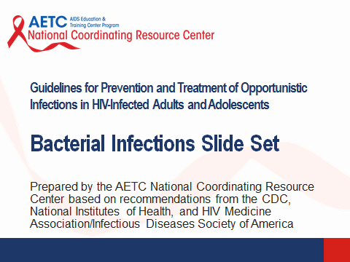

Information for Providers Assisting HIV Patients Returning to Mexico and Central America / Información para Proveedores que Asisten a Pacientes que Regresan a México y los Países de Centro América
Source: Pacific AIDS Education and Training Center, Los Angeles Area AETC, Arizona AETC, New Mexico AETC, South Central AIDS Education and Training Center, AETC National Coordinating Resource Center
Description: These fact sheets were developed to assist providers who have patients leaving the United States for Mexico and Central American countries. The goal of the information is to improve continuity of care for migrant patients with HIV. Fact sheets are available in both English and Spanish.
Download this resource

African American Cultural Considerations in HIV/AIDS
Source: South Central AETC
Description: Slide presentation that discusses the statistics regarding the HIV epidemic in the African American (AA) community; the historical context of the AA relationship with the health care and scientific community; the socioeconomic and political issues that plague the AA community; how stereotypes in the media affect the general mental, physical, and emotional health of those in the AA community; and possible solutions and strategies to help improve the state of AA health and reduce transmission of HIV.
Link to slide presentation

Website Accessibility Infographic
Source: AETC National Coordinating Resource Center
Description: This infographic illustrates the importance of making your online resources and program activities accessible for all users, and provides strategies and tips for starting the process of improving your website. This resource is available in JPEG, PDF and PPT formats.
Link to infographic file formats
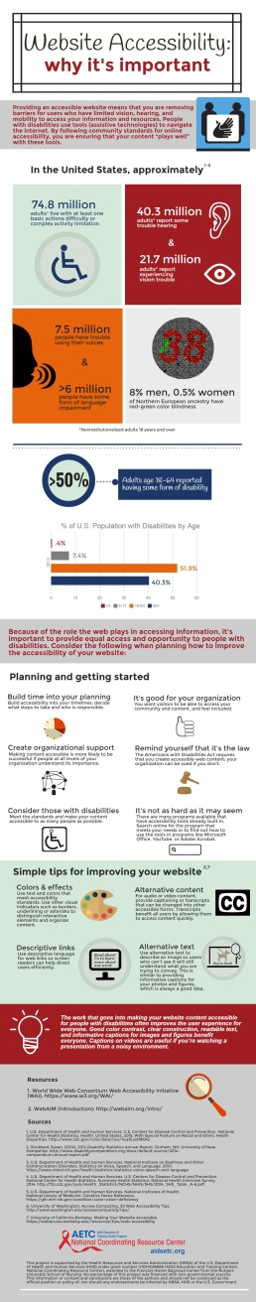
The 12th National Conference on HIV/AIDS & Aging – September 23, 2016, Dorchester, MA
Source: New England Association on HIV over Fifty, New England AETC, University of Massachusetts
Description: This event is designed to promote engagement and mutual respect among professionals in aging and HIV policy, research, advocacy, and care; to champion the viewpoints and voices of those over 50 facing the health challenges of aging, including HIV/AIDS, its risks, treatment and prevention in an increasingly complex health and social matrix; to ask how factors of age and disease states effect HIV prevention, diagnosis and treatment; and to explore how HIV effects the experience of aging. Registration opens June 6th.

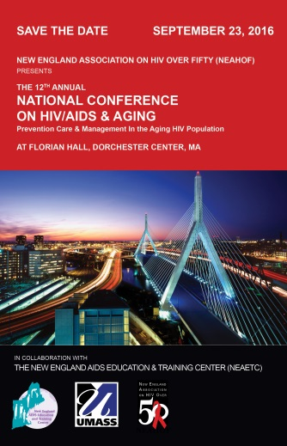

Minority AIDS Initiative
His Health
Source: National Alliance of State and Territorial AIDS Directors (NASTAD)
Description: His Health is a new online resource scheduled to launch summer 2016 that provides a compendium of care models, training modules, and resources for enhanced linkage, retention, and engagement strategies targeting Black men who have sex with men (MSM). This site is designed for healthcare providers and offers continuing medical education and continuing nursing unit credits to increase capacity to accelerate healthcare service delivery to Black MSM.
Link to project overview

In It Together: A Health Literacy Guide for Health Professionals Serving Black MSM Living with HIV
Source: Health Resources and Services Administration, HIV/AIDS Bureau, John Snow, Inc.
Description: This resource is designed to improve the capacity of health departments and community-based organizations to deliver health literate HIV services to Black/African American men who have sex with men (MSM). It provides strategies to help providers offer clear HIV care and treatment information to their clients while engaging them in discussions about their desired health outcomes.
Download the resource
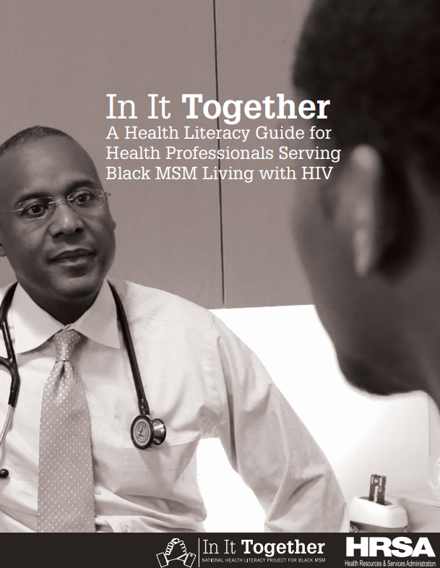

Transgender HIV Testing Toolkit
Source: The University of California San Francisco (UCSF), Center of Excellence for Transgender Health
Description: This Toolkit was launched in connection with the first National Transgender HIV Testing Day - April 18, 2016. It consists of five modules designed to reflect the most current HIV prevention research and best practices for serving trans and gender non-binary people. Guidelines to increase access and trans cultural competence among HIV testing programs and services are included. The purpose of this resource is to encourage and support community-based organizations and prevention programs to provide HIV testing services, and engage trans community members in promoting status awareness among trans people through community events and HIV testing campaigns.
Download the complete toolkit for health service programs
Download the condensed toolkit for health departments
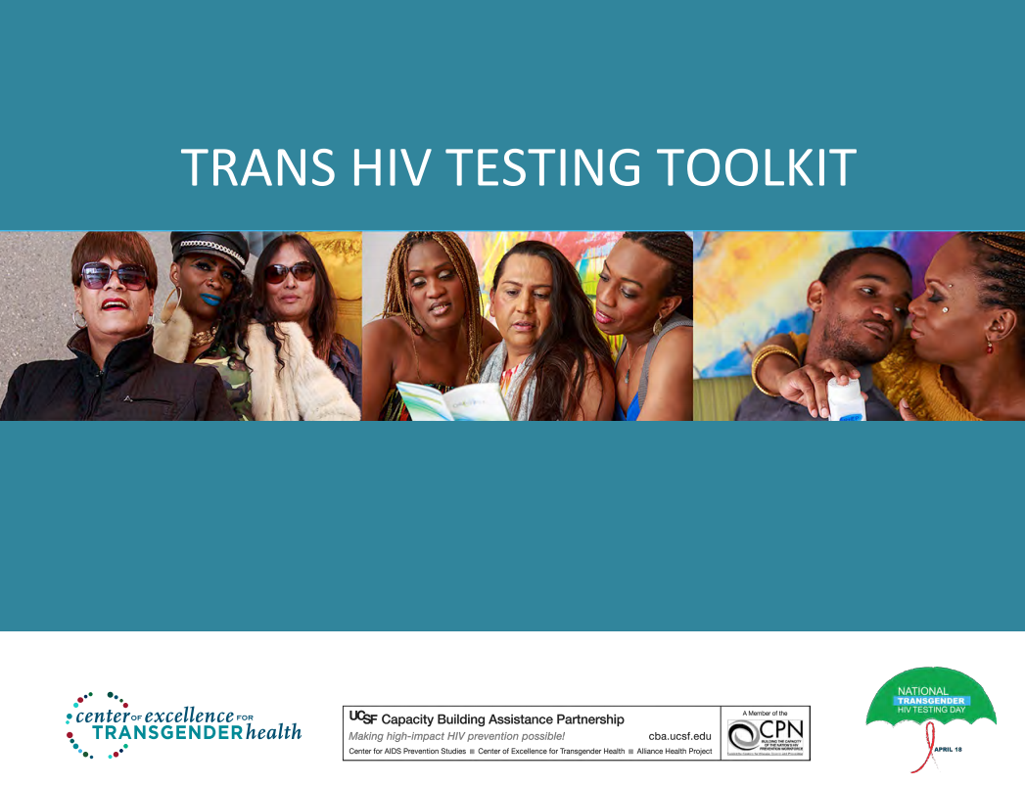

Practice Transformation
STEPS Forward- Practice Improvement Strategies
Source: American Medical Association
Description: The goal of this online, practice-based initiative is to provide physicians and medical staff with proven strategies that can improve practice efficiency and help each practice reach better patient experience, better population health and lower overall costs with improved professional satisfaction. Thirty-five modules are available with topics that range from patient care and workflow processes, to technology and finance. CMEs are offered for most activities.
Link to training modules

Save-the-date: Patient-Centered Medical Homes (PCMH) Congress – October 7-9, 2016, Chicago, IL
Source: National Committee for Quality Assurance (NCQA)
Description: PCMH Congress is the conference for "medical neighbors" working together to provide the highest level of coordinated care. This program is intended for leaders and professionals focused on the redesign of care delivery. It is especially beneficial to those who are, or who are considering becoming, an NCQA-recognized PCMH, PCMH Certified Content Expert (CCE), or Patient-Centered Specialty Practice (PCSP).
Link to conference agenda
Link to registration

Interprofessional Education

Save-the-date: Interprofessional Care for the 21st Century: Redefining Education & Practice (conference) – October 28-29, 2016, Philadelphia, PA
Source: Thomas Jefferson University, Jefferson Center for Interprofessional Education
Description: The purpose of this conference is to showcase scholarly work and works in progress related to interprofessional education and/or practice. This conference reflects on innovative implementation and evaluation strategies of the interprofessional competencies. Educators, clinicians, practitioners, researchers, health system leaders, policymakers, patient organizations, students and other interested stakeholders in the health and social services arena should attend.
Link to registration, conference agenda and more information

Other resources, news and events:
Register for the 2016 National Ryan White Conference on HIV Care & Treatment - August 23-26, 2016, Washington, DC
Source: Health Resources and Services Administration HIV/AIDS Bureau (HRSA HAB)
Description: The theme of the National Conference is “Forward Momentum: Accelerating Access. Optimizing Care. Transforming Public Health.” It will feature seven session tracks: Program Management, Data to Care, Emerging Issues, Health Care Landscape, Quality Management, Innovative Practices, and Clinical Pathway. Visit RyanWhite2016.org to register for the National Conference, inquire about exhibiting, book your hotel room, check out the conference agenda, and more. Registration deadline is July 25, 2016. Follow on Twitter at @RyanWhite2016 to stay on top of all 2016 National Ryan White Conference on HIV Care and Treatment news and important updates. For any technical issues and questions, please contact admin@ryanwhite2016.org.
National Institutes of Health is seeking participants for REPRIEVE Clinical Trial
Source: National Institutes of Health, AIDS Clinical Trials Group, Gilead, Kowa American Corporation
Description: Providers, do you have HIV-infected clients over 39? If so, they may qualify for the REPRIEVE Trial.
Heart disease among HIV-infected individuals is emerging as a major public health problem despite effective treatments that suppress viral load. People living with HIV are 50 to 100% more likely to develop heart disease, including heart attack and stroke, compared with people who do not have HIV. Currently, there are no approved strategies for heart disease prevention tailored to people living with HIV. REPRIEVE, which stands for a Randomized Trial to Prevent Vascular Events in HIV, is a large-scale randomized clinical research trial looking to change that. The trial will test whether a daily dose of pitavastatin reduces the risk of heart disease among HIV-infected individuals. Your client may qualify to participate in REPRIEVE if he or she:
• Is HIV-positive
• Is between the ages of 40 and 75
• Has been on antiretroviral therapy (ART) for at least 6 months prior to study entry
• Has no history of heart disease (including heart attack or stroke)
• Is not currently using a statin drug
• Has a low to moderate risk for developing heart disease, as determined by the American College of Cardiology/American Heart Association Risk Calculator

Consider recommending participation in this historic study to help address the growing problem of HIV-related heart disease. Visit www.reprievetrial.org or call 1-877-29-HEART for more information.
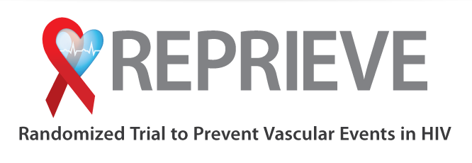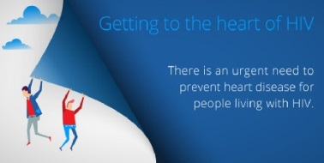

Strategies to Improve the Health of Older Adults Living with HIV
Source: National Center for Innovation in HIV Care
Description: This brief explores the unique challenges that older adults living with HIV (LWH) may face and offers resources for health care providers and AIDS service providers to address these challenges. Five key steps for caring for older adults LWH are outlined: training staff to provided culturally competent care, screening for comorbidities, addressing substance use, promoting sexual health and HIV/STI prevention, and strengthening social support networks.
Download this resource

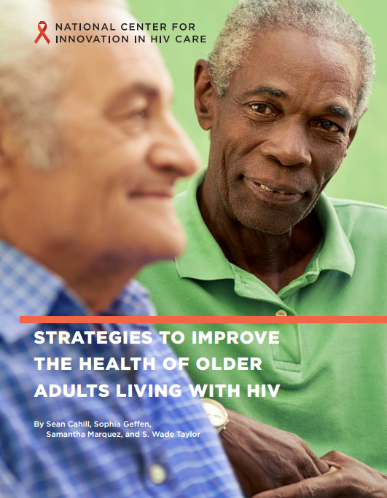

Evaluation Toolkit for Promotor(a) de Salud (Community Health Worker) Programs
Source: MHP Salud
Description: This Toolkit was developed to help Health Centers, health departments, migrant health programs, Primary Care Associations, and other organizations design an evaluation system from beginning stages through the improvement of existing evaluation efforts, to determine what evaluation strategies work best for their program. The Toolkit is community focused and tailored to address issues relating to underserved, hard-to-reach populations; however, it can be adapted to meet the needs of your program.
Download this resource
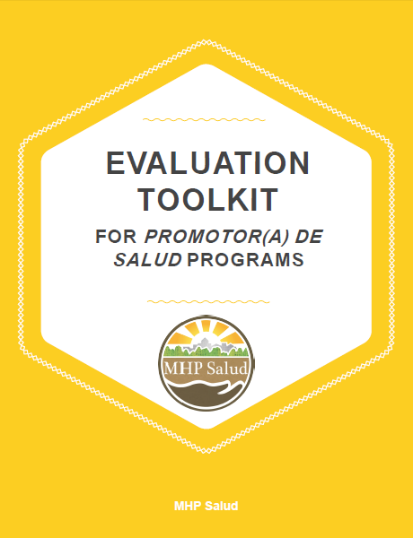

Oral Health Integration in Statewide Delivery System and Payment Reform (brief)
Source: Washington Dental Service Foundation, Center for Health Care Strategies, Inc.
Description: Medicaid dental coverage varies from state to state and beneficiaries face inadequate and uneven access to oral health care. In response, states are creatively including oral health in broader payment and delivery system reforms; this brief explores how it’s being done.
Download this resource

New HIV-related articles on Consultant360
Source: Consultant360, HMP Communications LLC
Description: New HIV-related articles have been added to the HIV/AIDS topic page on Consultant360, an online resource for clinicians. Create an account at the link above to read the following:

- Study: Combined HCV, HIV Vaccine Possible
“A combined vaccine against hepatitis C virus (HCV) and HIV was found to be safe and effective in a small human trial, according to an ongoing study conducted by the European PEACHI consortium.
The results of phase 1 of the study were presented on April 13 at the European Association for the Study of the Liver (EASL) International Liver Congress 2016 in Barcelona, Spain.”

- HIV-Infected Patients Less Likely to Get Cancer Treatment
“Researchers reviewed national cancer registry data on more than 2.2 million adults, including about 10,000 who also had HIV, to see how often people received radiation, surgery or medications to attack tumors.
The HIV-infected patients were more than twice as likely as people without the virus to have received none of these treatments for tumors of the lung, breast, prostate, cervix, and upper gastrointestinal tract, the study found.”

Register NOW: United States Conference on AIDS (USCA), September 15-18, 2016, Hollywood, FL
Source: NMAC (formerly known as the National Minority AIDS Council)
Description: This year’s program will offer session tracks that address current issues such as the epidemic among populations in the Caribbean diaspora and the importance of race in HIV services, biomedical HIV prevention, and women and violence (see link to conference tracks below). This conference is designed to help healthcare professionals improve their skills and learn about new and innovative methods needed to bring change to the communities encountering rising HIV infection rates.
Link to registration
Link to conference tracks

Register NOW: 2016 STD Prevention Conference, September 20-23, 2016, Atlanta, GA
Source: U.S. Centers for Disease Control and Prevention
Description: The theme of this year’s program is Transcending Barriers. Creating Opportunities.
The conference will highlight barriers to assessment, assurance, and policy development in the face of consistent financial challenges and shifting disease priorities, and focus on how these challenges can be transformed into opportunities for moving STD prevention forward.
Link to registration

Awareness Days
National Caribbean American HIV/AIDS Awareness Day – June 8
National HIV Testing Day – June 27
National HIV/AIDS & Aging Awareness Day – September 18
National Gay Men’s HIV/AIDS Awareness Day – September 27

