Quarterly Newsletter-Summer 2017
AETC Program related news, resources and events:
Resources & Events
NEW! AETC Program Postcard
Source: AETC NCRC
Description: This new promotional card replaces the double parallel fold brochure and companion bookmark, providing a more streamlined and centralized resource for those interested in learning more about the AETC Program. We encourage you to keep copies of this postcard available to share with your colleagues and offer as handouts during training events and conferences, to serve as a reminder that the AETC Program continues to provide free, expert, clinical HIV education and capacity building support to healthcare systems throughout the U.S. and its territories. To order FREE postcards, contact the AETC NCRC at info@aidsetc.org.
Download the postcard PDF
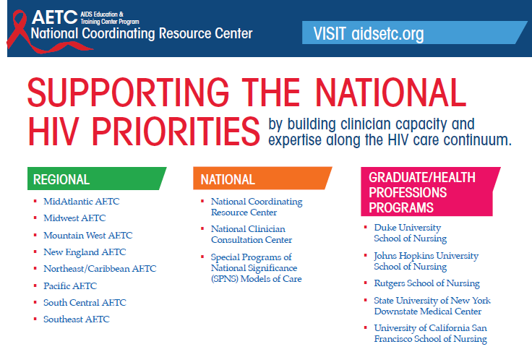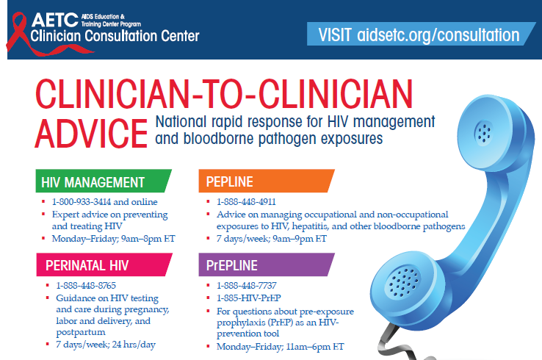
Updated AETC Program Description Slide Set
Source: AETC NCRC
Description: This resource is designed to quickly orient users to the goals, mission and overall work of the AETC Program. It provides a brief overview of the program’s structure, training modalities and special initiatives and collaborations, and highlights top training outcomes based on the most current data available from the Health Resources and Services Administration’s AETC Annual Data Report (2015).
Download the slide set
Northeast/Caribbean AETC Launches its New Website
Source: Northeast/Caribbean AETC
Description: The Northeast/Caribbean AETC has launched an expansive and responsive website that features a new clean design to improve site navigation and overall user experience. Simplified navigation tabs provide clarity about the content that can be found on this website, like upcoming trainings and events, capacity building programs, clinical tools and technical support, and additional information presented by the Northeast/Caribbean region (New York, New Jersey, Puerto Rico and the U.S. Virgin Islands) of the AETC Program. Click on the link below to experience the new website.
Link to website

Care of People Aging with HIV: Northeast/Caribbean AETC Toolkit
Source: Northeast/Caribbean AETC
Description: This toolkit is designed for clinicians and other professionals who care for people aging with HIV. It provides links to screening and assessment instruments, along with programs and papers that offer clinically useful materials.
Link to toolkit

2017 Ryan White HIV/AIDS Program (RWHAP) Clinical Conference – August 21-23, 2017, San Antonio, TX
Source: AETC NCRC, International Antiviral Society-USA (IAS-USA)
Description: Register now for the Health Resources and Services Administration (HRSA), HIV/AIDS Bureau funded AETC Program’s 17th RWHAP Clinical Care Conference. This technical conference will provide state-of-the-art research, care, and treatment updates for experienced clinical decision makers (physicians, advanced practice nurses, and physician assistants) who are responsible for the day-to-day medical care and treatment of persons living with HIV and those integral to the provision of medical care in HRSA funded RWHAP sites. Attendance to this conference is limited, and all attendees must be approved. Attendance criteria and more information including conference agenda with topics and speakers, venue description, information about CE credits, and details about travel can be found on the AETC NCRC website (aidsetc.org) the IAS–USA website (iasusa.org).
Link to IAS-USA conference site

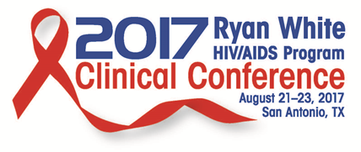
Save-the-Date: 13th Annual National Conference on HIV/AIDS & Aging - September 29, 2017, Brookline, MA
Source: New England Association on HIV Over Fifty, New England AETC
Description: Save the date for this annual event dedicated to presenting the most up-to-date information on the care and treatment of people living with HIV over the age of fifty. The conference will cover themes such as hepatitis, mental health, substance use, and more. Conference agenda and registration information will be available soon.
Link to conference site
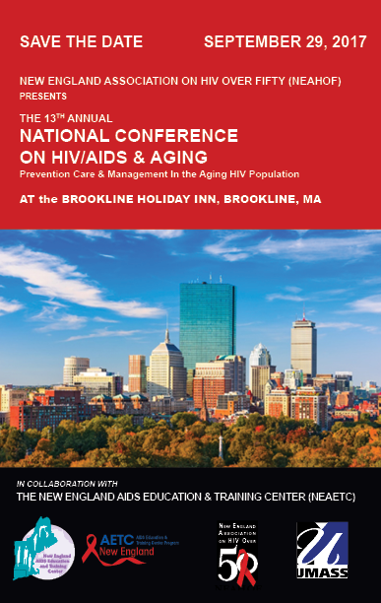

Visit the National Clinician Consultation Center HIV hotlines and warmlines to obtain timely and appropriate responses to clinical questions related to treatment of persons living with HIV infection and/or possible health care worker exposure to HIV and other blood-borne pathogens.
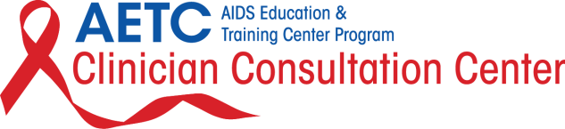

Practice Transformation
Toolkit to Improve Safety in Ambulatory Surgery Centers
Source: U.S. Dept. of Health and Human Services, Agency for Healthcare Research and Quality
Purpose: To serve as a model toolkit for HIV care related practice transformation, this toolkit helps ambulatory surgery centers (ASCs) apply the proven principles and methods of AHRQ's Comprehensive Unit-based Safety Program (CUSP), to prevent surgical site infections (SSI) and other complications and improve safety culture in their facilities. The toolkit includes resources used by ASCs that participated in the AHRQ Safety Program for Ambulatory Surgery project. The toolkit is organized into 3 sections: implementation, sustainability and resources. Each section contains customizable resources such as guides, tools, slide sets, and videos to support implementation.
Link to download the toolkit

Quality Improvement Essentials Toolkit
Source: Institute for Healthcare Improvement (IHI)
Description: A collection of 10 tools, each of which includes a short description, instructions, an example, and a blank template, to help healthcare sites launch and manage a successful improvement project. Register on the IHI website to download the complete toolkit with all 10 tools, or to download tools individually.
Link to toolkit home page

Interprofessional Education

Interprofessional Practice and Education: Re-Launch of New Assessment and Evaluation Home Page
Source: National Center for Interprofessional Practice and Education, University of Minnesota
Description: The National Center for Interprofessional Practice and Education has re-launched their Assessment and Evaluation website page based on the experiences and interactions with users who seek measurement tools and information. The purpose of the redesign is to improve and simplify measurement tools search and navigation, and provide additional resources to promote best practices in assessment and evaluation.
Link to new website page

The Nexus Summit 2017: Provocative Ideas for Practical IPE – August 20-23, 2017, Minneapolis, MN
Source: National Center for Interprofessional Practice and Education, American Interprofessional Health Collaborative, University of Minnesota Center for Spirituality and Healing
Description: The Nexus Summit brings together a community focused on advancing interprofessional team-based practice and education across multiple disciplines within the U.S. This year’s conference will have a special focus on affirming and advancing the commitment to teams, resiliency and well-being, and engaging leaders in interprofessional education. Early-bird registration deadline is July 28th, 2017.
Link to conference site

Other resources, news and events:
Models that Work: Program Outcomes and Promising Practices for Young Men who have Sex with Men (YMSM) of Color (webinar) – June 23, 2017, 2:00-3:00 PM ET
Source: YMSM+LGBT Center of Excellence, Addiction Technology Transfer Center Network
Description: This is the first of a 2-part webinar series featuring four model programs serving YMSM of color. U.S. Dept. of Health & Human Services, Substance Abuse and Mental Health Services Administration (SAMHSA) Targeted Capacity Expansion (TCE) HIV grantee award winners will share their successes and lessons learned providing substance use disorder treatment and HIV prevention services. Jorge Diaz from the Nuevo Amanecer/New Dawn program at Bienestar Human Services and Wendell Glenn from the ADAM Project at Behavioral Health Services, Inc., will present on this call. (Save the date for the second webinar which will be held on July 28, 2017). This training is appropriate for providers and healthcare professionals who specialize in primary care, public health, substance use disorder treatment, mental health, and HIV prevention and treatment. CEUs are available. Contact Brandy Oeser at btoeser@ucla.edu or (310) 267-5331 with any questions or for more information.
Link to webinar registration
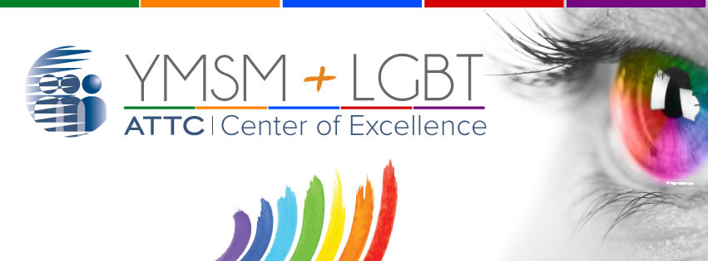

New HRSA SPNS Technical Assistance and Training Materials on Improving Patient Outcomes
Source: Integrating HIV Innovative Practices (IHIP), U.S. Dept. of Health and Human Services, Health Resources and Services Administration (HRSA) HIV/AIDS Bureau (HAB) Special Projects of National Significance (SPNS)
Description: HRSA has just released a comprehensive set of new technical assistance and training materials entitled Improving Health Outcomes: Moving Patients Along the HIV Care Continuum and Beyond. These materials were created as part of the IHIP project. IHIP takes evidence-informed interventions and care models, researched and tested under HRSA’s SPNS program, and creates easy-to-follow replication guides to support engagement of hard-to-reach populations. New resources are organized along the phases of the HIV care continuum and showcase innovation, effectiveness, and rationale for each featured intervention. Materials include achievable and practical guidance, resource and capacity checklists, and step-by-step processes. Included in the bundle of new resources are the following:
- Training manual
- Series of 10 case studies
- Pocket guides
- TA webinars, featuring experts and frontline staff
Link to resources
A National Strategy for the Elimination of Hepatitis B and C: Phase Two Report
Source: National Academies of Sciences, Engineering, and Medicine, Health and Medicine Division
Description: In an effort to describe a strategy for eliminating viral hepatitis as a U.S. public health problem by 2030, the National Academies, with support from the U.S. Centers for Disease Control and Prevention and the U.S. Department of Health and Human Services, the American Association for the Study of Liver Diseases, the Infectious Diseases Society of America, and the National Viral Hepatitis Roundtable, convened an expert committee to outline a national strategy. The committee produced two reports. The first report, Eliminating the Public Health Problem of Hepatitis B and C in the United States: Phase One Report, concluded that both hepatitis B and C could be eliminated as a public health problem in the U.S., but that there are substantial obstacles to meeting this goal. This second report recommends specific actions to hasten the end of these diseases and lays out five areas—information, interventions, service delivery, financing, and research—to consider in the national plan.
Link to download the report
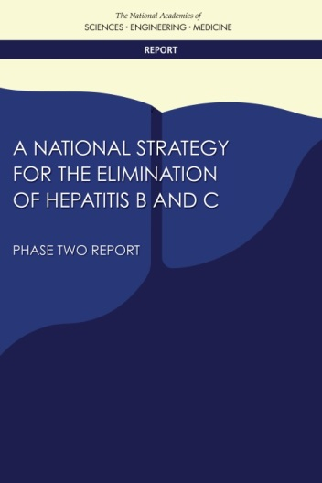

Selecting an Initial ART Regimen (guideline)
Source: New York State (NYS) Department of Health, AIDS Institute, Medical Care Criteria Committee
Description: This resource which provides recommendations for NYS for prescribing antiretroviral therapy (ART) regimens for treatment-naïve, non-pregnant adults with HIV-1 infection without acquired resistance, is based on a review of published data regarding efficacy of treatment regimens, and includes factors that influence adherence, including pill burden, tolerability, and dosing schedule.
To help guide the choice among regimens of similar efficacy, each table includes comments that address selected pertinent issues regarding each regimen, while other sections include a review of relevant issues, patient considerations, essential laboratory assessments, and the rationale for the recommendations.
Link to print the guidelines

CDC Vital Signs: African American Health, Creating Equal Opportunities for Health (fact sheet & infographic)
Source: U.S. Dept. of Health and Human Services, U.S. Centers for Disease Control and Prevention (CDC)
Description: This updated resource highlights the health disparities that exist within the African American community when compared to whites, and makes recommendations for local, state and federal agencies/organizations and healthcare professionals and to address the health inequities to improve health outcomes for African Americans across the U.S.
Link to download the resource
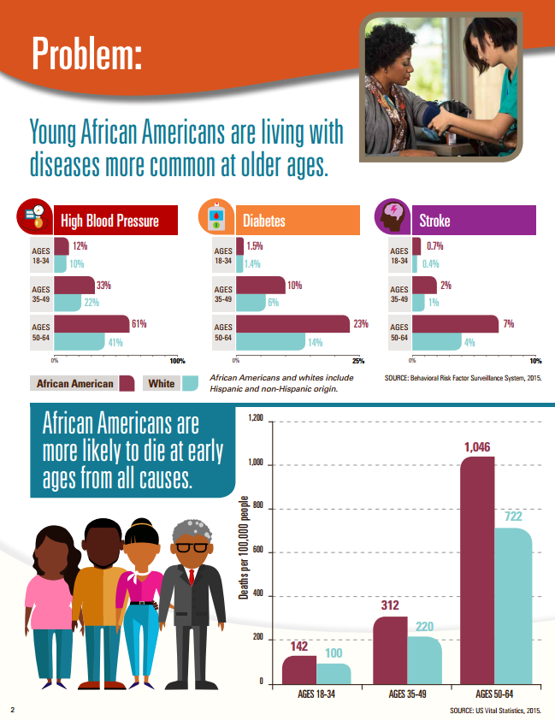

Models for Improving Linkage to Care for People Living with HIV (PLWH) Released from Jail or Prison (resource guide)
Source: The National Center for Innovation in HIV Care
Description: This resource guide summarizes effective models and best practices of linkage to care programs for PLWH who are leaving jail or prison and reentering society. Its purpose is to help AIDS service organizations and community-based organizations provide continuity of care for formerly incarcerated PLWH as they reenter society. It is based on project reports, training manuals, and resource guides on post-incarceration linkage to care programs, including the HRSA-CDC Corrections Demonstration Project, the HRSA HAB SPNS program: Enhancing Linkages to HIV Primary Care & Services in Jail Settings Initiative (EnhanceLink), The Bridging Group's Project START Plus, and others.
Link to resource guide
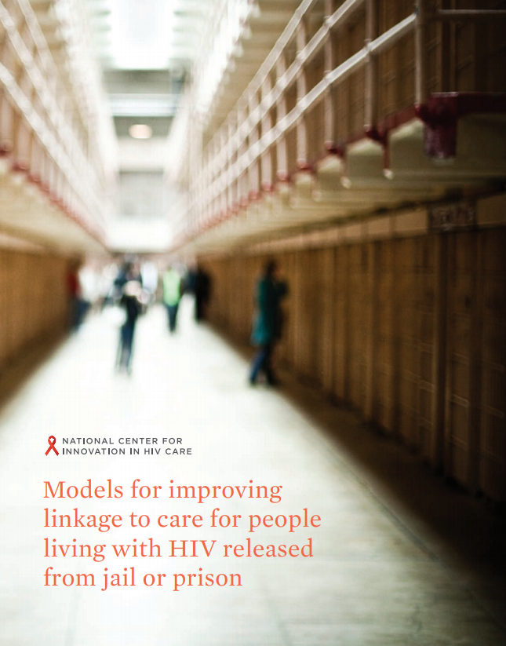

PrEParing: Pre-Exposure Prophylaxis (PrEP) for Providers and Patients (online course)
Source: Johns Hopkins University
Description: The purpose of this course is to prepare participants with essential information, concepts and practical advice regarding PrEP from leaders in the field. A first of its kind learning opportunity, both providers and patients learn from the same experts through content that meets the needs of both audiences, while facilitating the opportunity for a shared community space.

This course is for individuals who are interested in gaining a basic understanding about PrEP for HIV prevention. Healthcare providers will learn about cutting-edge research and PrEP guidelines, how to initiate a PrEP program, clinical management and how to provide culturally sensitive sexual health and primary care to diverse communities. Patient lessons are intended for persons considering PrEP for themselves, those already on PrEP as well as their friends, allies and advocates. Healthcare providers interested in patient—level PrEP education should also consider this track. The course session is 6 weeks long.
Link to course enrollment

2017 United States Conference on AIDS (USCA) - September 7-10, 2017, Washington, DC
Source: National Minority AIDS Council (NMAC)
Description: At the 2017 USCA, attendees will hear from federal officials about various agency implementation plans and expected changes related to Medicaid and service delivery. In addition to skills-building sessions offered through abstract submissions, late-breaker sessions will be offered to reflect the most current domestic issues leading up to the conference. Scholarships are available; application deadline is June 30th. Follow the link below to register and learn more.
Link to conference site
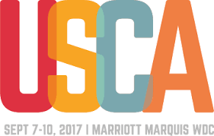

Registration for ANAC2017 is now OPEN!
Source: Association of Nurses in AIDS Care (ANAC)
Description: ANAC2017 will celebrate 30 years of working with nurses and nurse practitioners in HIV and its associated conditions, co-infections and co-morbidities. This year’s conference will take place in Dallas, TX, from November 2-4, 2017. Conference objectives include:
- Analyze strategies to sustain and advocate for ongoing advances in HIV/AIDS care given the shifts in the domestic political, economic and social climate
- Discuss innovative biomedical, psychosocial and behavioral research in HIV and associated co-morbidities
- Evaluate the global impact of nurses’ and other health professionals' roles in addressing HIV health disparities, HIV risk and social determinants of health
- Demonstrate an enhanced ability to care for key populations living with, or affected by HIV and related co-morbidities
- Improve nurses and other professionals’ capacity to identify, treat and care for individuals at risk for and/or living with viral hepatitis
Follow the link above to register, view the conference agenda, and learn more about lodging and other activities to take part in during your stay in Dallas.
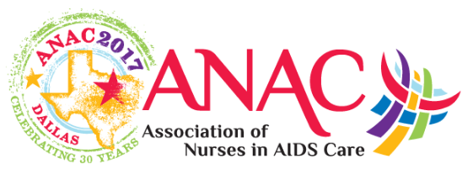

Awareness Days
HIV Long-Term Survivors Day – June 5
Caribbean American HIV/AIDS Awareness Day – June 8
National HIV Testing Day – June 27
African American Hepatitis C Action Day – July 25

