Quarterly Newsletter-Winter 2016
AETC Program related news, resources and events:
Resources
Strengthening the HIV Workforce
Source: Southeast AETC
Description: The purpose of this report is to synthesize current literature, provide examples of model programs and practices, and offer recommendations related to strengthening the HIV workforce, particularly in the Southeast U.S. region. Using a multidisciplinary lens, the authors explore workforce capacity issues, from novice to expert, related to Building the Pipeline, Capacitation, Collaboration, and Retention.
Link to report
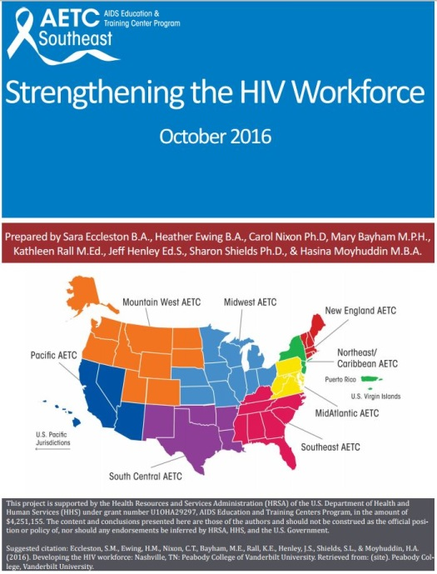

Updated HIV Treatment Guideline Pocket Cards
Source: Southeast AETC
Description: These pocket cards provide a summary of critical information regarding antiretroviral agents and other treatment regimens for people living with HIV infection in the U.S. The resources are adapted from existing guidelines set forth by different programs and committees of the U.S. Dept. of Health and Human Services, and are updated as new treatment information becomes available. Most recently updated are:
- ARV Therapy in Adults & Adolescents – September 2016
- Opportunistic Infections (OIs) in HIV/AIDS – June 2016
- Pre-Exposure Prophylaxis (PrEP), Non-Occupational Post-Exposure Prophylaxis (nPEP) and Occupational PEP (oPEP) – June 2016
- Treatment of Tuberculosis (TB) in Adults with HIV Infection – May 2016
Printed copies will be available soon. They are available for download via the Southeast AETC website.
Link to download the resources
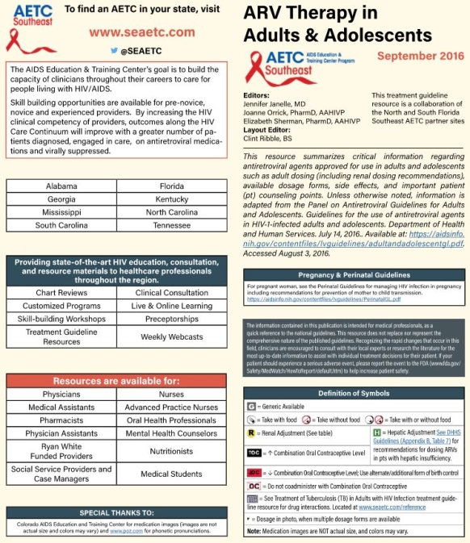

From Diagnosis to Treatment: How to Build an HCV Clinical Toolkit
Source: Southeast AETC
Description: This toolkit provides clinical guidance on the care and treatment of HCV including testing and prevention, HCV and comorbidities, HIV and STDs, nutrition, sexual activity, and more. The toolkit is comprised of webinars and online training, and includes a series of downloadable materials for patients.
Link to toolkit

Updates from the National Clinician Consultation Center (NCCC):
- PEPline New Hours:
The National Clinician Consultation Center’s Post-Exposure Prophylaxis Hotline (PEPline) will now be available from 9:00 am until 12:00 am (midnight), Eastern Time, seven days a week at the same number: 1-888-448-4911. Please visit the website for additional resources in managing occupational and non-occupational exposures to HIV and hepatitis B and C.

- Case of the Month:
  - Cesarean Delivery for Women Living with HIV

- Recent publications:
  - Editorial: Primary Care for Patients with HIV Infection: It’s Not Who Should Provide It, It’s How to Provide It
  - Initial Management of Patients with HIV Infection

Minority AIDS Initiative
Updated: Assisting HIV Patients Returning to Mexico and Central America / Asistiendo a los Pacientes que Regresan a México y Centroamérica
Source: Pacific AETC, Los Angeles Area AETC, Arizona AETC, South Central AETC, New Mexico AETC, AETC National Coordinating Resource Center
Description: These updated fact sheets were developed to assist providers who have patients living with HIV infection leaving the United States for Mexico and Central American countries. The goal of the information is to improve continuity of care for migrant patients with HIV. Fact sheets are available in both English and Spanish (each file has both languages). Fact sheets can be downloaded as one resource or accessed individually by region.
Link to all files

National African American MSM Leadership Conference on HIV/AIDS and other Health Disparities – January 19-22, 2017, Dallas, TX
Source: NAESM, Inc.
Description: The purpose of this conference is to increase participants’ knowledge of public health challenges and related solutions, trends, emerging issues and evidence gaps in health equity among black gay men, and increase utilization of effective evidence-based education programs and health promotion practices to improve health outcomes among black gay men. This conference provides a space to discuss and examine social determinants of health in the context of spirituality, religiosity, and faith through the perspectives of black gay men, and present information that demonstrates promising outcomes in achieving the goals National HIV/AIDS Strategy.
Link to conference registration and more information
Practice Transformation
Update on AETC Program Practice Transformation Projects (PTP): Facilitating Training on Coaching Basics (TCB)
Source: AETC National Coordinating Resource Center (NCRC), National Quality Center (NQC)
Description: AETC NCRC is collaborating with the NQC to facilitate TCB in support of PTP coach development. PTP participants will be asked to complete standardized screening tools to assess their coaching skills, prior coaching experiences, project management, and quality improvement (QI) knowledge, which will be followed by a 3-day interactive workshop session to focus on the skills and behaviors of being a successful coach, and to develop individualized Personal Improvement Plans. The workshop provides hands-on, real-world exercises for effectively coaching individuals and teams. Study Groups will be developed, and participants will work with an identified Study Group during and after the training. Participants are expected to have measurable coaching skill improvement as a result of this program. The purpose of this training is to increase synergy between PTP coordinators and coaches, increase QI competencies, and share best practices and challenges to create a unified process of coaching to be used across the AETC Program. The workshop is scheduled for early 2017. This training is adapted from the NQC’s TCB Program, and tailored to meet the goals of the AETC Program’s PTP. Follow the link below to learn more about the NQC’s TCB Program for your training needs.
Link to NQC website

​​Colorado State Innovation Model Practice Transformation Toolkit
Source: University of Colorado Department of Family Medicine
Description: This resource includes a compendium of existing resources - organized by building blocks and action steps - to assist care teams at any stage along the practice transformation process.
Link to toolkit

Interprofessional Education

What and how do Students Learn in an Interprofessional Student-run Clinic? An Educational Framework for Team-based Care (research article)
Source: Medical Education Online 2016
Description: The purpose of this article is to derive a framework for understanding student learning during team-based care provided in an interprofessional student-run clinic serving underserved patients.
Link to article

Other resources, news and events:
Clinician Guidelines on HIV Criminalization
Source: Association of Nurses in AIDS Care (ANAC)
Description: HIV criminalization refers to the use of criminal law to arrest and penalize people for alleged, perceived or potential HIV exposure; alleged nondisclosure of a known HIV-positive status prior to consensual sexual contact or non-intentional HIV transmission. This guide does not replace or supersede existing laws, professional and ethical standards, practice standards or institutional policies, but rather provides an understanding for clinicians of the practices, laws and policies that criminalize alleged HIV exposure, that create an environment of fear and discrimination and do not reflect current knowledge of transmission risk.
Link to resource
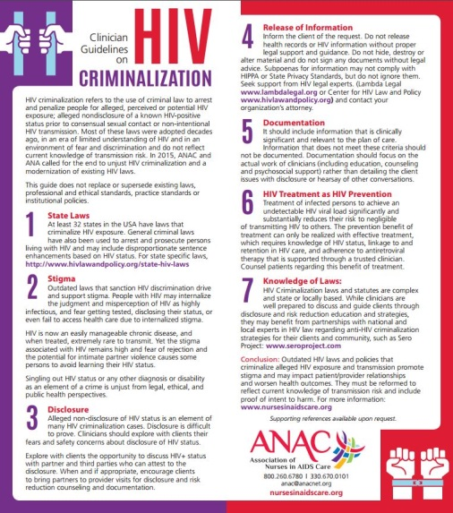

In Brief: Rural Behavioral Health: Telehealth Challenges and Opportunities
Source: U.S. Dept. of Health and Human Services, Substance Abuse and Mental Health Services Administration (SAMHSA)
Description: This resource explores barriers to accessing substance use disorder and mental health treatment services in rural communities and the benefits of telehealth for these communities. It assists healthcare providers with implementing telehealth technologies as a means to increase access to services.
Link to brief

Issue Brief: HIV and Transgender Communities
Source: U.S. Dept. of Health and Human Services (HHS), U.S. Centers for Disease Control and Prevention (CDC)
Description: This issue brief outlines what the available data tell us about the effects HIV has taken on the transgender community, why transgender people are at particular risk, and the ways in which CDC and its partners in public health can continue to work together to address the HIV prevention and other healthcare needs of transgender people.
Link to brief

Providing Affirmative Care for Patients with Non-binary Gender Identities
Source: National LGBT Health Education Center, Fenway Institute
Description: Non-binary people face numerous health disparities as well as stigma, discrimination, and a lack of access to quality care. This document includes important terms and definitions, data, case scenarios, and expert-informed practices that offer suggestions for how professionals of all roles and disciplines within any healthcare organization can implement changes to improve the experiences of patients with non-binary gender identities.
Link to publication
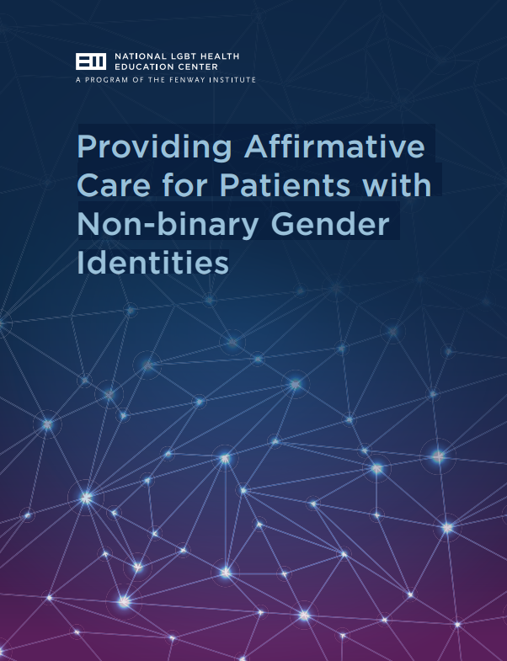

Conference on Retroviruses and Opportunistic Infections (CROI) – February 13-16, 2017, Seattle, WA
Source: CROI Foundation, International Antiviral Society-USA (IAS-USA)
Description: CROI brings together top basic, translational, and clinical researchers from around the world to share the latest studies, important developments, and best research methods in the ongoing battle against HIV/AIDS and related infectious diseases. CROI is a global model of collaborative science and the premier international venue for bridging basic and clinical investigation to clinical practice in the field of HIV and related viruses. Registration is now open; early-bird rates are available through January 4, 2017.
Link to conference registration and more information

Save-the-Date: IAS-USA Full Day CME Courses, 2017
Source: International Antiviral Society-USA (IAS-USA)
Description: IAS–USA full-day courses are designed to blend interactive, advanced-level presentations with balanced, timely, scientifically rigorous, and clinically relevant information about HIV and HCV disease management. They offer American Board of Internal Medicine (ABIM) Maintenance of Certification (MOC) points in addition to CME credits, continuing nursing education units, and continuing pharmacy education credit. The early registration fee is $75 for the course, credits, and lunch. Click on the links below for details about courses planned for New York City and Washington, DC, in February and May 2017, respectively. Information about upcoming live activities in Atlanta, Chicago, San Francisco, and Los Angeles can be found at www.iasusa.org.
New York, NY – February 24, 2017
Washington, DC – May 22, 2017

The Opioid Crisis: How Health Care Can Take Action (seminar) – March 13-14, 2017, Boston, MA
Source: Institute for Healthcare Improvement (IHI)
Description: This seminar is designed to equip health care organizations with strategies and tools to impact each of the four primary drivers of the opioid crisis identified, by the IHI’s Innovation Team:
- Limit the supply of opioids
- Raise awareness of the risk of opioid addiction
- Identify and manage opioid-dependent population
- Treat opioid-dependent individuals

Learning objectives include implementing a system approach in addressing the opioid crisis, and identifying strategies to impact the drivers of the opioid crisis. It is intended for all healthcare professionals including physicians, nurses, care/risk managers, program managers, health system administrators, and others. For more about this topic, read IHI’s Innovation Report: Addressing the Opioid Crisis in the United States.
Link to seminar registration and more information

Facing Addiction in America: The Surgeon General’s Report on Alcohol, Drugs and Health
Source: HHS
Description: This report reviews available information that can be used to address substance use disorders and related consequences. Key findings are detailed by chapter, and the report includes supplementary materials that highlight recommendations for specific audiences.
Link to full report
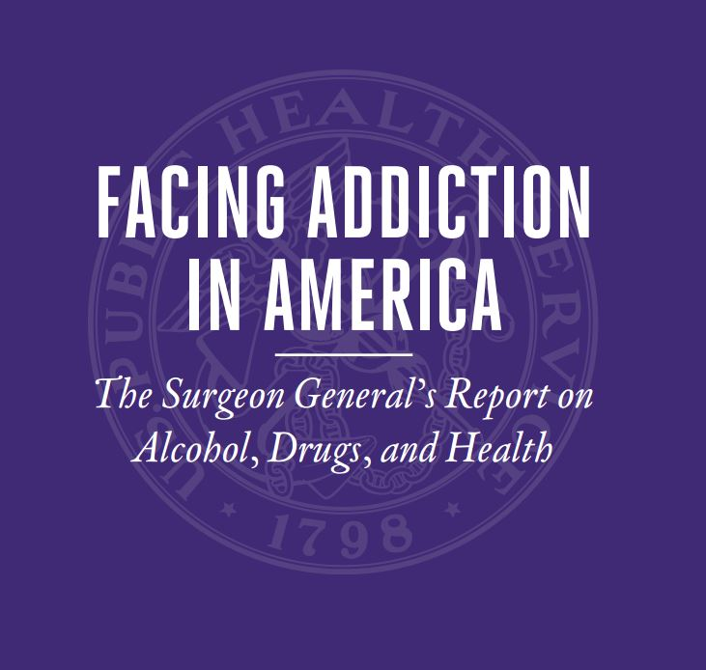

New HIV-related articles on Consultant360
Source: Consultant360, HMP Communications LLC
Description: New HIV-related articles have been added to the HIV/AIDS topic page on Consultant360, an online resource for clinicians. Create an account at the link above to read the following:
- Study: Smoking Effects Lifespan in HIV Patients More the Virus Itself: A recent study investigated the effects of smoking on life expectancy in individuals infected with HIV.
- ACIP: Routine Meningococcal Vaccination for HIV-Infected Individuals: The CDC’s Advisory Committee on Immunization Practices has recommended routine vaccination with meningococcal conjugate vaccine for HIV-infected.
- New Regimen Effective in Women with HIV-1: New research compared treatment with a new option for HIV, dolutegravir, against older regimens in women previously untreated for HIV.
- Non-Hodgkin Lymphoma Risk is Higher in HIV Patients with Hepatitis B or C: New research investigated whether chronic hepatitis B or C virus infection were associated with increased incidence of non-Hodgkin lymphoma in patients also infected with HIV receiving antiretroviral therapy.

Awareness Days
World AIDS Day – December 1
National Black HIV/AIDS Awareness Day – February 7
National Women and Girls HIV/AIDS Awareness Day – March 10
National Native HIV/AIDS Awareness Day – March 20

