# Quarterly Newsletter-Winter 2017

**AETC Program related news, resources and events:**

**Resources & Events**

[Continuing Education Credits Now Available for the AETC HIV/HCV Co-infection Curriculum](https://www.aidsetc.org/hivhcv)

**Source:** AETC NCRC, MidAtlantic AETC, New England AETC, Northeast/Caribbean AETC, South Central AETC, Southeast AETC, U.S. Dept. of Health and Human Services (HHS), Health Resources and Services Administration HIV/AIDS Bureau (HRSA HAB)

**Description:** We are pleased to announce that continuing medical and nursing education credits (CME/CNEs) are now availablefor *HIV/HCV Co-infection: An AETC National Curriculum*, developed as a component of HRSA HAB’s Jurisdictional Approaches to Curing Hepatitis C among HIV/HCV Co-Infected People of Color project. The curriculum is structured around six core competencies identified as essential for providers treating co-infected people living with HIV; CME/CNEs are available for each module. Topics covered include prevention, screening, diagnosis and treatment recommendations as well as barriers and other co-factors that may impede optimal treatment outcomes for co-infected people of color. The curriculum was developed to provide evidence-based education for healthcare providers and trainers of healthcare providers to increase their knowledge of HIV and HCV co-infection among people of color in the U.S. and its territories. Credits are being provided through Rutgers School of Nursing.

[*Link to register for CEUs*](https://rutgersnursing.wufoo.com/forms/x19re4r81hi52qa/)

[Updated: Two-Drug, Single Tablet Regimen added to the National HIV Curriculum Antiretroviral Medications Summary](https://www.hiv.uw.edu/page/treatment/drugs/dolutegravir-rilpivirine)

**Source:** University of Washington, AETC National Coordinating Resource Center, HHS, HRSA HAB

**Description:** Dolutegravir-rilpivirine is a two-drug, single-tablet regimen that may be used to replace an existing antiretroviral regimen in persons who have suppressed HIV RNA levels on a stable antiretroviral regimen for at least 6 months; the dolutegravir-rilpivirine two-drug regimen should only be used in persons with no history of antiretroviral treatment failure and no known mutations associated with resistance to either dolutegravir or rilpivirine.

**

[Immune Activation in Treated HIV: Does It Still Matter (webinar) - January 16, 2018, 11:00 AM – 12:00 PM ET](https://aidsetc.org/calendar/immune-activation-treated-hiv-does-it-still-matter)

**Source:** Mountain West AETC

**Description:** This talk will examine the role of inflammation in persistent largely non-AIDS morbidity and mortality in treated HIV infection and current research studies on interventional strategies to mitigate risk. While waiting for definitive evidence, strategies that can be pursued in clinical practice now and which ones should probably be avoided will be discussed.

[*Link to webinar registration*](https://aetcnec.virtualforum.com/pifidform.cfm?erid=67268&sc=804300&aetccode=98)

[Warm Handoffs from Medical Providers to Drug Treatment Providers (webinar) – January 17, 2018, 12:00 – 1:00 PM ET](https://aidsetc.org/calendar/warm-handoffs-medical-providers-drug-treatment-providers)

**Source:** MidAtlantic AETC

**Description:** The purpose of this webinar is to enable participants to increase their knowledge of best practices for creating warm handoffs between medical providers and drug treatment providers and identify possible ways to overcome possible barriers to creating a warm handoff. CEUs are available for this activity.

[*Link to webinar registration*](https://www.maaetc.org/events/view/10441)

[Implementing Routine Testing in a Methadone Treatment Site (webinar) -January 24, 2018, 12:00 – 1:00 PM ET](https://aidsetc.org/calendar/implementing-routine-testing-methadone-treatment-site)

**Source:** MidAtlantic AETC, Johns Hopkins School of Nursing

**Description:** The purpose of this webinar is to enable participants to increase their knowledge of medication-assisted treatment (i.e. buprenorphine, methadone, and/or naltrexone). CEUs are available for this activity.

[*Link to webinar registration*](https://www.maaetc.org/events/view/10442)

*Visit the* [***National Clinician Consultation Center HIV hotlines and warmlines***](http://nccc.ucsf.edu/) *to obtain timely and confidential responses to clinical questions related to treatment of persons living with HIV infection and/or possible health care worker exposure to HIV infection, hepatitis C virus infection, and substance use.*

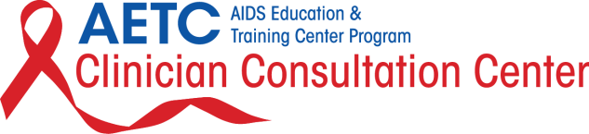

**Practice Transformation**

[New Evidence-informed Technical Assistance Resources for HIV Interventions](https://careacttarget.org/ihip)

**Source:** Integrating HIV Innovative Practices (IHIP)

**Description:** These evidence-informed HIV care continuum resources are accessible on dynamic and intuitive IHIP web pages to make for easy uptake. Research has demonstrated the importance of HIV care continuum activities; therefore, practice transformation that is inclusive of such interventions that help clients move along the stages of the continuum are particularly important.

The IHIP products are informed by Special Projects of National Significance (SPNS) research and evaluation. New resources include TA webinar trainings on system linkages, women of color, and oral health. Additional timely IHIP resource topics include:

• integrating buprenorphine opioid treatment

• jail linkage programs

• hepatitis C coinfection

• engaging hard-to-reach populations (including communities of color, women, and YMSM)

• health information technology

• medication access programs

• in-reach, and

• out-reach

Add these resources to your practice transformation toolbox to help implement training into practice to improve care delivery.

*[Link to resources](https://careacttarget.org/ihip)*

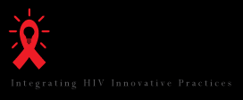

**Interprofessional Education (IPE)**

[Measuring the Impact of IPE on Collaborative Practice and Patient Outcomes](https://www.nap.edu/catalog/21726/measuring-the-impact-of-interprofessional-education-on-collaborative-practice-and-patient-outcomes) (report)

**Source:** Institute of Medicine, Board on Global Health, Committee on Measuring the Impact of Interprofessional Education on Collaborative Practice and Patient Outcomes

**Description:** Although the value of IPE has been embraced around the world - particularly for its impact on learning - many in leadership positions have questioned how IPE affects patient, population, and health system outcomes. This report measures the impacts of IPE on collaborative practice and health and system outcomes, and describes the research needed to strengthen the evidence base for IPE outcomes. It presents a model for evaluating IPE that could be adapted to any setting.

[*Link to download the report*](https://www.nap.edu/login.php?record_id=21726&page=https%3A%2F%2Fwww.nap.edu%2Fdownload%2F21726)

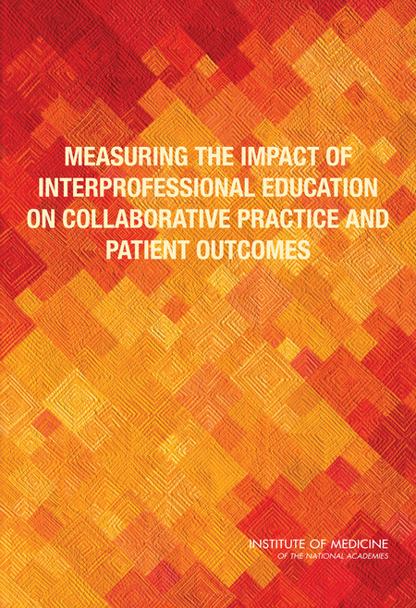

**Minority AIDS Initiative/Secretary's Minority AIDS Initiative Fund**

[2018 National African American Men who have Sex with Men (MSM) Leadership Conference on Health Disparities and Social Justice – January 18-21, 2018, Atlanta, GA](http://naesm.org/event/leadership-conference/?instance_id=15)

**Source:** National AIDS Education & Services for Minorities (NAESM)

**Description:** This program provides a space for the new generation of HIV public health professionals to collaborate and help shape the future of African-American MSM/young MSM public health matters, and examine the social determinants of health in the context of spirituality, religiosity, and faith through the perspectives of black gay men. The NAESM 2018 Leadership Conference offers knowledge exchange opportunities at the national level to identify and troubleshoot the intersection of health equity, social justice across a range of disciplines and sectors that define the experiences of black gay men.

This year the [Georgia AETC](https://aidsetc.org/aetc-program/georgia-aids-education-and-training-center) is pleased to be collaborating with NAESM by offering a clinical track at the 2018 Leadership Conference. The purpose of this track is to provide technical assistance and training to build the capacity of Black healthcare professionals to 1) help improve the health and well-being of individuals and communities of color; 2) increase the diversity of the health professional and scientific workforce; and 3) address primary healthcare needs through programs in education, research, and service, with emphasis on people of color and the underserved urban and rural populations in Georgia and the nation.

[*Link to conference registration*](http://dsdesignconcepts.com/NAESMDEVSITE/leadership-conference/registration/)



[Support LGBTQ College and University Students of Color (archived training)](https://www.whatworksinyouthhiv.org/event/support-lgbtq-college-and-university-students-color)

***Source:*** What Works in Youth HIV, HHS, Office of Adolescent Health

**Description: (**Recorded June 2017) In this training, campus service providers will learn how to help lesbian, gay, bisexual, transgender, and queer (LGBTQ) college and university students of color prevent HIV and feel healthy and connected on campus overall. Webinar panelists describe their work to address the gaps in services and feelings of isolation that LGBTQ students and students of color face, and the What Works in Youth HIV team share resources to examine current practices for supporting LGBTQ students. This training package includes a webinar recording, presentation slides and a short video.

[*Link to access training*](https://www.whatworksinyouthhiv.org/event/support-lgbtq-college-and-university-students-color)



**Other Resources, News and Events**

[National STD Curriculum launched in Response to Increasing STD Rates](https://www.std.uw.edu/)

**Source:** HHS, U.S. Centers for Disease Control and Prevention (CDC), University of Washington STD Prevention Training Center, University of Washington, University of Alabama, Birmingham

**Description:**

According to the CDC, more than two million cases of chlamydia, gonorrhea and syphilis were reported in the United States in 2016—the highest number ever. In response to the growing need for well-trained healthcare providers, the University of Washington STD Prevention Training Center has developed the National STD Curriculum website. The site addresses the epidemiology, pathogenesis, clinical manifestations, diagnosis, management, and prevention of STDs. It is free, up-to-date, and integrates the most recent CDC STD Treatment Guidelines. Features include:

• Seven Self-Study Modules

• Twelve Question Bank topics with 100+ interactive board-review style questions

• Modular learning in any order with an individual progress tracker

• Group registration and tracking for staff, students, and healthcare organizations

• Free continuing education credits (CME and CNE)

This website replaces the former CDC STD Self Study Modules for Clinicians. The website is intended for all healthcare professionals with an interest in STD diagnosis and management.

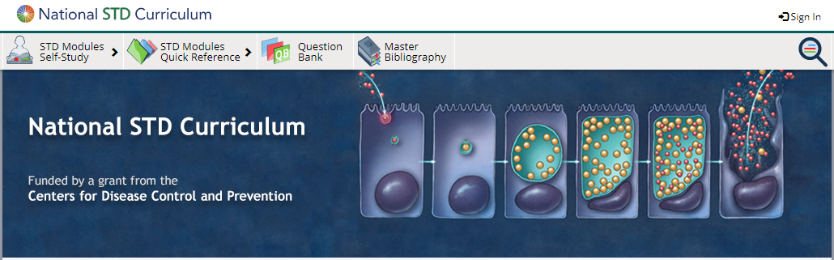

[Conference on Retroviruses and Opportunistic Infections (CROI) – March 4-7, 2018, Boston, MA](http://www.croiconference.org/)

**Source:** CROI Foundation, International Antiviral Society-USA (IAS-USA)

**Description:** CROI brings together top basic, translational, and clinical researchers from around the world to share the latest studies, important developments, and best research methods in the ongoing battle against HIV/AIDS and related infectious diseases. CROI is a global model of collaborative science and the premier international venue for bridging basic and clinical investigation to clinical practice in the field of HIV and related viruses.

[*Link to conference website*](http://www.croiconference.org/)

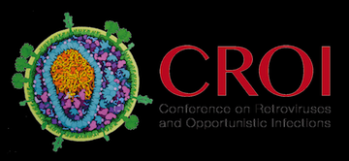

**ACTHIV Special Training for Effective Providers in HIV (STEP-HIV) Webinar Series**

**Source:** The American Conference for the Treatment of HIV (ACTHIV), American Academy of CME, Inc.

**Description:** The following are CME/CE webinar activities from ACTHIV’s STEP-HIV initiatives which were developed to promote HIV workforce development through education for healthcare professionals who are in training or who are in practice but are new to HIV medicine:

* **Case Studies in HIV and HCV Coinfection** focuses on the approach to evaluation and management of patients with HIV and chronic HCV infection. This course expires January 19, 2018. [*Launch the course*](http://www.acthiv.org/webinar_HCV_Coinfection.asp)
* **Case Studies in Recognizing and Managing Opportunistic Infections in HIV-Infected Individuals** focuses on the recognition and management of opportunistic infections encountered among HIV-infected patients and provides a review of guidelines on when to start ART in the setting of an opportunistic infection that can be implemented in your practice. This course expires March 20, 2018. [*Launch the course*](http://www.acthiv.org/webinar_OpportunisticInfections.asp)
* **Case Studies on Improving Patient Engagement through the HIV Continuum of Care** focuses on the stages of the HIV Care Continuum and – using New York City as an example – shows how data systems can be used to improve HIV prevention and care services provided by the healthcare team. This course expires May 16, 2018.[*Launch the course*](http://www.acthiv.org/webinar_HIV_Continuum.asp)

[ACTHIV 2018 – April 5-7, 2018, Chicago, IL](http://www.acthiv.org/)

**Source:** The American Conference for the Treatment of HIV, Beaumont, American Academy of CME, Inc.

**Description:** This is a state-of-the-science conference specifically targeted toward U.S. frontline providers of care to persons at risk of, or with HIV infection. This conference offers interactive sessions covering a variety of relevant topics, and Exhibit Hall and Poster Session activities which provide great networking opportunities. Abstract submissions and exhibitor applications are still being accepted.

[Link to registration and more information](http://www.acthiv.org/default.asp)

*Please be advised that the HIV/AIDS Bureau (HAB) recipient staff funded by the Ryan White HIV/AIDS Program (RWHAP) attending the ACTHIV conference may not utilize travel and conference attendance funds allocated in RWHAP program budgets.*



[SYNChronicity 2018 – April 22-24, 2018, Arlington, VA](http://healthhiv.org/synchronicity/)

**Source:** HealthHIV, National Coalition for LGBT Health

**Description:** This national conference provides a distinct approach to HIV, HCV and LGBT health education and training. SYNC 2018 participants will have the unique opportunity to engage with clinicians, service providers, government officials, community based organization leaders, advocates, and others. The SYNC 2018 program will include five plenary sessions featuring pre-eminent thought leaders and experts discussing health reform, health systems, and health equity. Track sessions include:

1. The LGBT Health Track - Details best practices to address health disparities in LGBT communities and the unique health needs of LGBT individuals.
2. The MSM of Color Health Track - Identifies strategies to increase retention and engagement in health services and build leadership among MSM of color.
3. The Black Women’s Health Track - Bolsters programming and interventions addressing health issues among Black women.
4. The HCV Health Track - Syncs strategies to facilitate engagement in HCV testing and cure therapy in at-risk communities.
5. The Preventative Health Track - Integrates public health and primary care in delivering preventative services.
6. The Generational Track - Identifies the unique health needs of people across generations, focusing on youth and persons 50 and older.
7. The Systems Health Track - Helps HIV organizations move from compliance to sustainability with federal grants, revenue building, and strategic thinking within the new healthcare landscape.

CME, CE and CHES credit hours will be available at ALL SYNC 2018 plenary and track sessions. Limited scholarships are available for youth, consumers, transgender individuals, and community-based organization staff members. Three major factors will be considered in awarding these scholarships: a) applicant’s commitment to HIV, HCV, and/or LGBT health; b) leadership; and c) demonstration of need.

[*Link to conference registration*](http://healthhiv.org/synchronicity/3711-2/)

[*Link to scholarship application*](http://healthhiv.org/synchronicity/syncscholarships/?eType=EmailBlastContent&eId=84f43434-d6a3-4ada-a488-aa5962359d27)

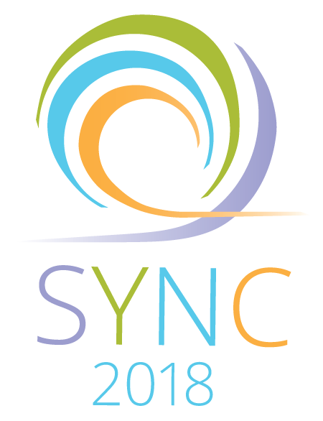

[HIV Clinical Fellowship Opportunity](http://www.hivma.org/HIVMA_Clinical_Fellowship.aspx)

**Source:** HIV Medicine Association (HIVMA)

**Description:** The HIVMA Clinical Fellowship program supports newly trained physicians with gaining HIV clinical experience working with medically underserved patient populations. The goal of the program is to boost the population of HIV physicians and strengthen the commitment to provide clinical care to HIV-infected patients in minority communities. HIVMA awards grants to support one-year of HIV clinical training to up to two fellows per year. Grants are made to the institution to support a stipend of $60,000 plus additional funding to cover fringe benefits for one year. An additional $10,000 is paid to the institution to offset administrative costs and to provide for additional educational opportunities. Applications for the 2018-2019 program are now being accepted. **The deadline to apply is January 8, 2018.** Strong preference will be given to African American and Latino candidates and to applicants pursuing training in the southeastern U.S. Contact Kumba Sennaar at [ksennaar@hivma.org](mailto:ksennaar@hivma.org) for more information.

[*Link to application*](http://www.hivma.org/HIVMA/Career_Training/Minority_Clinical_Fellowship_Apply_Online/)

[Amigos y Amantes](http://www.amigosamantes.com/)

**Source:** HHS, National Library of Medicine

**Description:** This website features short video episodes and links to resources that focus on different character's needs for HIV prevention information: a questioning young man, an out young MSM, the young MSM's mother, and a young woman in a long-term, unhealthy heterosexual relationship. The final episodes show the decision-making point for the young adults to visit a clinic, and each episode also has its own [companion print handout](http://www.amigosamantes.com/recursos/guias/) reiterating key educational points. The website and materials are designed for the Spanish speaking community; however, an English version of all materials will be available soon.

[*Link to website*](http://www.amigosamantes.com/)



[Teen Dating Violence Awareness Month (February) Toolkit](https://healthfinder.gov/NHO/FebruaryToolkit2.aspx)  
**Source:**HHS, Office of Disease Prevention and Health Promotion

**Description:** One in three teenagers in the U.S. will experience physical, sexual, or emotional abuse in a relationship. Teen Dating Violence Awareness Month (February) is a national effort to raise awareness about relationship abuse in teens and young adults and promote programs that prevent it. This toolkit provides resources and social media campaign messages to encourage schools, community-based organizations, parents, and teens to take action toward meaningful change to reduce relationship abuse among teenagers and young adults.

[*Link to toolkit*](https://healthfinder.gov/NHO/FebruaryToolkit2.aspx)

**Awareness Days**

[Teen Dating Violence Awareness Month – February](https://www.whatworksinyouthhiv.org/event/teen-dating-violence-awareness-month-0)

[National Black HIV/AIDS Awareness Day – February 7](https://www.hiv.gov/events/awareness-days/black)

[National Women and Girls HIV/AIDS Awareness Day – March 10](https://www.hiv.gov/events/awareness-days/women-and-girls)

[National Native HIV/AIDS Awareness Day – March 20](https://www.hiv.gov/events/awareness-days/native)

