Quarterly Newsletter-Winter 2015

**AETC Program related news, resources and events:**

*Resource & Events:*

* [HIV Testing in the Oral Health Care Setting](http://aidsetc.org/resource/hiv-testing-oral-health-care-setting)

**Source:** New York State Department of Health, AIDS Institute, Northeast/Caribbean AETC Oral Health Regional Resource Center

**Description:** These documents provide key recommendations for implementing an HIV testing program in the oral health care setting. Documents include a technical assistance manual and an algorithm that can be used as an instrument for planning. [Click here to access the tools](http://www.hivguidelines.org/clinical-guidelines/hiv-and-oral-health/hiv-testing-in-the-oral-health-care-setting/).

* [Advanced Practice Nursing Education in HIV Care Infographic](http://aidsetc.org/resource/advanced-practice-nursing-education-hiv-care-infographic)

**Source:** AETC National Coordinating Resource Center, Rutgers School of Nursing

**Description:** This infographic highlights the importance of and need for specialized HIV care education in the primary care setting to address growing needs of the aging HIV population, in contrast to the shortage of HIV care specialists. [Click here](http://aidsetc.org/resource/advanced-practice-nursing-education-hiv-care-infographic) to download this resource in a variety of formats.

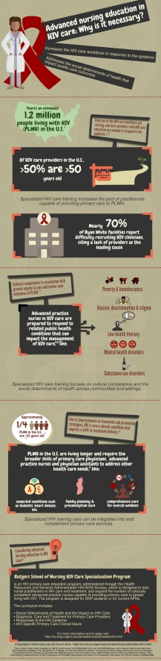

* The 15th Ryan White HIV/AIDS AETC Program Clinical Care Conference – December 15-17, 2015

The 15th Ryan White HIV/AIDS AETC Program Clinical CARE Conference (December 15-17, 2015) will be presented virtually, as a live webcast. Webcast attendees will be able to view live daily plenary lectures from their desktop computers or mobile devices. Registration for the virtual conference is free and is only necessary if you intend to claim CME, Nursing, or Pharmacy Credits, or a Certificate of Participation. Continuing Education Credits are only available for the live webcast of the plenary lectures, not for the archived webcast of the plenary lectures or the archived workshop sessions. Additional information, and the log-in URL for the days of the live webcast, can be found on the [AETC National Coordinating Resource Center website here](http://aidsetc.org/2015-RWCC) or the [IAS-USA website here.](https://www.iasusa.org/AETCRyanWhiteClinical)

*Updates from the Clinician Consultation Center:*

[PEP Tips: Follow-Up Testing One Year After an Exposure](http://nccc.ucsf.edu/2015/10/19/pep-tips-what-warrants-testing-one-year-after-an-exposure/)

[Oct. case of the month: Exposure Management: Labor and Delivery and Breastfeeding](http://nccc.ucsf.edu/2015/10/05/case-of-the-month-post-exposure-management-in-pregnancy/)

[Nov. case of the month: PEP Management and Kidney Disease](http://nccc.ucsf.edu/2015/11/09/case-of-the-month-pep-management-and-kidney-disease/)

**Minority AIDS Initiative**

* [Implementing Comprehensive HIV and STI Programs with Men Who Have Sex with Men: Practical Guidance for Collaborative Interventions](http://www.unfpa.org/publications/implementing-comprehensive-hiv-and-sti-programmes-men-who-have-sex-men)

**Source:** United Nations Population Fund, Global Forum on MSM & HIV, United Nations Development Programme, World Health Organization, United States Agency for International Development, World Bank

**Description:** This tool contains practical advice on implementing HIV and sexually transmitted infection programs with men who have sex with men (MSM). It is based on recommendations contained within the [Consolidated Guidelines on HIV Prevention, Diagnosis, Treatment and Care for Key Populations](http://www.unfpa.org/resources/consolidated-guidelines-hiv-prevention-diagnosis-treatment-and-care-key-populations), published in 2014 by the World Health Organization. Topics covered include community empowerment, addressing violence, condom and lubricant programming, other health-care services, and service delivery. The tool also covers the use of information and communications technology in programming, and offers strategies and best practices from around the globe for managing programs and building the capacity of organizations. [Click here to download the resource.](http://www.unfpa.org/sites/default/files/pub-pdf/MSMIT_for_Web.pdf)

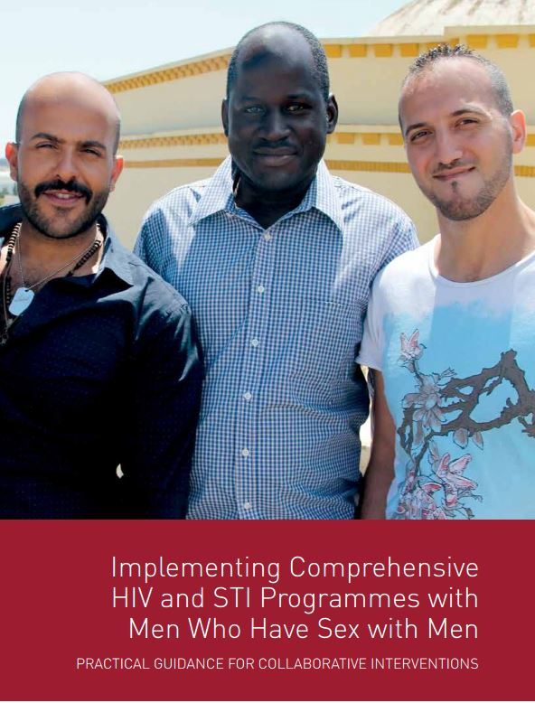

* [Become a Certified Native STAND (Students Together Against Negative Decision Making) Educator](http://www.oregonprc.org/projects/current/native-students-together-against-negative-decisions.html) (training opportunity)

**Source:** Center for Healthy Communities, Northwest Portland Area Indian Health Board

**Description:** Tribes and American Indian/Alaska Native organizations are invited to participate in this training that will take place from June 26 – July 1, 2016, in Portland, OR. Native STAND is a positive youth development program that builds decision making skills on healthy relationships, STD/HIV prevention, and reproductive health. Applications are due February 1, 2016. [Click here](http://www.oregonprc.org/application-for-our-summer-training-program.html) for requirements and more details.

**Practice Transformation**

* [Improvement Coach Professional Development Program](http://www.ihi.org/education/InPersonTraining/ImprovementCoach/ImprovementCoachFebruary2016/Pages/default.aspx)

**Source:** Institute for Healthcare Improvement

**Description**: This 12-week/3-part training begins with a web-based component on February 25, 2016, and is intended to develop quality improvement (QI) skills so that participants can identify, plan and execute improvement projects throughout their organization and coach teams to deliver measurable results. It is designed for quality team members, quality facilitators and clinical leaders, and the intended outcome is for participants to become QI leaders. [Click here](http://www.ihi.org/education/InPersonTraining/ImprovementCoach/ImprovementCoachFebruary2016/Pages/default.aspx) for registration and more information.

* [Advanced Measurement for Improvement Seminar](http://www.ihi.org/education/InPersonTraining/AdvancedMeasurementforImprovement/feb2016AdvancedMeasurementforImprovement/Pages/default.aspx?utm_campaign=Advanced+Measurement+2015&utm_source=hs_email&utm_medium=email&utm_content=22925284&_hsenc=p2ANqtz-_ffJZx_HHmanavZB--bkDdqspovZON1hxi7oGAay7SLkiNAO2K9yF-7g9mbwHUfbiI1pK66nlor3SL6EKPVVmZxosP7w&_hsmi=22925284) – February 4-5, 2016, San Diego, CA

**Source:** Institute for Healthcare Improvement

**Description:** The purpose of this interactive seminar is to help participants develop and apply practical measurement and data analysis plans to examine system performance and identify opportunities for improvement. Some learning objectives include developing a comprehensive plan for measurement, utilizing improvement science principles to identify measures that track improvement initiatives, understanding and applying key measurement concepts such as population, stratification, sampling methods, and more. This program is targeted for senior leaders, data analysts, information specialists, quality improvement managers, directors of administration, clinical leaders, pharmacists and others responsible for tracking project performance. [Click here](http://www.ihi.org/education/InPersonTraining/AdvancedMeasurementforImprovement/feb2016AdvancedMeasurementforImprovement/Pages/default.aspx?utm_campaign=Advanced+Measurement+2015&utm_source=hs_email&utm_medium=email&utm_content=22925284&_hsenc=p2ANqtz-_ffJZx_HHmanavZB--bkDdqspovZON1hxi7oGAay7SLkiNAO2K9yF-7g9mbwHUfbiI1pK66nlor3SL6EKPVVmZxosP7w&_hsmi=22925284) for registration and more information.

**Other resources, news and events:**

* [Updated IAPAC Guidelines for Optimizing the HIV Care Continuum for Adults and Adolescents](http://jia.sagepub.com/content/early/2015/10/23/2325957415613442.full.pdf+html)

**Source:** International Association of Providers of AIDS Care

**Description:** Updated recommendations for interventions to optimize HIV care including increasing HIV testing and linkage to care, treatment coverage, retention in care, and viral suppression; and recommendations for monitoring along the HIV care continuum. [Click here](http://aidsetc.org/resource/iapac-guidelines-optimizing-hiv-care-continuum-adults-and-adolescents) to access the guidelines and slide set.

* [HIV Surveillance Report: Diagnosed HIV Infection among Adults and Adolescents in Metropolitan Statistical Areas—United States and Puerto Rico, 2013](http://www.cdc.gov/hiv/pdf/library/reports/surveillance/cdc-hiv-surveillancereport-vol20-no4.pdf)

**Source:** U.S. Centers for Disease Control and Prevention, National Center for HIV/AIDS, Viral Hepatitis, STD, and TB Prevention, Division of HIV/AIDS Prevention

**Description:** This surveillance report presents data on diagnoses of HIV infection during 2013 and persons living with diagnosed HIV infection at year-end 2012 (prevalence) for adults and adolescents (aged 13 years and older) residing in metropolitan statistical areas in the United States and Puerto Rico.

HIV programs may use this information to target populations and areas at greatest need for HIV prevention and treatment services.

* [Modernizing Public Health to Meet the Needs of People who use Drugs - Affordable Care Act Opportunities](https://www.nastad.org/sites/default/files/ModernizingPublicHealth-NASTAD.pdf)

**Source**: National Alliance of State and Territorial AIDS Directors, Elton John AIDS Foundation

**Description:** This white paper assesses new financing and delivery models for community-based drug user health and harm reduction services typically not covered by insurance. The paper identifies ways public health programs and providers are working with broader health care systems and payers, and exposes findings that contribute to disparities in access to prevention and care services and that require immediate attention. [Click here](https://www.nastad.org/sites/default/files/ModernizingPublicHealth-NASTAD.pdf) to read the full report.

* [ACE on the Go - Podcasts for HIV Clinicians](https://careacttarget.org/ace/podcasts)

**Source:** Affordable Care Enrollment Technical Assistance (ACE TA) Center, Association of Nurses in AIDS Care (ANAC), HealthHIV

**Description:** This podcast series provides convenient 5-minute conversations with experts on how providers can help their clients enroll, renew, and maintain health coverage; access financial support to cover medication costs, premiums and co-pays; and avoid gaps in care due to coverage changes. [Click here to access the podcasts](https://careacttarget.org/ace/podcasts) from your desktop computer or mobile device.

* [Tools and Resources for Integrating Behavioral Health into HIV Care](http://www.integration.samhsa.gov/integrated-care-models/hrsa-supported-safety-net-providers/hrsa-supported-hiv-providers)

**Source:** Substance Abuse and Mental Health Services Administration (SAMHSA) - Health Resources and Services Administration (HRSA) Center for Integrated Health Solutions

**Description:** A suite of tools and resources are compiled to support providers, healthcare administrators and staff with integrating behavioral health care into the HIV care continuum. They were developed to help healthcare professionals with questions about workforce development, business models, access to specialty treatment providers, policy and procedures, and reimbursement for the provision of behavioral health services. [Find links to all the related tools and resources here.](http://www.integration.samhsa.gov/integrated-care-models/hrsa-supported-safety-net-providers/hrsa-supported-hiv-providers)

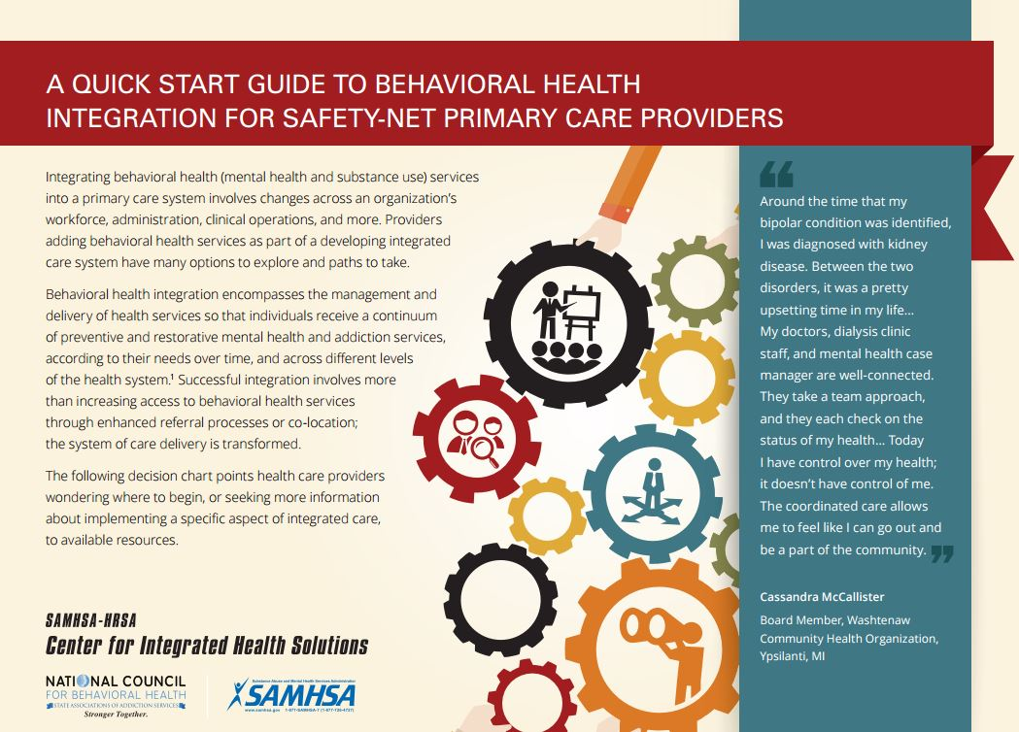

* [What’s New in the 2015 Perinatal HIV Guidelines (webinar recording & presentation slides)](http://aidsetc.org/resource/what%E2%80%99s-new-2015-perinatal-hiv-guidelines-0)

**Source**: U.S. Centers for Disease Control and Prevention Elimination of Perinatal HIV Transmission Stakeholders Group

**Description:** (Recorded October 7, 2015) The purpose of this training is to increase the understanding and awareness of recent changes to the perinatal HIV treatment guidelines and provide clinical cases to illustrate accurate interpretation of the guidelines. [Click here](http://aidsetc.org/resource/what%E2%80%99s-new-2015-perinatal-hiv-guidelines-0) to access the webinar recording and presentation slides.

* [American Geriatrics Society Updated Beers Criteria for Potentially Inappropriate Medication Use in Older Adults](http://geriatricscareonline.org/toc/american-geriatrics-society-updated-beers-criteria-for-potentially-inappropriate-medication-use-in-older-adults/CL001)

**Source:** American Geriatrics Society (AGS)

**Description:** This resource may be helpful for providers treating persons living with HIV over the age of 50. The updated and expanded Beers Criteria includes lists of potentially inappropriate medications for older adults who are not receiving hospice or palliative care, and is accompanied by a collection of new resources on alternative therapies, guidance on best practices for implementation of AGS recommendations, and more. [Find links to the resources here.](http://geriatricscareonline.org/toc/american-geriatrics-society-updated-beers-criteria-for-potentially-inappropriate-medication-use-in-older-adults/CL001)



* [The HIV Workforce in New York State: Does Patient Volume Correlate with Quality?](http://www.ncbi.nlm.nih.gov/pubmed/26423383)

Source: AIDS Institute, New York State Department of Health

**Description**: Study reveals that compared to patients cared for by experienced providers, patients cared for by low-volume prescribers (LVPs) had lower viral load suppression rates, and were less likely to have regular clinical visits, CD4 cell count measurements, or mental health and syphilis screenings, among other findings. It suggests that patient volume does correlate with quality, and that access to experienced providers is a determinant of delivering high-quality care which should guide HIV workforce policy decisions. [Click here](http://www.ncbi.nlm.nih.gov/pubmed/26423383) to read the full report.

* [2016 HIV Diagnostics Conference – March 21-24, 2016, Atlanta, GA](http://hivtestingconference.org/)

**Source:** The U.S. Centers for Disease Control and Prevention (CDC), Association of Public Health Laboratories (APHL), American Sexual Health Association (ASHA), American Sexually Transmitted Diseases Association (ASTDA)

**Description:** This conference provides attendees with information on currently available and cutting edge HIV tests and strategies for their use. Attendees include public health officials, laboratorians, HIV testing program managers, surveillance coordinators and industry representatives. This unique confluence of subject matter experts involved in every aspect of HIV testing has fostered the development and use of new HIV testing technology in the United States. The conference, the only meeting of its kind, offers a unique opportunity for persons involved in HIV testing to become familiar with test performance data, best practices, implementation of new HIV testing algorithms, quality assurance, and the application of new tests in a variety of settings. Continuing education points for this activity is pending. Late breaker abstract deadline is January 15, 2016. [Register and find more information here](http://hivtestingconference.org/).

* [Four new HIV-related articles on *Consultant360*](http://www.consultant360.com/topic/hiv-aids)

**Source:** Consultant360, HMP Communications LLC

**Description:** Four additional HIV-related articles have been added to the new HIV/AIDS topic page on *Consultant360,* an online resource for clinicians. Create an account at the link above to read the following:

1. Cancer Prevention More Important than Ever in HIV Population
2. WHO Ramps Up HIV Drug Push with Call for Early Treatment for All
3. Older HIV-Infected Individuals Living Longer with ART
4. Women are Missing from HIV Drug Trials.

* [Getting Yourself Prepared for PrEP flow chart - Spanish version now available](http://www.projectinform.org/pdf/PrEP_Flow_Chart_sp.pdf)

**Source:** Project Inform

**Description:**  This resource is suitable for both consumers and health navigators.Like the English version, one side outlines the process as an infographic to help consumers address possible issues that may come up when finding a doctor and getting a prescription for PrEP, and the other side may be useful for health navigators when assisting clients with accessing assistance programs for covering the cost of PrEP. The flow chart is designed to fit a legal-sized sheet of paper and can be easily printed from desktop computers. [Download the Spanish version here](http://www.projectinform.org/pdf/PrEP_Flow_Chart_sp.pdf).

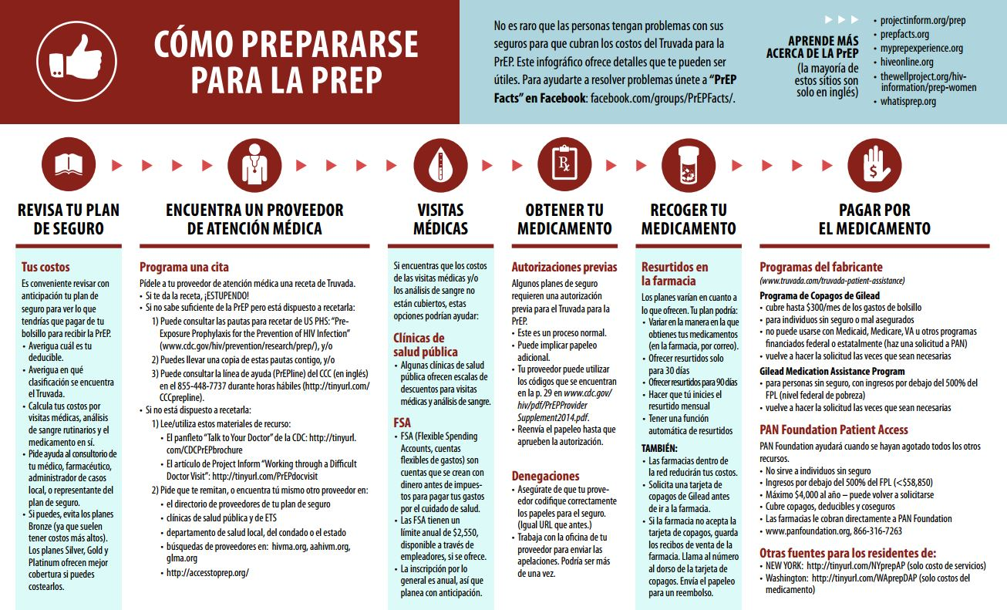

**Interprofessional Education:**

* [Vanderbilt Program in Interprofessional Learning](https://medschool.vanderbilt.edu/vpil/)

**Source:** Vanderbilt University School of Medicine

**Description:** Vanderbilt University School of Medicine offers an innovative educational

program designed to train healthcare professionals to meet the challenges of providing quality care

and improving health outcomes in the 21st century. This program is designed to help healthcare professionals work collaboratively and develop an understanding of and respect for their

healthcare colleagues with diverse training and skill sets. Follow the link above to watch a short

introductory video and learn more about the program.